ECE 254 Notes

# 1: Introduction

## Introduction to Operating Systems

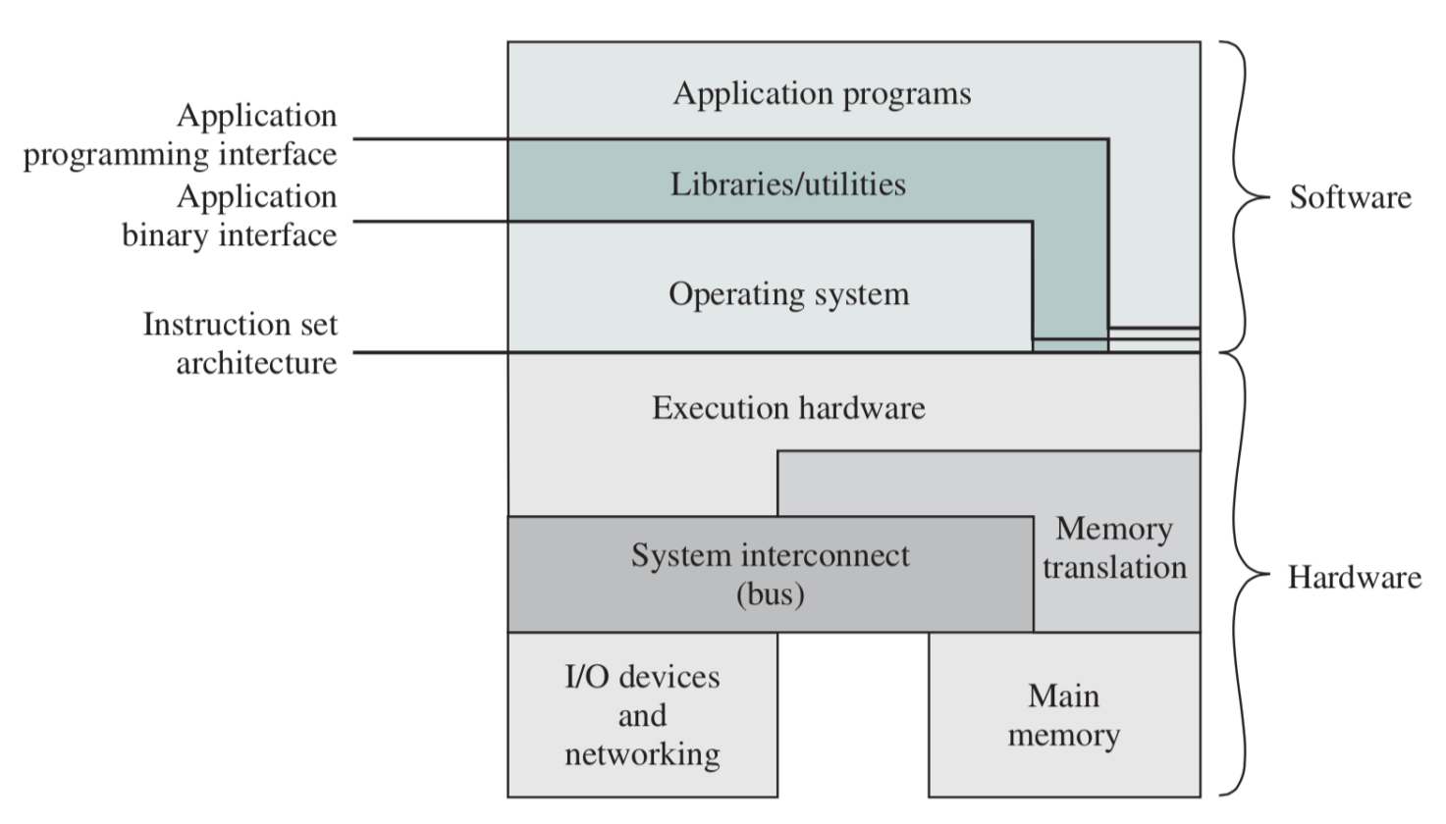

* **Operating system:** program that interfaces machines with applications (programs)
  + Piece of software that sits between hardware of a computer and applications that run on the computer
  + Resource manager: OS is responsible for dynamically allocating shared system resources (e.g. CPU time, memory) to executing programs
    - Keeps track of who currently owns what
    - Handles conflicting resource requests
  + Environment Provider: OS provides an environment for other programs to run in
    - Abstracts away details of hardware, allowing other programs to run efficiently without worrying about hardware specifics
    - Works when other programs are sleeping, puts itself to sleep to allow other programs to execute
    - Collects/reports data about what is happening/has happened
  + Multitasking: OS creates and enforces rules for multiple programs to run, interact, and compete on the computer
  + Efficiency: OS in supercomputers want to maximize efficiency of hardware (i.e. CPU) usage
* **Kernel**: core portion of OS, that is always present in main memory and makes it all work

### Systems Programming

* **System programs**: layer above the OS; they aren’t part of the kernel, but they contain useful tools
  + File manipulation: create/delete/copy/rename files and directories
  + Status information: monitor state of system, e.g. CPU usage, memory, disk space, etc.
  + Programming language support: compilers and interpreters
  + Communication: remote login, file transfer, download utilities, messaging
* Writing system programs can require knowledge of hardware, and debugging can be limited
* Must account for concurrency – multiple regular programs can attempt to use system program at the same time

## History of Operating Systems

**1st Generation – Vacuum Tubes**

* 1940s – early 1950s
* Some digital computer devices existed, but no operating systems
  + Programming done by manually connecting cables or flipping switches
  + Only one program could run at a time; sign-up sheet to reserve block of time
  + 1950s: punch card invented

**2nd Generation – Mainframes**

* 1955 – 1965
* Mainframe computers were extremely large and expensive, required professional operators
  + Mainly only used by large companies, governments, universities
  + Programmers create jobs for written programs on punch cards
  + Operators input punch cards and takes printouts when program has completed
* To increase efficiency, **batch system** was created – group a bunch of jobs and do them together
  + Reduced mainframe idle time
  + Input/output could be read/printed using more limited systems, while the mainframe was executing batches

**3rd Generation – Integrated Circuits and Multiprogramming**

* 1965 – 1980
* IBM attempted to introduce the System/360, an OS designed to run on multiple different machines
* One of the reasons that OSes like Windows, Mac, and Linux are so successful is their ability to work on different hardware
  + They still operate on the batch principle, intended to keep the CPU busy
  + In older mainframes, CPU was the limiting factor, but in commercial applications, I/O was the limiting factor – hence, ideally several jobs were ready to go so CPU time would not be wasted
    - However, this meant long wait times between programmers submitting a job and getting back results
* **Timesharing**: each user gets a terminal connected to a central computer
  + Allows for a more interactive and responsive system
  + Fast compilation
  + CPU can be working on another batch job while output of compiler is being read
  + Introduced new problem: protecting multiple programs from each other
* **UNIX** emerged during this generation
  + IEEE developed **POSIX** standard for writing programs that run on different systems

**4th Generation – Personal Computers**

* 1980+
* IBM PC and MS-DOS came out; people began having their computers in their homes and offices
  + Graphical User Interfaces (GUIs) were introduced by Apple and Microsoft
  + Allowed a user to have multiple programs going on, requiring parallelism
* **Microprocessor:** single integrated circuit with supporting peripherals (instead of multiple connected integrated circuits)

# 2: Review of Computer Architecture

## Computer Organization

* To execute a program, we need:

1. **Main memory**: stores instructions and data
2. **System bus**: transports instructions and data between processor and memory
3. **Processor**: executes the instructions
4. **Input/output**: not strictly necessary to run programs, but provides lots of functionality

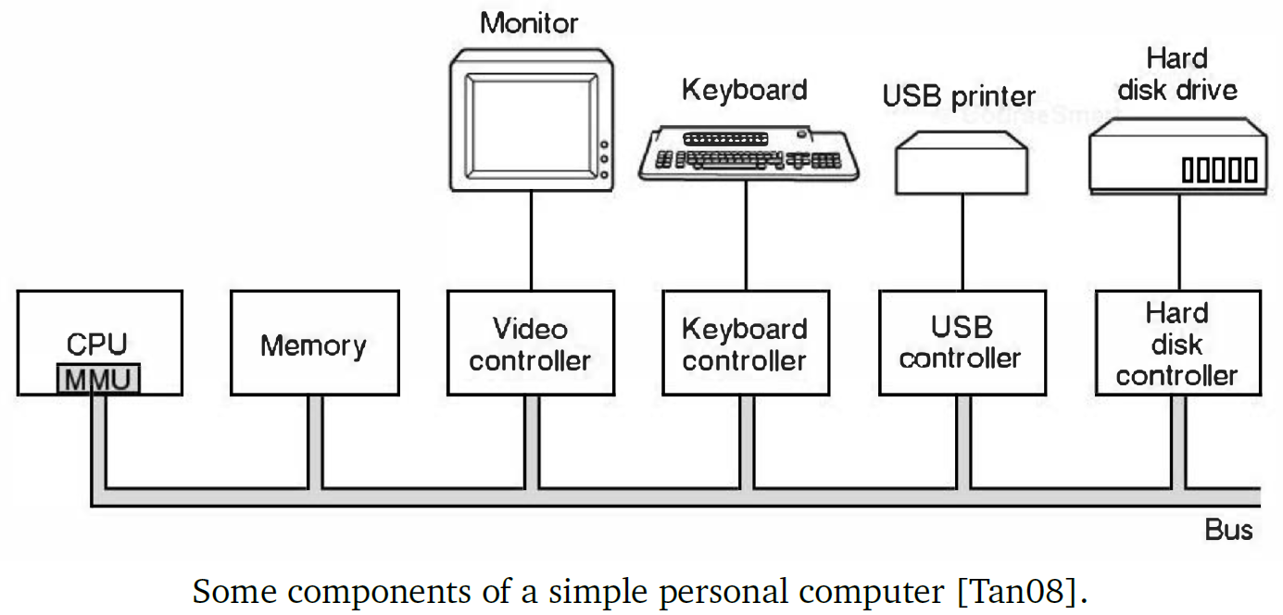

### Main Memory

* Ideally, memory is:
  + Fast so processor never has to wait
  + Large enough to hold all data
  + Inexpensive
* **Iron Triangle**: out of the three, can only have two
* Different levels of memory can operate at different speeds
  + The faster the memory, the more expensive and generally lower capacity
  + Fastest to slowest / least to largest capacity:
    - **Registers**
    - **Cache** – often broken down into different levels (e.g. L1, L2)
    - **Main memory (RAM)**

**Magnetic hard disk** – much slower than other memory, but also much larger capacity

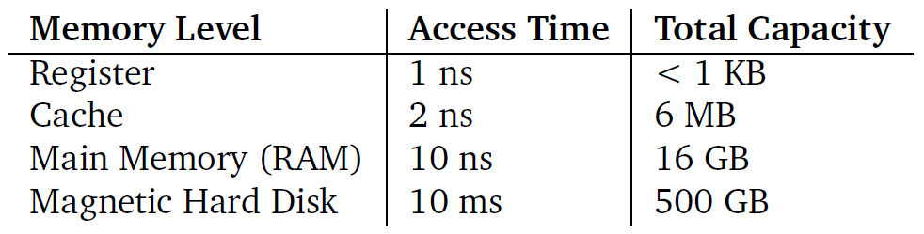

### System Buses

* Modern systems have multiple system buses that work at different speeds toward different functions
* Contention for buses by different components is a limiting factor in computer operation

### The Processor

* **Central Processing Unit (CPU)** is responsible for fetching instructions from memory, decoding them, and executing them
  + Pipeline: when fetching, decoding, and executing happen in parallel
  + Word: the largest unit on which a processor operates (e.g. 64-bit OS = 64-bit word size)
  + Instructions: CPU instructions are processor-specific, and some operations are only available in “supervisor mode”, not “user mode” (e.g. disabling interrupts)
  + Registers: locations (often word-sized) in the CPU to store data or instructions – holds key variables or temporary results
    - **Program counter**: points to memory address of next instruction; can be updated to hold a different address than the next one
    - **Status register**: array of bits that indicates the state of the processor through various arithmetic and non-arithmetic flags
      * Arithmetic flags: mathematical outcomes (e.g. overflow, division by zero)
      * Non-arithmetic flags: mode, invalid assembly instructions
    - **Instruction register**: most recently fetched instruction
    - **Stack pointer**: top of stack
      * Memory in an executing program is stored in a stack and a heap
    - **General purpose registers**: stores data and addresses, decided by the compiler

## Program Execution

* CPU instructions fall into the following categories:

1. **Processor-Memory**: transfer data between memory and processor
2. **Processor-I/O**: transfer data to/from I/O device
3. **Data Processing**: internal CPU operations – mathematical or logical operations
4. **Control**: alter sequence of operation

### Interrupts

* Temporary stopping of normal processor sequencing to handle a special case
* Improves processor utilization because it allows CPU to do something else while awaiting results of an operation
* Categorized by their origin:

1. **Program**: something happened in the program that prevented normal flow
2. **Timer**: regular interrupts to ensure every process has a chance to run; configured timers expire
3. **Input/Output**: successful or failed I/O operation, signalled by I/O controller
4. **Hardware failure**: something happens in the hardware (e.g. power failure)

* Generally, when an interrupt arrives, the CPU will:
  + Store current state of interrupted program by storing register values on the stack
  + Handle the interrupt
  + Restore the state by loading registers with values popped off the stack, and continue execution
* CPU can disable interrupts when it’s in the middle of something that should not be interrupted; once interrupts are re-enabled, they can be handled
  + If multiple interrupts are pending, they are handled by order of priority
  + Interrupt handling can be sequential (one at a time) or nested, if the interrupt handler doesn’t disable interrupts

## I/O Communication

1. **Programmed I/O**: polling – CPU issues I/O command, then periodically checks if operation has completed by checking I/O devices status register or memory location, which the device updates when it completes its operation

* Once the status indicates that it has finished, CPU can copy data into memory
* Inefficient – ties up CPU

1. **Interrupt-Driven I/O**: CPU issues I/O command, I/O module issues interrupt to indicate that it has finished, so that CPU can copy data into memory

* CPU is involved twice – initiates read/write command, then collects data

1. **Direct Memory Access (DMA)**: CPU only needs to set up the operation; rest is managed by a separate DMA controller

* CPU indicates operation to perform (R/W), source, destination, and how much data to be transferred
* Data is transferred to DMA controller, so I/O devices interact directly with memory while CPU can perform other operations
* CPU may have to contend with DMA controller for bus, but it is still more efficient

# 3: Operating System Structure and Traps

## Operating System Structure

* All modern operating systems follow a **layered structure**

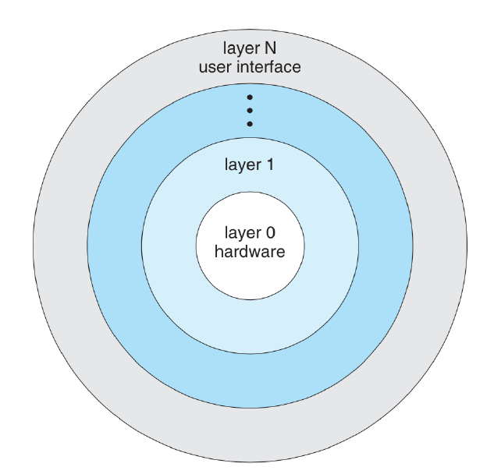

* + User interface has the most abstraction – don’t care about internal operations
  + Hardware has no abstraction
* Within each layer, OSes contain **modules** for different functions such as device driver, scheduling, and file system
  + Modules may be static, but are often loadable and swappable, meaning they can be added/removed and updated
    - E.g. when connecting a new device, the device driver is installed dynamically

### Layered Operating System with Modules

* Provides environment for program execution
* Provides various services to support programs, some of which are mandatory and others for convenience

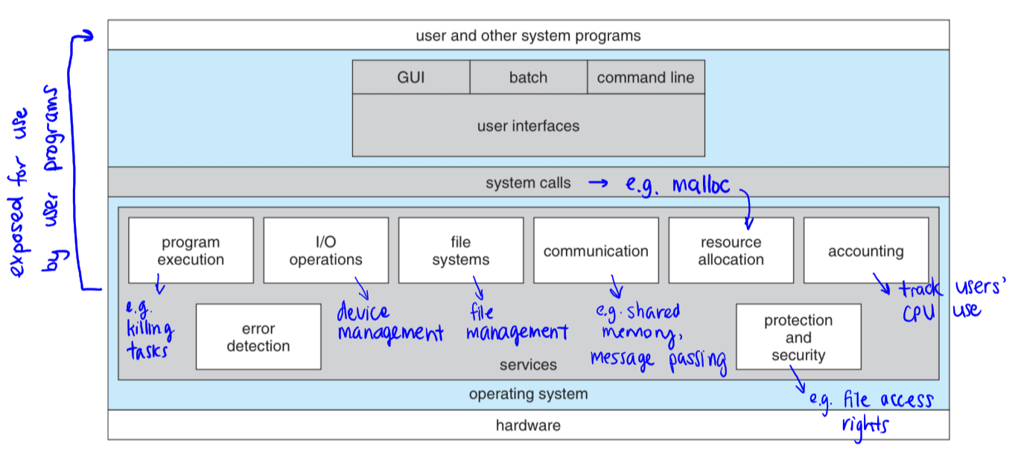

* **User interface**: how a user or program executes a program/command, and how results are returned to user; consists of Graphical User Interface (GUI), batch interface, and Command Line Interface (CLI)
* **System calls**: functions/procedures that the OS makes available to programs for use (e.g. malloc to allocate memory)
* **Program execution**: load programs into memory and run them, and terminate when necessary
* **I/O operations**: manages system I/O devices; recognizes and initializes new devices to make them available
* **File systems**: management of programs and data – intersection of memory and I/O
* **Communication**: between computer and Internet, and between multiple processes
* **Resource allocation**: allocation of resources, keeping track of which programs are currently using what resources, and conflict mediation
* **Accounting**: track statistical data on resource use by different programs; ensures stability, improves usage, or for billing purposes
* **Error detection**: detect and handle errors from user programs or I/O devices
* **Protection/security**: authentication and enforcing access rights to certain elements of a system (e.g. user vs. administrator accounts)
* **Invoking system calls**: allows user programs to interact with OS services

## Traps

* **Traps**: software-generated interrupts, usually by an error or from a user program request; sometimes known as exceptions
  + Errors: OS generally passes along trap to the program that caused it, in which case it might be handled by the program or just terminates it
  + Intentional traps: interrupt handler in the OS runs to deal with the request
    - Way of waking the OS from sleep state
* **User mode**: some instructions/operations are not available
* **Supervisor/kernel mode**: all instructions/operations are available
* Processors track what mode they are in with a mode bit
  + Computers always boot up in kernel mode, so OS can start/load
  + User programs always start in user mode
  + When a trap or interrupt occurs, OS switches to kernel mode; when it is finished, OS returns to user mode before user program resumes

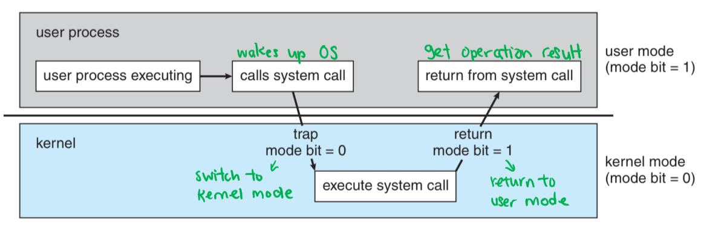

### Motivation for Dual Mode Operation

* User and supervisor modes exist to protect the system’s integrity against errant and malicious users
  + E.g. OS enforcing waiting turns to read from disk, instead of leaving it up to programs to wait until disk is available
* Switching between modes takes additional instructions and time, but it is worthwhile for the security and integrity benefits that it provides

### Invoking a System Call

Example: int bytesRead = read( filename, buffer, numBytes );

1. User program pushes function parameters onto the stack (e.g. filename, buffer, numBytes)
2. User program invokes system call (e.g. to read procedure)
3. read system call puts its identifier (system call number) in a designated location (typically a register)
4. System call issues trap instruction, notifying the OS
5. OS takes over, switching from user to kernel mode; control transfers to trap handler, in predefined location within the kernel, which checks the identifier in the designated location
6. OS runs system call handler to match identifier (e.g. read from file)
7. Handler executes and finishes; control exits kernel and returns to system call (e.g. read function) in user mode
8. System call (e.g. read function) returns control to user program

# 4: Processes

## Processes

* Modern OSes support programs running concurrently, which are managed by processes
* **Process**: a program in execution; consists of three things:
  1. Compiled executable of the program (instructions + data)
  2. Current state of the program
  3. Any necessary resources to run the program (e.g. allocated memory)
* Two instances of the same program = two processes
* Many OS requirements revolve around processes:
  + Scheduling: OS must choose which processes to run at what time, to maximize utilization and/or minimize response time
  + Resource allocation: OS must allocate resources to processes and keep track of who’s using what
  + Inter-process communication: OS must support communication and data transfer between processes

### The Process Control Block

* **Process Control Block (PCB)**: an operating system’s data structure for managing processes; contains everything the OS needs to know about a program
  + OS creates and updates it constantly for each running process
  + When a program finishes executing and has cleaned up, its PCB is thrown away
* PCBs usually contain:
  + Identifier: unique process ID (**pid**)
  + State: current state of process
  + Priority: how important this process is compared to others
  + Program counter: stores address of next instruction, when needed
  + Register data: stores current register values, when needed
  + Memory pointers: pointers to code, data needed by process, and any OS-allocated memory
  + I/O status: any outstanding requests, files, or I/O devices assigned to this process
  + Accounting: data about process’s use of resources (optional)

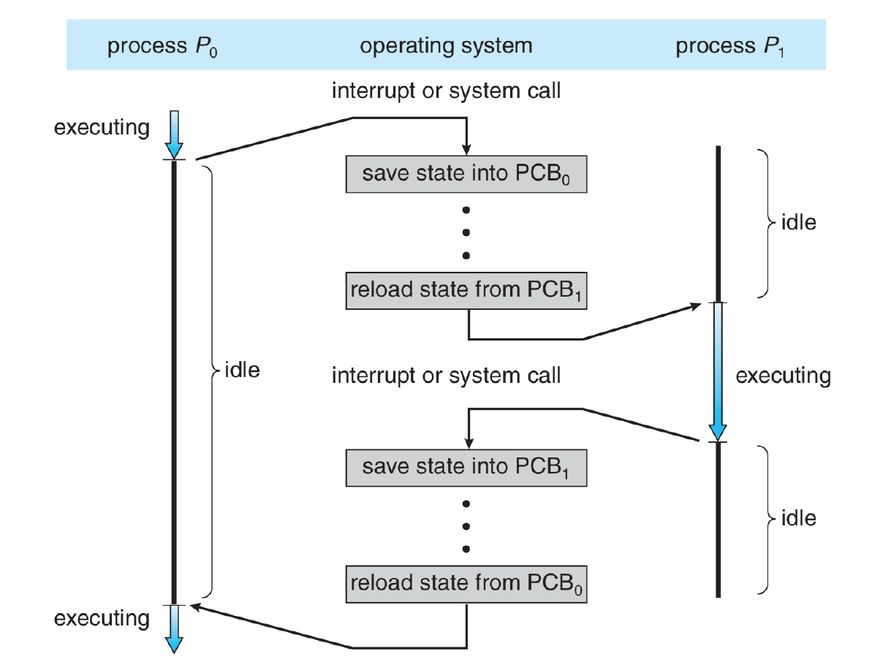

* Program counter and register data make up execution state; the two fields are only stored when needed, such as when a system call (trap) or process switch occurs

### The Circle of Life

* When a process is created, OS creates a new PCB and initializes the fields in the block
* PCB is then added to the list of active PCBs
* After a process terminates, OS may collect some data (e.g. accounting information) and then remove the PCB from the active PCBs

**Process creation**

* Three main events can lead to process creation:
  1. System boot up – OS starts and begins creating various background and foreground processes
  2. User request – to start a new process
  3. One process spawns another – spawning process = parent, spawned process = child

**Process destruction**

* Processes can die in four ways:
  1. Normal exit (voluntary) – process finishes or user asks process to finish
  2. Error exit (voluntary) – program chooses to terminate due to an error
  3. Fatal error (involuntary) – OS detects error and sends it to program, which can result in involuntary termination if the exception is unhandled (e.g. stack overflow or division by zero)
  4. Killed by another process (involuntary) – by user request, or parent process killing timed-out child processes, etc.

### Process Family Tree

* In UNIX, relationships between a parent process and its child processes is maintained, forming a hierarchy
  + **Process group**: a process and all of its descendants
  + Each process has one parent and can have zero or more children
  + Processes can’t disinherit their children
* **init**: in UNIX, the very first process – parent to all processes
* In Windows, parent processes get references to their children, but references can be given to other processes (adoption); this cannot be done in UNIX
* When a process terminates, it does so with a **return code**
  + 0 = success, other value = error of some sort
* When a parent spawns a child process in UNIX, it can get the child process’s return code
  + **Zombie**: time between when a child process finishes and when its parent collects its return value
    - During this time, the child process is dead but not gone
      * Its PCB is still in the active list
      * Process is still in possession of its allocated resources
    - Only after its return code is collected, does the process clean up
  + **wait**: in UNIX, call to get the return value of a child process right away, allowing the child to be cleaned up
* **Orphan**: a child process whose parent died before it
  + In UNIX, init automatically adopts all orphan processes
  + By default, init will wait on all its children, doing nothing with the return value, to ensure that they do not become zombies when they finish
  + Programs can be intentionally orphaned so that they run in the background

# 5: Process State

* PCB contains a variable to maintain the state of a process, which can be thought of as a finite state machine (FSM)

### Two-State Model

* **Running**: currently executing
* **Not Running**: not currently executing

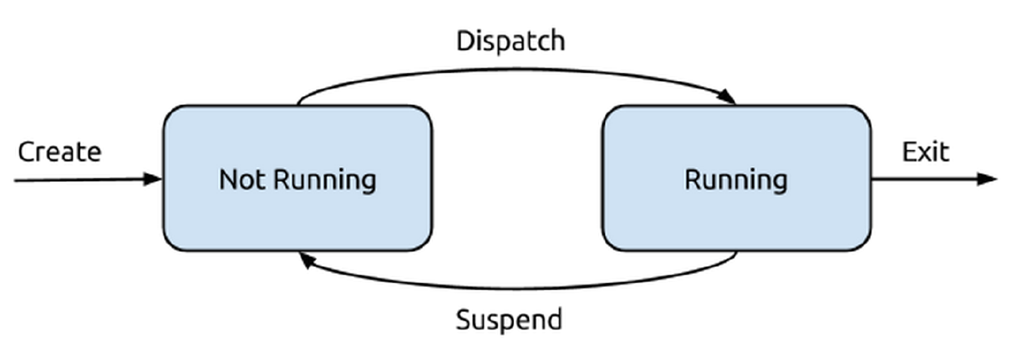

* **Create**: process is created, enters Not Running state
* **Dispatch**: not currently running process begins executing, enters Running state
* **Suspend**: running process pauses execution, enters Not Running state
* **Exit**: process reaches exit statement, gets removed from list of processes

### Three-State Model

* **Running**: currently executing
* **Ready**: not executing, but ready to execute if selected
* **Blocked**: not executing, not able to execute until some event occurs

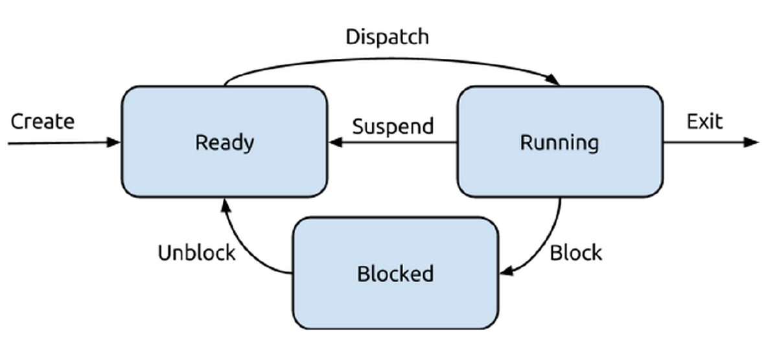

* **Create**: process is created, enters Ready state
* **Dispatch**: not currently executing process begins executing, enters Running state
* **Suspend**: running process pauses execution but can still run if allowed, so moves to Ready state
* **Exit**: process reaches exit statement, gets removed from list of processes
* **Block**: running process requests resource but doesn’t receive it right away, so it cannot proceed
* **Unblock**: blocked process receives requested resource, ready to run again so it moves to Ready state

### Five-State Model

* Terminated state handles case of zombie processes in UNIX, where they aren’t ready to run (since they’ve already finished) and they aren’t Blocked waiting for a resource
* New state deals with newly created processes while OS performs administrative tasks:
  + Define identifier
  + Initialize PCB
  + Put process in New state
* OS has created process, but hasn’t started execution it yet
  + Could be due to system limiting number of concurrent processes
  + Processes in New state are typically on disk, not in memory
* **Running**: currently executing
* **Ready**: not executing, but ready to execute if selected
* **Blocked**: not executing, not able to execute until some event occurs
* **New**: newly created process that hasn’t been added to list of processes ready to run yet
* **Terminated**: finished executing, hasn’t been cleaned up yet

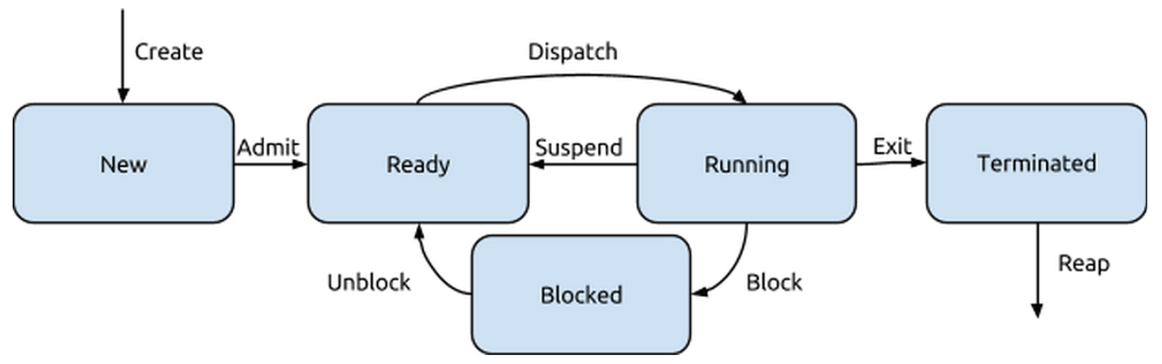

* **Create**: process is created, enters New state
* **Admit**: process is added to list of ready to run processes, enters Ready state
* **Dispatch**: not currently executing process begins execution, enters Running state
* **Suspend**: running process pauses execution, but can still run when allowed
* **Block**: running process requests resource but doesn’t receive it right away, so it cannot proceed
* **Unblock**: blocked process receives requested resource, is ready to run again, so it moves to Ready state
* **Exit**: process finishes execution, enters Terminated state; return value still available
* **Reap**: terminated process’s return value is collected by wait, so it can be cleaned up

### Swapping Processes to Disk (Seven-State Model)

* When processes get blocked, they can be swapped to disk instead of remaining in main memory
* However, it’s possible for users to want to run more processes than can be accommodated in main memory
  + Stack/heap space allocated to running programs can be very large (up to GBs)
* **Swapping**: transferring a process between disk and main memory
  + Involves transfer of the entire process and its data, so can involve several hundred megabytes, or even gigabytes of data
  + When the process is going to run again, need to transfer all the data back to memory
  + Very expensive process, so should only be done when necessary
* Two scenarios to consider:
  + Process is ready but there isn’t enough memory space – need to swap out Ready process
  + Process is blocked – swap out Blocked process

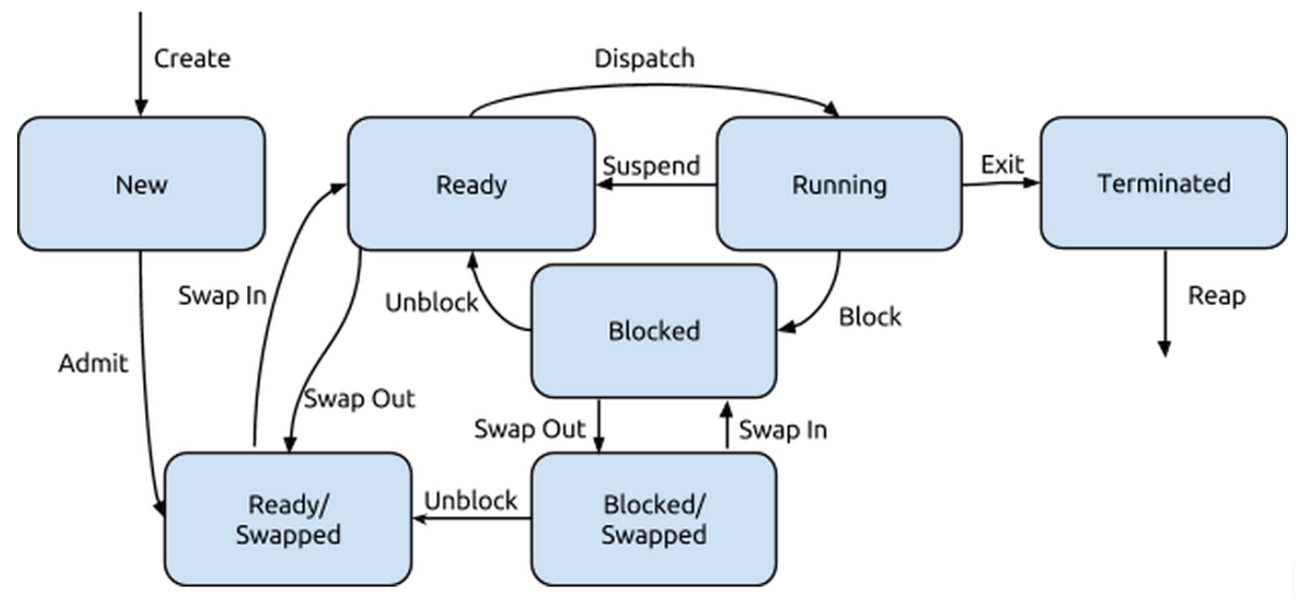

* **Blocked/Swapped**: not ready to run, not in memory
* **Ready/Swapped**: ready to run, not in memory
* **Admit**: by default, new processes start out on disk instead of in memory
* **Unblock (between swapped states)**: blocked process receives resource and is now ready to run, but is still on disk

# 6: Processes in UNIX

## The Process in UNIX

* Processes in UNIX can create other processes
  + The parent of all processes is **init**, which always has pid = 1
  + **kill**: terminate a process
  + **ps**: obtains list of processes
  + **&**: tells a process to run in the background
    - E.g. **gcc [filename] &** or **sudo service [name] start &**
    - shell will respond with process ID of new child
    - & actually tells parent process to disown child, causing it to be adopted by init
  + **fork**: spawn a child copy of a process
  + **screen**: UNIX window manager – creates multiple processes to support switching between multiple windows without having to save/logout

### Spawning Child Processes

* Child processes can be duplicates of parent processes or a new program
* When a process spawns a child, the child generally needs resources such as memory or files
  + Child can request OS resources directly
  + Parent can partition or share already-allocated resources amongst its children, but children can only access a subset of parent resources
    - Prevents processes from overloading system by spawning too many children
* During initialization, the parent may pass some data to the child

### Example of a Fork

pid_t pid;

int childStatus;

pid = fork();

if (pid < 0) {

/* fork failed due to error */

return 1;

} else if (pid == 0) {

/* child process */

execlp(“/bin/ls”, “ls”, NULL);

} else if (pid > 0) {

/* parent process */

/* parent waits for child to complete */

wait(&childStatus);

}

return 0;

### UNIX Workflow for Spawning Child Processes

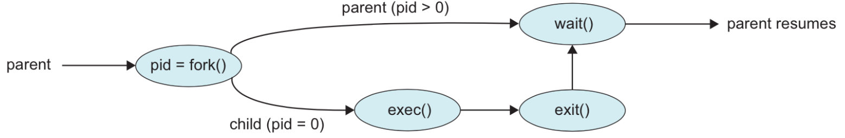

1. **fork** – parent spawns a child process that is a copy of itself

* Returns negative value: fork failed
* Returns 0: process is the new child
* Returns positive value: process ID of new child returned to parent

1. Both parent and child processes resume execution from after the fork statement

* Parent process can call **wait** to be blocked until child process finishes execution
* Child process can call **exec** to replace itself with a new program

1. When child process finishes, it calls **exit** to return a value

* If parent was **wait**ing, it gets the return value and may resume

## UNIX System V Process Management

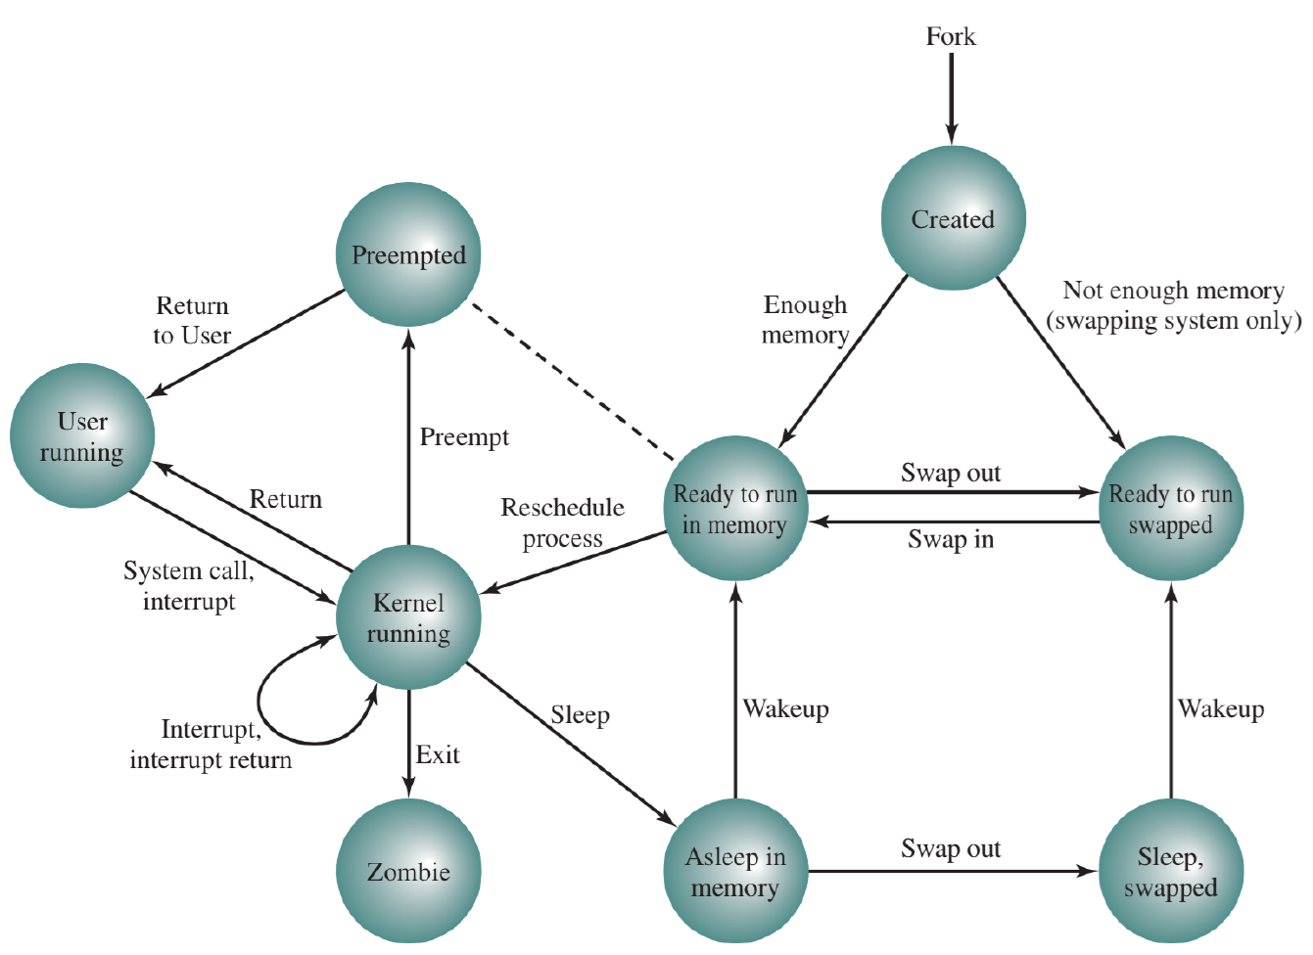

* UNIX processes belong in one of two categories:
  + **System processes**: run in kernel mode
  + **User processes**: run in user mode
* A process can be in nine states:

1. **User Running**: running in user mode
2. **Kernel Running**: running in kernel mode
3. **Ready to Run, in Memory**: ready to run, in memory
4. **Asleep, in Memory**: blocked, in memory
5. **Ready to Run, Swapped**: ready to run, not in memory
6. **Sleeping, Swapped**: blocked, not in memory
7. **Pre-empted**: process is returning from kernel to user mode, but kernel decides to run another process at this time
8. **Created**: newly created, not yet ready to run
9. **Zombie**: process is done but parent hasn’t collected return information yet

* Similar to seven-state model from earlier, with distinction of user mode and kernel mode
* Pre-empted state is like Ready to Run, in Memory but with the distinction of how the process got to that state

### Process Creation

* When fork is called, OS executes the following steps in the parent process, in kernel mode:
  1. Allocates slot in process table for new child process
  2. Assigns unique process ID to child process
  3. Makes a copy of the parent process’s process image, except any shared memory
  4. Increments counters for any parent-owned files, to show that there is an additional process referencing those files
  5. Child process is in Ready to Run state
  6. Child process receives return value of 0, parent process receives return value of child’s process ID
  7. System chooses which process to execute:
     + Run parent process, child is in Ready to Run state
     + Run child process, parent is in Ready to Run state
     + Run another process, both parent and child are in Ready to Run state

### The Fork Bomb

* **Denial-of-service (DOS) attack** that forks as many processes as possible until system can no longer manage the amount of processes and crashes or becomes too slow to do anything in
  + For $n$ fork call, $2^{n}$ processes are spawned – exponential growth
* To prevent against fork bombs, system can impose limits on:
  + Total number of processes that a user can create
  + Rate at which user can spawn a new process

# 7: Inter-Process Communication

## Inter-Process Communication (IPC)

* Facilities provided by operating systems to allow processes to coordinate or exchange data with each other
* Sender transfers a message (data) to receiver
  + Processes should agree on how what data a message contains and how the data is formatted
* Sending/receiving of messages can be synchronous or asynchronous:

1. **Synchronous send, synchronous receive**: sender is blocked until receiver collects message; receiver is blocked (waits) until message arrives
2. **Synchronous send, asynchronous receive** (uncommon): sender is blocked until receiver collects message; receiver continues whether or not a message is available
3. **Asynchronous send, synchronous receive**: sender continues execution after sending message, receiver waits until message has arrived before continuing
4. **Asynchronous send, asynchronous receive**: sender continues execution after sending message, receiver checks for message but continues regardless of whether or not it’s available

* During asynchronous receives, receiver may send a message confirming that it has received the message; in this case, the receiver becomes the sender of the acknowledgement, and sender becomes the receiver
* Producer-consumer problem: paradigm for understanding IPC
  + Producer creates information, which is later used by consumer

## Implementation Strategies

* There are three approaches to implementing IPC:
  + Shared memory
  + File system
  + Message passing

### Shared Memory

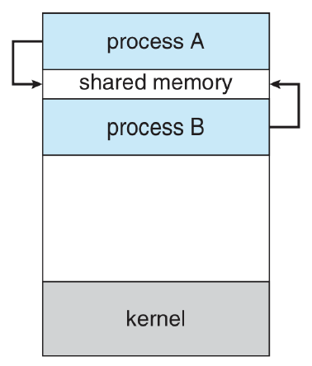

* A region of memory is shared between multiple processes, all of whom can read and write to it
  + Normally, regions of memory are associated with exactly one process, and OS will intervene if other processes try to access it
  + For shared memory, OS must be notified to allow multiple processes to access the area, and won’t free up the memory until all processes accessing it terminate
* With shared memory, it’s possible for one process to overwrite the changes of another, so coordination is required

### File System

* Processes can communicate through messages stored in the file system
  + Producer writes to a file in an agreed-upon location, consumer reads from the same file
* Unlike shared memory, file system persists messages (e.g. will survive a reboot)
* Can also be used if the sender and receiver know nothing about each other
* If only one file is used, it’s possible for messages to be overwritten
  + To get around this, have senders use multiple files with unique IDs
  + Then, if one sender’s message hasn’t been received yet, another sender will just write to a different file without affecting the first message

### Message Passing

* Service provided by OS: sender passes message to OS, requests that it be delivered to a receiver
* Messages can be fixed or variable size
* Direct communication: each process that wants to send or receive messages explicitly names the recipient or sender of the communication
  + Symmetric addressing: sender and receiver know each other
  + Asymmetric addressing: sender names receiver when sending message, receiver can receive messages from anyone
* Indirect communication: messages are sent to and received from a mailbox
  + Mailboxes can belong to the OS or a specific process
    - If it belongs to a process, anyone can send messages to the mailbox but only the owner can receive messages
    - If it belongs to the OS, it is independent from any process, so any process can receive messages from it
      * OS needs system to determine which process is the receiver

### Message Queues

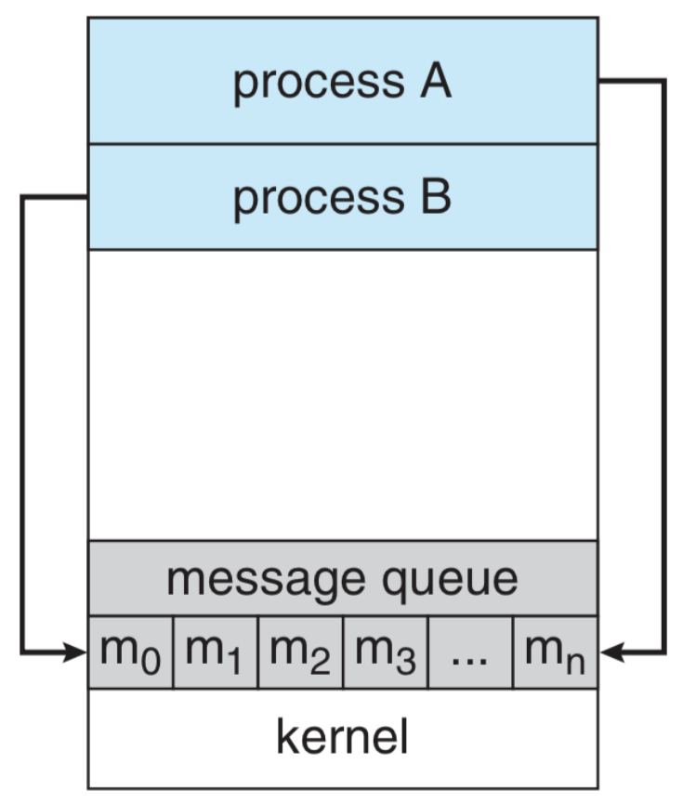

* What happens when a sender sends a message, then wants to send a second one before a receiver has collected the first?
* Three options:

1. **Block** – wait for last message to be received first
2. **Overwrite** last message
3. **Discard** current message

* **Message queue** solves the problem: sender always places message at end of queue, receiver always collects message from start of queue
  + If the queue is full, then sender faces the same three options (block, overwrite, discard) again

### UNIX Pipes

* Pipes facilitate producer-consumer communication in UNIX
  + Producer writes to one end of pipe, consumer reads from the other end
  + Unidirectional – for bidirectional communication, two pipes going in different directions are required
  + pipe( int[] fileDescriptors )
    - fileDescriptors[0]: read-end
    - fileDescriptors[1]: write-end
* Pipes are blocks of main memory that are interpreted as a circular queue; each queue entry is usually a fixed size of one character
  + Sender can place message in queue in small chunks, but receiver only receives one character at a time
  + Need a termination character (e.g. null character or line feed) to indicate end of message
* Named pipe: UNIX pipe that is stored on disk
  + May be used by any process, and persists even after the process that created it has terminated
  + Bidirectional communication can be achieved with a single pipe, but only one direction at a time

### Example of a Pipe

#define BUFFER_SIZE = 25;

#define READ_END = 0;

#define WRITE_END = 1;

char write_msg[BUFFER_SIZE] = “Greetings”;

char read_msg[BUFFER_SIZE];

int fileDescriptors[2];

pid_t pid;

if (pipe(fileDescriptors) == -1) {

/* pipe failed due to error */

return 1;

}

/* fork a child process */

pid = fork();

if (pid < 0) {

/* fork failed due to error */

return 1;

} else if (pid > 0) {

/* parent process */

/* close unused read end of pipe */

close(fileDescriptors[READ_END]);

/* write to pipe */

write(fileDescriptors[WRITE_END], write_msg, strlen(write_msg)+1);

/* close write end of pipe */

close(fileDescriptors[WRITE_END]);

} else if (pid == 0) {

/* child process */

/* close unused write end of pipe */

close(fileDescriptors[WRITE_END]);

/* read from pipe & print message */

read(fileDescriptors[READ_END], read_msg, BUFFER_SIZE);

printf(read_msg);

/* close read end of pipe */

close(fileDescriptors[READ_END]);

}

return 0;

# 8: Threads

## Threads

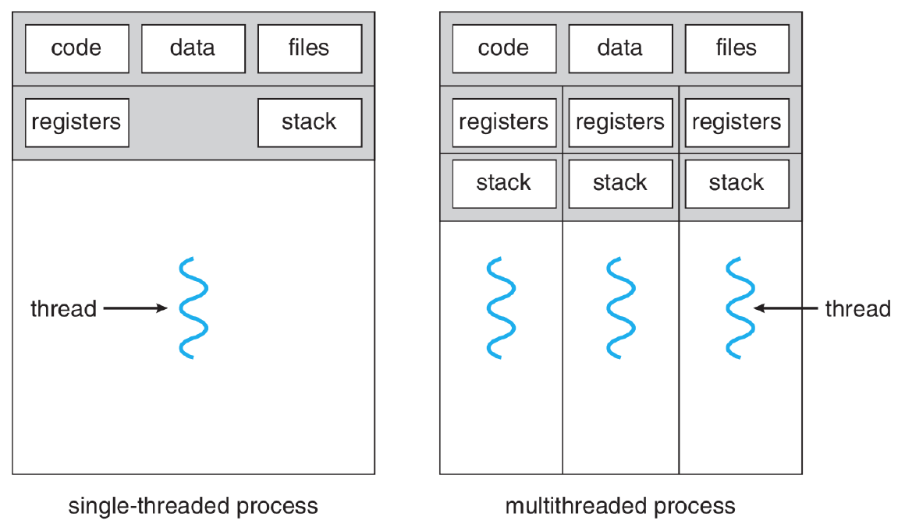

* **Thread of Execution**: sequence of executable commands that can be scheduled to run on the CPU
  + Every thread has its own:
    - Thread execution state: running, ready, blocked, etc.
    - Thread context: saved when it isn’t running
    - Execution stack
    - Local variables
    - Access to memory and resources of the process
* Multithreaded programs run on more than one thread
  + Threads can be created and destroyed dynamically within a program
  + Typically, user interface and time-consuming operations run on separate threads

### Motivation for Threads (over Processes)

* Creating new threads is faster than creating new processes (around 10x)
* Terminating/cleaning up threads is faster than terminating/cleaning up processes
* Switching between threads of the same process is faster (around 5x) than switching between processes, because less data needs to be saved/restored
* Communication between threads doesn’t require any IPC mechanisms, since they share the same memory space
* Threads allow a program to be responsive even when part of it is blocked

**Common Uses of Threads in Operating Systems**

* Foreground and background work: while keeping program responsive
* Asynchronous processing: without disrupting a user’s workflow
* Speed of execution: more work can get done in the same amount of time
* Modular structure: threads provide structure for program that does many different things

**Drawbacks**

* No protection between threads of the same processes – one thread can mess with memory used by another
* If any thread encounters an error, the entire process may be terminated

## Thread States

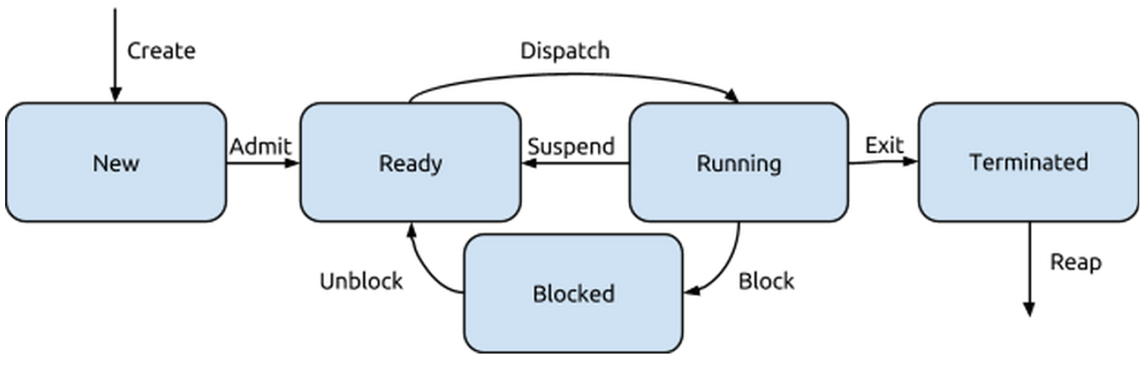

* If a process is swapped into memory, all its threads will exist in memory, so we only need to consider the **five-state model**
* If a process is terminated, all of its threads are terminated, regardless of what state they are in

### Thread Cancellation

* Running thread, known as the target, gets terminated before it finishes its work
* Two types:
  + **Asynchronous cancellation**: one thread immediately terminates the target
  + **Deferred cancellation**: target is informed that it is cancelled, allowing it to clean itself up before terminating; the thread is responsible for periodically checking if it has been terminated

## Thread Types

* **User-level threads (ULTs)** run at user level, while **kernel-level threads (KLTs)** run at kernel level
* Three approaches:

1. All threads are user-level – user-level threads exist through a user-side threads library; kernel is unaware of multiple threads
2. All threads are kernel-level
3. Combination of user-level and kernel-level threads

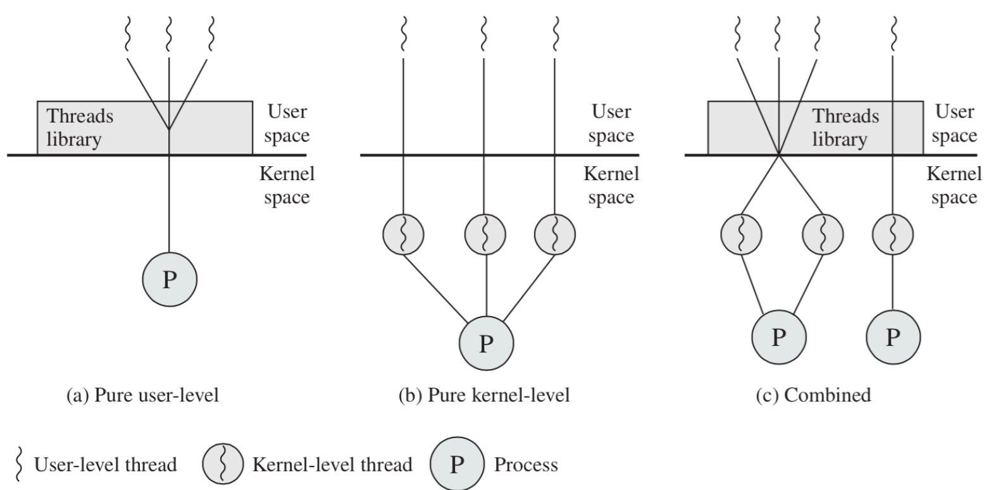

**User-Level Threads**

* Advantages
  + Thread switches do not require switching to kernel mode and then back again, since they are all user-side
  + Scheduling can be decided by program instead of by OS policy
  + Program can run multithreaded even if the kernel doesn’t support multiple threads
* Disadvantages
  + To the kernel, process contains one thread – hence if one user-level thread gets blocked, the whole process is blocked
    - **Jacketing**: conversion of blocking system call to non-blocking system call
      * Instead of calling system call directly, call thread library’s version
      * Jacket routine determines if running system call will block the application, to avoid OS blocking entire process

**Kernel-Level Threads**

* Advantages
  + Kernel is responsible for all thread management, so if one thread is blocked, others can continue
  + Kernel routines themselves may be multithreaded
* Disadvantages
  + Thread switch involves entering kernel mode with a trap, then returning to user mode, which takes more time

### Relationships Between User-Level and Kernel-Level Threads

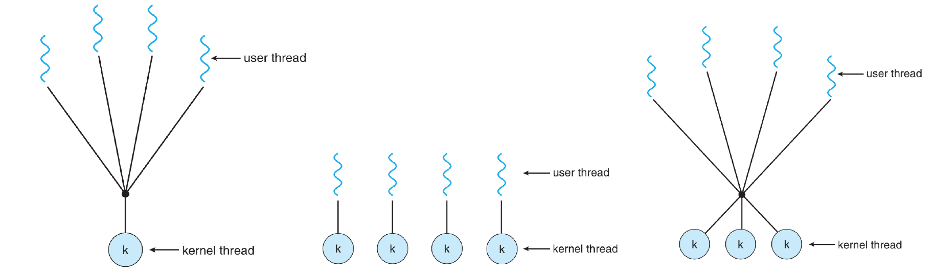



* **Many-to-One**: many user-level threads map to one kernel-level thread
  + Thread management done in user space
  + Using ULTs only takes this approach; few OSes actually use this
* **One-to-One**: creating a new user-level thread generates a new corresponding kernel-level thread
  + Using KLTs only takes this approach; Windows and Linux both use this
* **Many-to-Many**: maps many ULTs to an equal or smaller number of KLTs
  + Provides maximal concurrency in executing a single program

# 9: POSIX Threads

## POSIX Threads

* **pthread** is the POSIX standard for thread behaviour in UNIX and UNIX-like systems
  + Defines how threads behave, allowing code for one UNIX-like system to run more easily on others

### POSIX Thread Functions

* **pthread_create** – creates a new thread; works a lot like fork
* **pthread_exit** – terminates the calling thread and returns a value
* **pthread_join** – wait for a specific thread to exit; caller cannot proceed until the thread it is waiting on calls pthread_exit
* **pthread_yield** – releases the CPU to let another thread to run instead
* **pthread_attr_init** – create and initialize a thread’s attributes (e.g. priority, etc.)
* **pthread_attr_destroy** – remove a thread’s attributes by freeing the memory they take up
* **pthread_cancel** – signal cancellation to a thread; can be asynchronous or deferred

### Creating a pthread

typedef struct params {

int param1;

int param2;

} params_t;

void* add (void *arg) {

params_t *params = (params_t*) arg;

int sum = arg->param1 + arg->param2;

pthread_exit(sum);

}

int main() {

pthread thread1;

params_t arg;

arg.param1 = 5;

arg.param2 = 7;

pthread_create(&thread1, NULL, &add, &arg);

}

## The fork and exec System Calls

* When a parent process calls fork, it spawns a child process that is the clone of the parent
  + Normally, fork will duplicate all the threads in the parent process
  + But what if the child calls exec right after and replaces itself with a different program? All the work to duplicate the threads would be wasted
* Solution: two versions of fork – one which one copy all threads and one which will only copy the currently executing thread

## Signals

* UNIX systems use **signals** to indicate events, including exceptions
  + Synchronous: signal occurs as result of program execution (e.g. division by zero)
  + Asynchronous: signal occurs outside of the process (e.g. using pressing Ctrl-C in the console, or one thread sending a signal to another)
* By default, the kernel handles all signals sent to a process using a default handler
* Processes can also inform the OS that it is prepared to handle a certain signal itself
* Synchronous signals are sent to the thread that triggered it, but asynchronous signals can be handled in multiple ways:

1. Deliver signal to the thread that the signal applies to
2. Deliver signal to every thread in the process
3. Deliver signal to certain threads in the process
4. Assign a specific thread to receive all signals for a process

* To deliver a signal to a thread in UNIX: kill( pid_t pid, int signal )
* For POSIX threads: pthread_kill( pthread_t tid, int signal )

## Cancellation

* To cancel a pthread, call pthread_cancel ( pthread_t tid)
* By default, a pthread is set up for deferred cancellation
  + In a thread, to check if the thread has been cancelled, call pthread_testcancel and if signalled, clean up then call pthread_exit

# 10: Symmetric Multiprocessing (SMP)

* Most modern devices use multi-core processors that can execute multiple instructions from different threads at once
* Asymmetric multiprocessing: one boss processor, other processors are workers that take instructions from the boss and complete specific actions
* **Symmetric multiprocessing**: a standalone computer system with:

1. 2+ general purpose processors
2. Processors share same main memory and I/O devices connected by a bus
3. All processors can perform the same functions
4. The system is controlled by an OS that provides interactions between processors and their programs

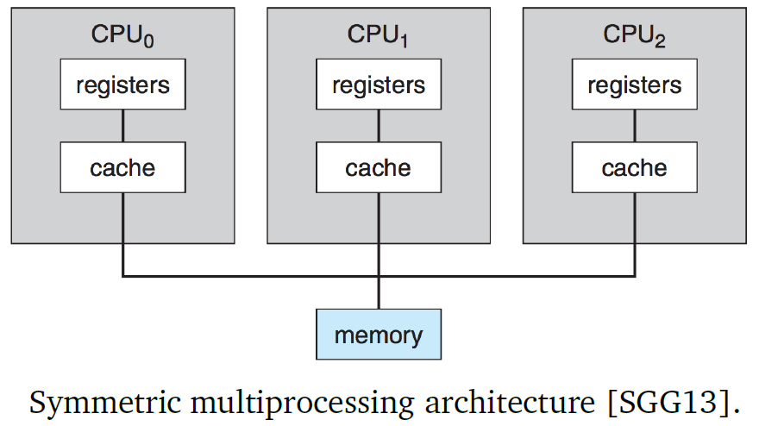

* What happens where there are more processes/threads than available cores?
  + **Time slicing**: each CPU runs each task for a designated period (e.g. 20 ms), switching between different tasks until all programs complete

## Parallelism and Speedup

* If a task can be fully parallelized, it means that adding a second executing thread would double the speed of execution of the task
* If a task can be partially parallelized, it means that the task can be divided up, but doubling the execution threads won’t halve the execution time
* If a task cannot be parallelized, it means that no amount of extra execution threads will speed it up
* **Amdahl’s Law**: general case of how much faster a task can be completed based on how many processors are available
  + $S$ = portion of application that must be completed serially (one at a time)
  + $N$ = number of available processing cores
 $$speedup ≤ \frac{1}{S+\frac{1-S}{N}}$$

 + This value converges to $\frac{1}{S}$, which shows that the amount of speedup is limited to the size of $S$
  + As the number of processors increase, the amount of time reduced diminishes

## Merge Sort Example

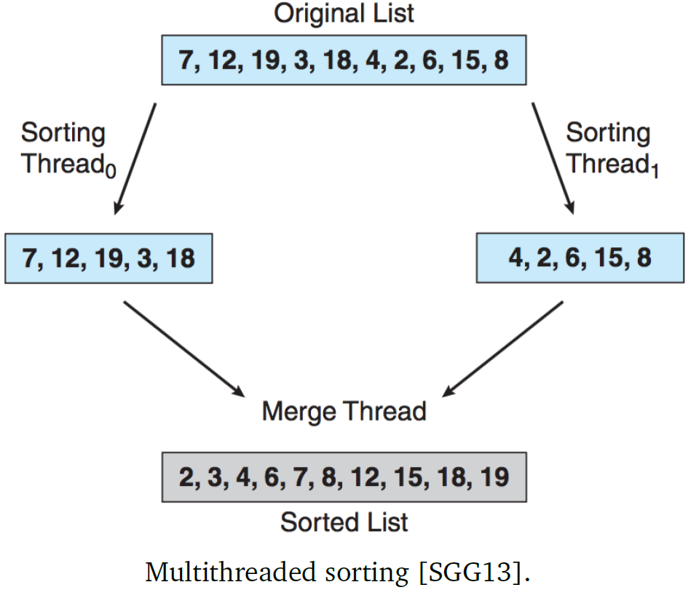

* Merge sort is a divide-and-conquer algorithm that breaks up the array into smaller pieces, sorts those pieces, and merges the result; we could have multiple threads do the sorting, and one thread for merging
  + Original run time of merge sort is $O(n\log{n})$ but if each thread executes on its own core, the run time is reduced to $O(n)$

### Merge Sort Code

typedef struct interval {

double *array;

size_t a;

size_t c;

} interval_t;

void insertion_sort(double *array, size_t a, size_t b);

void merge(double *array, size_t a, size_t b, size_t c);

void merge_sort(double (array, size_t n) {

/* create arguments to pass into method */

interval_t arg;

arg.array = array;

arg.a = 0;

arg.c = n;

merge_sort_internal(&arg);

}

void *merge_sort_internal(void *void_arg) {

interval_t *arg = (interval_t *)void_arg;

if (arg->c – arg->a >= 10) {

insertion_sort(arg->array, arg->a, arg->c);

return NULL;

}

size_t b = (arg->a + arg->c) / 2;

interval_t arg1, arg2;

arg1.array = arg->array;

arg1.a = arg->a;

arg1.c = b;

arg2.array = arg->array;

arg2.a = b;

arg2.c = arg->c;

pthread_t other_thread;

/* create a new thread to run half of the sorting */

pthread_create(&other_thread, NULL, merge_sort_internal, &arg2);

/* run the other half of the sorting */

merge_sort_internal(arg1);

/* wait for the other thread to finish */

pthread_join(other_thread, NULL);

merge(arg->array, arg->a, arg-> b, arg->c);

return NULL;

}

# 11: Concurrency: Synchronization and Atomicity

## Synchronization

* Concurrency: in a system with multiple processes or threads, when more than one process/thread is making progress at the same time
* Parallelism: more than one process/thread is executing on a CPU at a given instance
* For synchronization in computers, we may require two things:
  + **Serialization**: a guaranteed order of events (e.g. ensure that Event A takes place before Event B)
  + **Mutual exclusion**: ensuring Event C and D cannot happen at the same time (e.g. guaranteeing that a process P1 doesn’t try to write to an area of shared memory while another process P2 is trying to read it)

### Serialization through Messages

* Assume Alice and Bob work day shifts and night shifts respectively at a power plant. Due to safety reasons, Alice cannot leave until Bob arrives. This situation requires serialization – the event of Bob arriving must occur before the event of Alice leaving
  + Serialization in this situation can be solved by message passing, which is a valid solution for many synchronization problems
* Two events are **sequential** if we can be certain of the order that they occur in
* If we cannot tell by a program, or guarantee what order two events occur in, they are **concurrent**
* **Non-determinism**: when the order of concurrent events can change on different runs of the program

### Shared Data and Atomic Operations

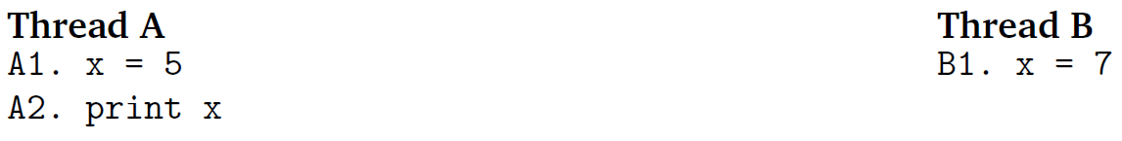

* This is an example of a non-deterministic program – since there is no co-ordination mechanism, we do not know which order the statements will occur in
* We don’t even need multiple threads to have concurrency problems; having interrupts in the system is sufficient
* **Atomic operations** cannot be interrupted
  + Generally, OSes will provide some atomic operations, but there will always be some non-atomic operations

### Mutual Exclusion through Flags

* If we don’t care about the specific order of events, but want to ensure that multiple threads don’t try to update the same variable, we can use **mutual exclusion (mutex)**
* **Critical section**: a section of code that should be accessed by at most one thread at a time
  + Should be as short as possible – part of S in Amdahl’s Law, so it contributes to limiting the speed increase from multiple threads/cores

Approach 1 – opposite-value flag variable

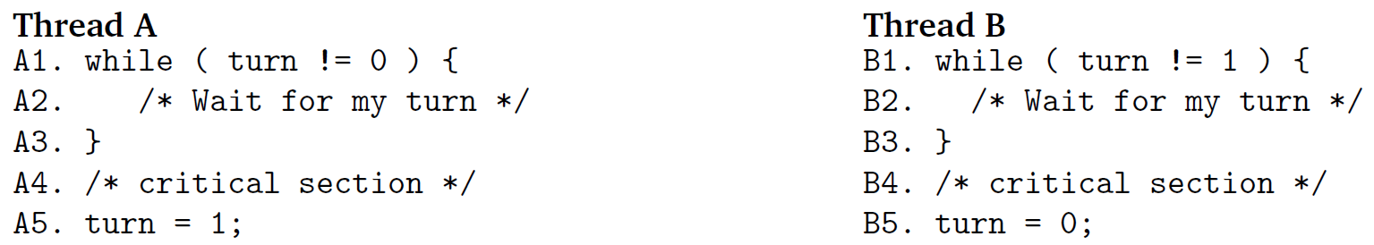

* Strict alternation – first Thread A runs, then B, then A, then B
* What if Thread A needs to run more frequently than Thread B?

Approach 2 – single flag variable

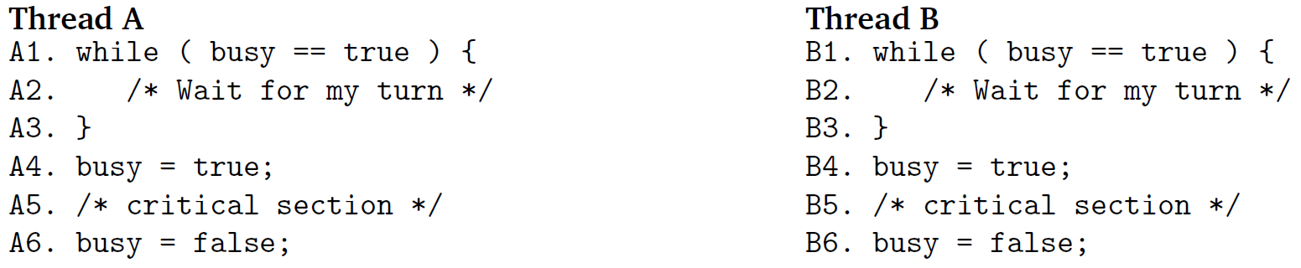

* Problem with flags: require two distinct steps, reading of and writing to busy
* If thread switch occurred between read and write operations, then both threads would be in the critical section at the same time

Approach 3 – separate flag variables

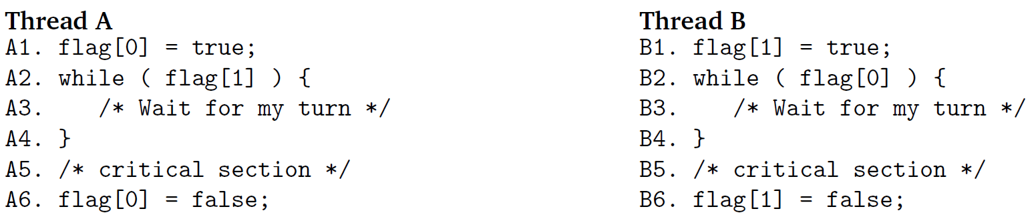

* If thread switch occurs after A1, then both flag[0] and flag[1] are true, so both threads would be stuck forever

### Test-and-Set

* The **Test-and-Set instruction** is a special atomic read and write machine instruction that is performed in a single machine cycle, and thus uninterruptible
  + If the flag variable is 0, it will set it to 1 and return true – it is the current thread’s turn to run its critical section
  + If the flag variable is 1, it will return false – the current thread must keep waiting

boolean testAndSet(int i) {

if (i == 0) {

i = 1;

return true;

}

return false;

}

Then, both threads could implement this code:

while (!testAndSet(busy)) {  
 /* wait turn */

}

/* critical section */

busy = 0;

* **Busy-waiting**: the while loop is checked constantly until the condition is true, a waste of CPU time and resources

# 12: Semaphores

## Mutual Exclusion through Messages

Desirable properties of a mutual exclusion solution:

1. Mutual exclusion must apply
2. A thread that stops execution outside its critical section must not interfere with other threads
3. It must not be possible for a thread requesting access to a critical section to be delayed indefinitely
4. When no thread is in the critical section, a thread that requests access should receive it right away
5. Solution should apply to a general case – no assumptions are made about what the threads do or how many processors there are in the system
6. A thread remains inside a critical section for a finite time only – there must be a way to indicate that the thread has left the critical section

## Semaphore

* Semaphores are systems of signals that are used for communication
* **Binary semaphore**: a variable has two values, 0 or 1, and can be initialized to either value
  + **wait**: program tries to enter critical section
    - If semaphore = 1, set it to 0 and the current thread can enter its critical section
    - If semaphore = 0, block the current thread
  + **signal**: program indicates it has finished its critical section
    - If semaphore = 1, do nothing
    - If semaphore = 0, and there is a task blocked waiting, unblock that task; else, set it to 1
* Semaphores require an OS to work, since it is the OS’s job to block and unblock threads, and know not to schedule them again until they’ve been unblocked
* There is no way of “checking” the current value of a semaphore
  + A thread doesn’t know in advance if it’ll be blocked waiting on a semaphore
  + When a thread signals a semaphore, it doesn’t know if there are any other threads waiting on it
* What if a thread simply calls signal before it calls wait (very bad behaviour)?
  + **mutex**: binary semaphore with supplementary condition that only the thread that has called wait can signal that semaphore

### Binary Semaphore Syntax

* semaphore_init( semaphore_t *sem, int i ): initialize a semaphore (to 0 or 1)
* semaphore_wait( semaphore_t *sem ): wait on a semaphore
* semaphore_signal( semaphore_t *sem ): signal a semaphore

### Example: Applying Semaphores to a Linked List

typedef struct single_node {

void *element;

struct single_node * next;

} single_node_t;

typedef struct single_list {

single_node_t *head;

single_node_t *tail;

int size;

semaphore_t mutex;

} single_list_t;

void single_list_init( single_list_t *list ) {

list->head = NULL;

list->tail = NULL;

list->size = 0;

semaphore_init(&(list->mutex), 0);

}

bool push_front( single_list_t *list, void *obj ) {

single_node_t *tmp = (single_node_t *) malloc(sizeof(single_node_t));

if (tmp == NULL) {

return false;

}

tmp->element = obj;

semaphore_wait(&(list->mutex)); {

/* critical section */

tmp->next = list->head;

list->head = tmp;

if (list->size == 0) {

list->tail = tmp;

}

++(list->size);

} semaphore_signal(&(list->mutex));

return true;

}

### Counting Semaphore

* A **general semaphore** that is initialized with a maximum value
* A thread that waits on the semaphore will decrement it by 1
  + If the decrement makes the semaphore <= 0, the calling thread is blocked
  + Otherwise, the calling thread can continue
* A thread that signals the semaphore with increment it by 1
* semaphore_init( semaphore_t *sem, int i, int n ): initialize a semaphore to i, with a maximum value of n
  + The initialized value of i is the maximum number of threads that can be in the critical section at a time

# 13: Synchronization Patterns

* There are many synchronization patterns that can be solved using semaphores

## Signalling

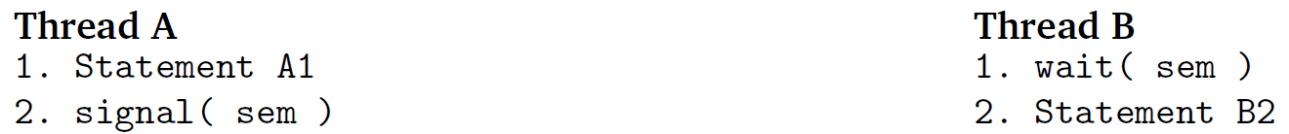

* Indicate that something has happened – in this case, it makes sense for a thread that didn’t call wait to signal the semaphore
* Ensures that statement A1 always executes before statement B2

## Rendezvous

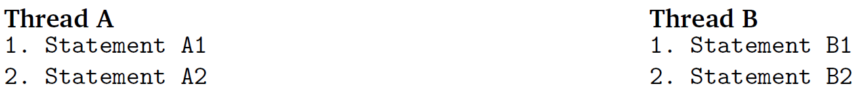

* Two threads should be at the same point before they “meet up”, i.e. either of them proceeds
  + A1 should execute before B2 and B1 should execute before A2

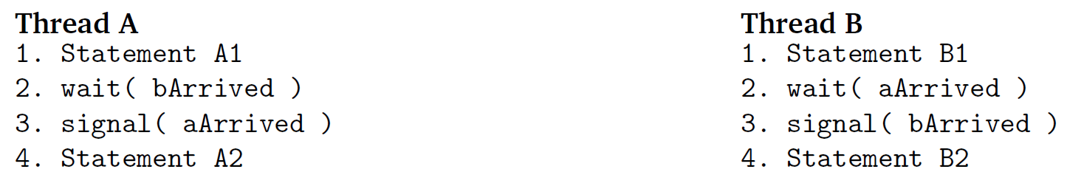

* This solution has a problem: Thread A runs, waits on bArrived, and gets blocked; Thread B runs, waits on aArrived, and also gets blocked; both threads are blocked indefinitely

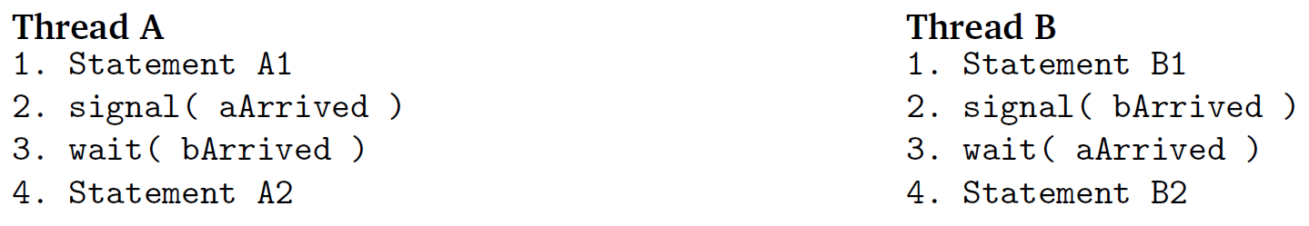

* The solution to the above problem is to signal before waiting
  + Thread A runs, signals aArrived, and waits on bArrived
  + Thread B runs, signals bArrived; Thread A is unblocked and runs to completion
  + Thread B waits on aArrived, which is already signalled, so it can run to completion right away
* Regardless whether Thread A or B runs first, the order (A1 before B2 and B2 before A2) is ensured

## Mutual Exclusion

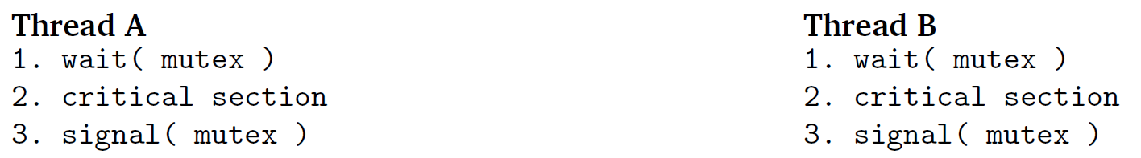

* In this case, the mutex semaphore must be initialized to 1, so that whichever thread runs first will proceed immediately (initializing the semaphore to 0 would block both threads forever)
* This is a symmetric solution because both threads do the same thing
* If different threads have different sections of code, it is an asymmetric solution

## Multiplex

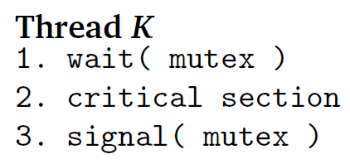

* Identical to mutual exclusion, except that multiplex uses a general semaphore to allow multiple threads in a critical section at a time
* Example: database wants to limit the number of concurrent queries that can run at the same time

## Barrier

* Generalization of rendezvous pattern, where n threads meet up at the same point before continuing execution

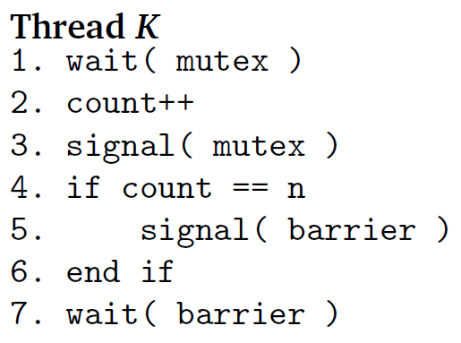

* This solution doesn’t work, because if more than one thread is waiting, only the first thread gets unblocked; the rest are stuck permanently

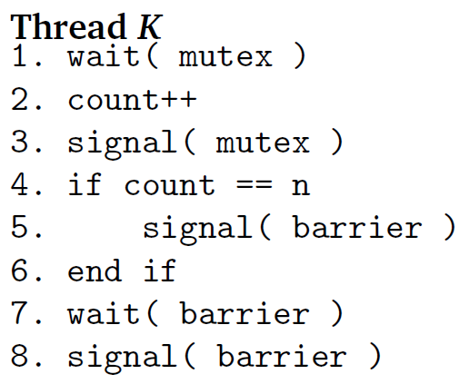

* Better solution: have each thread unblock the next:
* **Turnstile pattern**: allows one thread at a time to go through, but can also be locked to block all threads

## Reusable Barrier

* The barrier solution can only be used once; once the barrier is open, it can’t be closed again
* To create a reusable barrier, we can decrement count after the rendezvous occurs

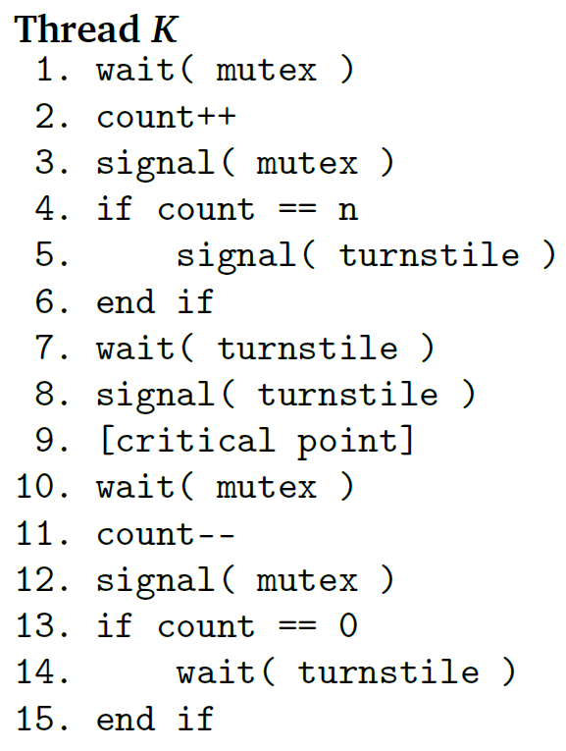

* Two problems:
  + If a process switch occurs at line 4 on the (n – 1)th thread, more than one thread will signal the turnstile
  + If a process switch occurs at line 13 on the (n-1)th thread, more than one thread will wait on the turnstile and deadlock will occur
* First solution: put count checks in critical section

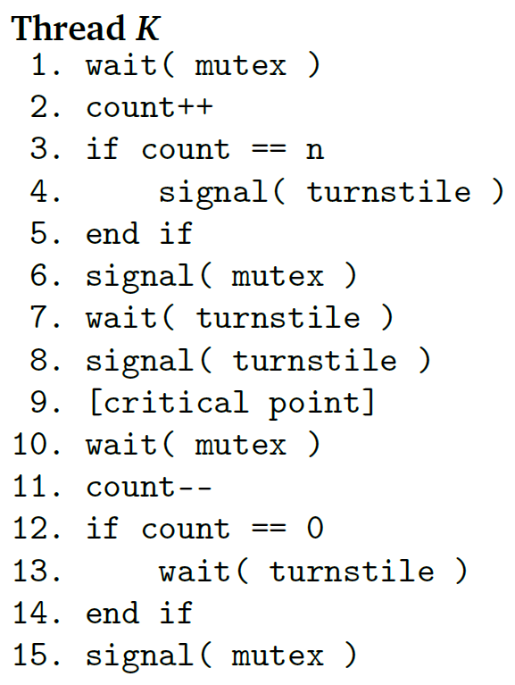

* What if a thread gets through the second mutex in a loop, and gets back to the first mutex?
* Solution: **two-phase barrier** – introduce second turnstile; all threads wait at the first turnstile until the last one gets there and lets them through, then all threads wait at the second turnstile until the last one gets there and lets them through

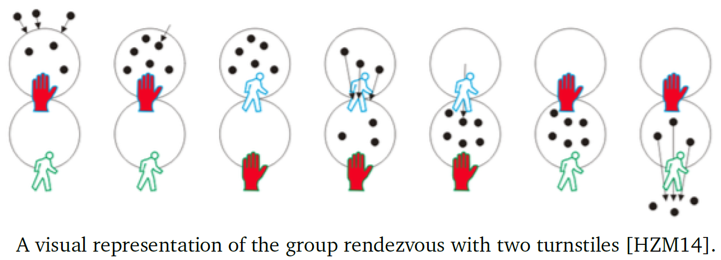

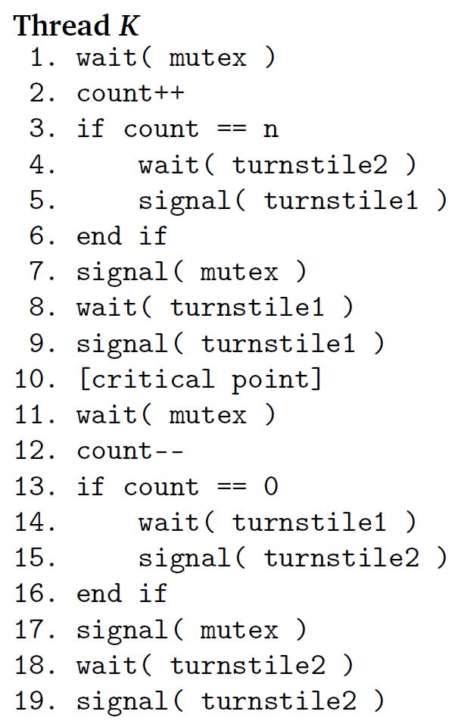

# 14: Classical Synchronization Problems

## The Producer-Consumer Problem

* Processes share a buffer of a fixed size $N$
  + Producers generate data and put it into the buffer
    - If the buffer already contains $N$ items, the producer must wait until there is space
  + Consumers take data out of the buffer
    - If the buffer is empty, the consumer must wait until an item gets added
* If busy-waiting is permitted, we can use a single mutex to achieve this

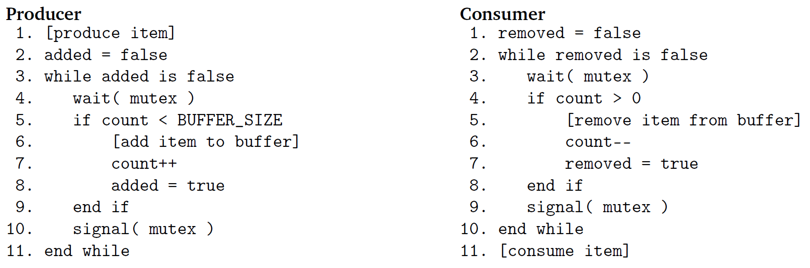

* To be more efficient, we can use two general semaphores
  + items: represents how many spaces in the buffer are full, starts at 0
  + spaces: represents how many spaces in the buffer are empty, starts at BUFFER_SIZE

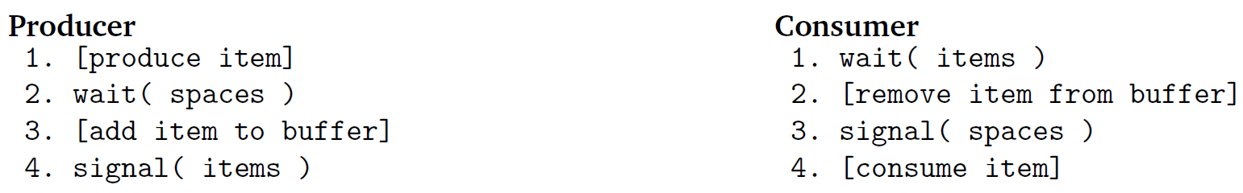

* This solution only works for a single producer and consumer, because we would run into problems if multiple producers wanted to add / consumers wanted to remove data at once
* To generalize the solution to allow for multiple producers and consumers, we need a binary semaphore mutex, initialized to 1, which essentially combines the two previous solutions

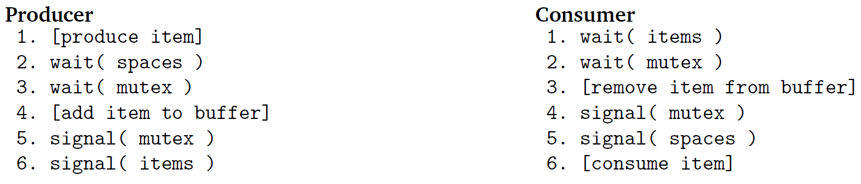

* Even though we have nested wait statements, deadlock won’t occur

## The Readers-Writers Problem

* Concurrent reading and modification of data by more than one thread
* Writers modify the data, readers read the data without modifying it; some concurrency is allowed
  + Any number of readers can be in the critical section at once – a reader can enter the critical section if there aren’t any writers in it
  + Only one writer can be in the critical section at once – a writer can only enter the critical section if no one else is in it
* Solution 2:
  + Binary semaphores mutex and roomEmpty
  + Counter for number of readers

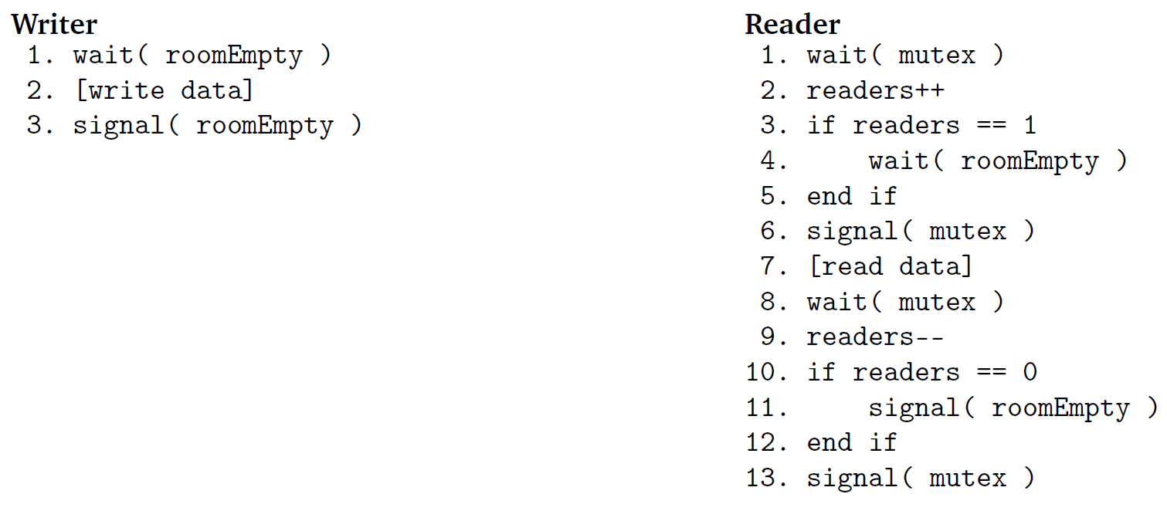

* Writers only enter the critical section if roomEmpty, and signal roomEmpty when they leave (since only one writer can be in the room at once)
* The first reader checks roomEmpty; additional readers don’t have to check since multiple readers can enter the room at once; the last reader signals roomEmpty, unlocking it for writers
* **Starvation** problem: what if readers come in and out of the room, and there is never a moment when there are no readers? Then the writers never get to run
* Solution 2: requires new binary semaphore turnstile

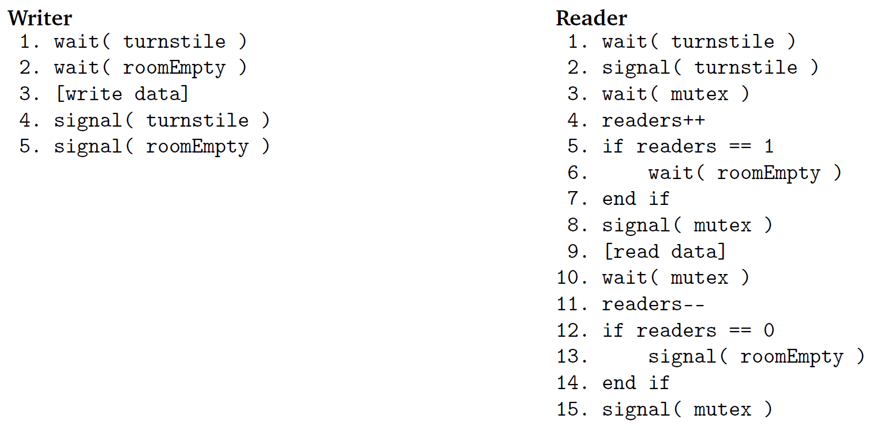

* Writers:
  + When a writer arrives, it waits on turnstile; if it can proceed, it locks turnstile and waits for roomEmpty
  + Since turnstile has been locked, no new readers can enter the room; when the last reader exits, the writer can enter
  + When the writer exits, it signals turnstile, which may unblock a reader or writer
* Readers:
  + If turnstile is locked when a reader arrives, it means that a writer is in the critical section, so readers queue at the turnstile
  + When turnstile gets unlocked, the reader signals turnstile to allow any other readers that have been queued to also enter

## The Dining Philosophers Problem

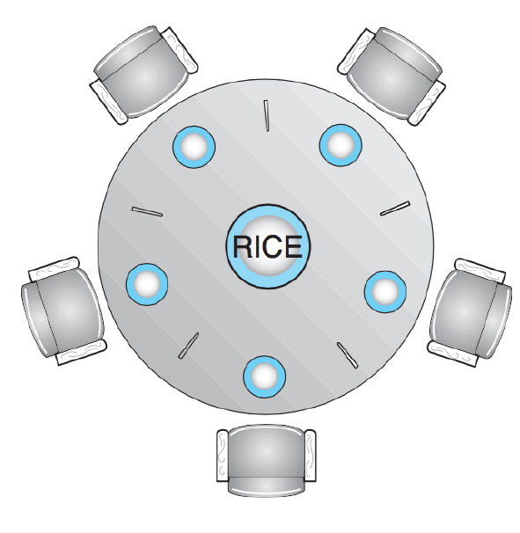

* Five philosophers share a table with five single chopsticks
  + When a philosopher wishes to eat, she tries to pick up the two chopsticks closest to her; if she gets both chopsticks, she can eat
  + Since only one person can be in possession of each chopstick at once, each chopstick can be represented by a binary semaphore
  + If all five philosophers sit down at the same time and attempt to grab first their left, then their right chopstick, none of the philosophers can get both chopsticks and so they are all stuck – deadlock
* Solution 1: Protect the table with a binary semaphore – only one philosopher at a time can enter and eat; this is very inefficient
* Solution 2: Limit the number of philosophers to 4 (with a general semaphore) – by pigeonhole principle, one person will be able to grab both chopsticks
* Solution 3: If some of them try to pick up their left and others try to pick up their right chopstick first, then deadlock will not occur

# 15: Deadlock

* **Deadlock**: the permanent blocking of a set of processes that either compete for system resources or communicate with each other
  + A set of processes are truly deadlocked when each process in the set is blocked on some event that can only be triggered by another blocked process

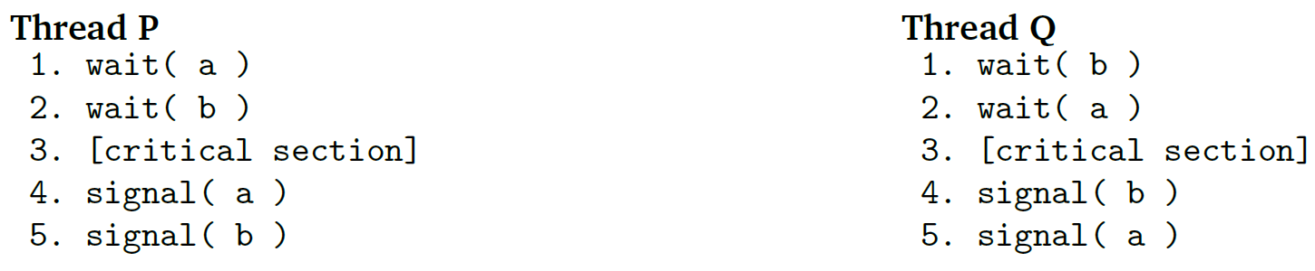

* In this example, if a thread switch occurs after Thread P locks a, and Thread Q locks b, then both threads are now stuck waiting on each other
* Joint progress diagram: visually represents the advancement of the two threads

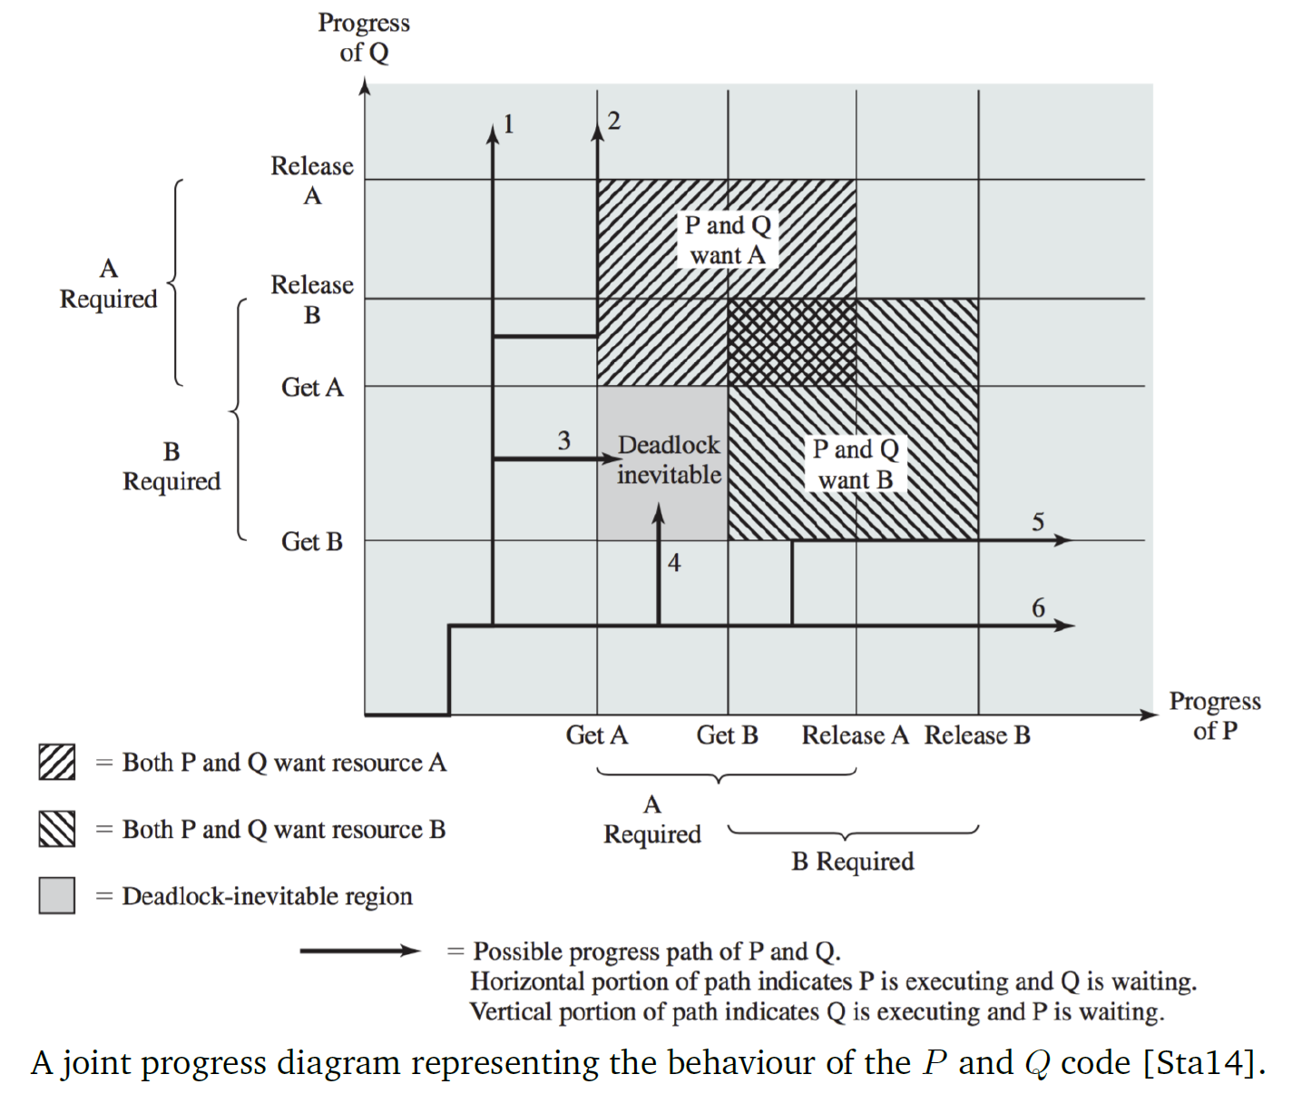

* 6 possible execution paths:

1. Thread Q acquires B and then A, releases B and then A. Thread P acquires both resources and releases them.
2. Thread Q acquires B and then A. Thread P executes and then blocks waiting for A. Thread Q releases B and A. Thread P is unblocked, acquires both resources, and releases them.
3. Thread Q acquires B, then Thread P acquires A. Deadlock occurs.
4. Thread P acquires A, then Thread Q acquires B. Deadlock occurs.
5. Thread P acquires A and then B. Thread Q executes and is blocked waiting for B. Thread P releases A and then B. Thread Q is unblocked, acquires both resources, and releases them.
6. Thread P acquires A and then B, releases A and then B. Thread Q acquires both resources and releases them.

* The region that says “deadlock inevitable” is called the **fatal region**; If a fatal region exists, it means that deadlock is inevitable

## Reusable and Consumable Resources

* **Reusable resource**: a resource that can be used by one process at a time and is not depleted by use; a process can lock the resource, use it, release it, and then other processes may acquire it
  + E.g. processors, memory, files, semaphores
* **Consumable resource**: a resource that is created and destroyed upon consumption
  + E.g. interrupts, signals, and messages

## Conditions for Deadlock

1. **Mutual exclusion**: a resource belongs to, at most, one process at a time
2. **Hold-and-wait**: a process that is currently holding some resources may request additional resources and be forced to wait for them
3. **No pre-emption**: a resource cannot be forcibly taken from a process; only the process currently holding the resource can release it
4. **Circular-wait**: resource allocation graph has a cycle

* If any of the first three conditions are true, deadlock is possible, but it will only occur if the fourth condition is true
* A resource allocation graph is a directed graph that tells us the state of the system in terms of processes and resources

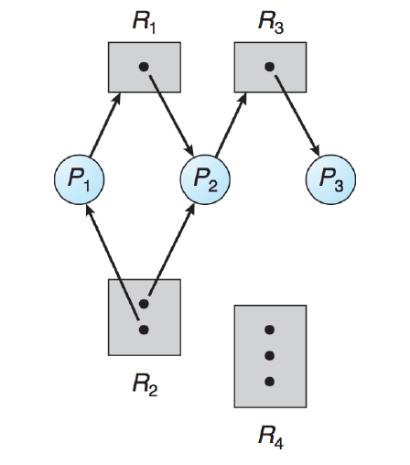

* + Pn represent processes
  + Rn represent resources; the dots represent the number of resources available
  + Arrows from Pn 🡪 Rn represent a process requesting a resource
  + Arrows from Rn 🡪 Pn represent a process holding a resource
* If a cycle exists in the graph, deadlock may exist

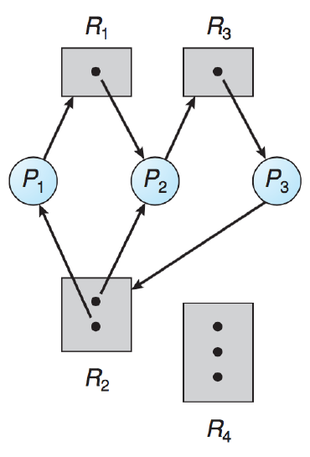

* However, deadlock may also not exist even when a cycle exists

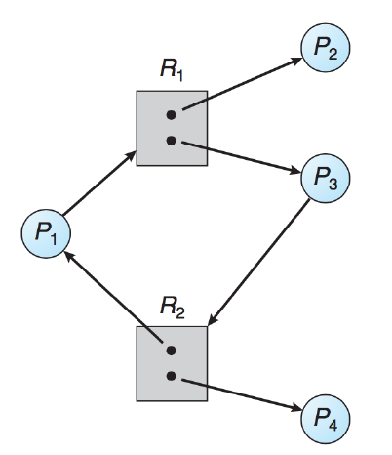

* + In this case, once P2 or P4 (which aren’t part of the cycle) release their resources, the other two processes can proceed

## Dealing with Deadlock

There are four basic options to deal with deadlock:

1. Ignore it
2. Deadlock prevention
3. Deadlock avoidance
4. Deadlock detection

### Ignore It

* Pretend that deadlock can never happen, or if it does happen, it is the application developer’s fault
* If two processes get deadlocked, the user may see no progress or a “not responding” dialog, and they may have to manually kill the processes

### Deadlock Prevention

* The first three options (mutual exclusion, hold-and-wait, no pre-emption) are all required for deadlock to be possible; if we eliminate one, then deadlock isn’t possible
* **Mutual exclusion**: not very possible to remove, since it prevents errors like inconsistent state or crashes
* **Hold-and-wait**: to prevent hold-and-wait, we must guarantee that when a process requests a resource, it doesn’t have any other resources
  + One solution: all processes must request all resources at the start of a program; no resource can be request during execution
    - Not very plausible, as it involves processes needing to know in advance what resources it needs
    - Has performance implications as some resources may not be needed until much later, so the process spends a lot of time waiting before it can run
  + **Two-phase locking**: processes attempt to lock a group of resources at once; if it doesn’t get all of them, it must release all the ones it got and try again
* **No pre-emption**: OS remove resources from blocked processes and adds them to the list of resources that the blocked process is waiting for; it can then allocate those resources to other processes, and when they become available again then the blocked process can be unblocked
  + For pre-emption to work, the resource must be of a type where the state can be saved and restored
  + Thus, pre-emption can only make deadlock less likely, not prevent it completely

# 16: Deadlock Avoidance

## Deadlock Avoidance

* The best way to avoid deadlock is to prevent a cycle in the resource allocation graph
* In the Dining Philosophers problem, one solution was to limit the number of philosophers to 4; this was a way to prevent a cycle in the resource allocation graph (because there aren’t enough requests to create a cycle)

### Ordering of Resources



* From this previous example, it is clear to see that if both Threads P and Q requested a and b in the same order, deadlock wouldn’t occur
* Generalized principle: for a system with a set of resource $R=\{R_{0},R_{1},R_{2}, … R_{m}\}$ and a function $f(R_{i})$ that maps every $R_{i}$ to a unique integer, we use the integer to compare resources
  + If a process has been assigned $R_{i}$, it can only request $R_{j}$ if $f\left(R_{j}\right)>f(R_{i})$
  + To get $R_{i}$ when in possession of $R_{j}$, where $f\left(R_{j}\right)>f(R_{i})$, the process must first release all its resources $R_{k}$, where $f\left(R_{k}\right)≥f(R_{i})$
* Example: in the Dining Philosophers problem, each chopstick is assigned a value from 0 to 4
  + Each philosopher must request their chopsticks in ascending order, meaning that the last philosopher, who would have requested chopstick 4 then chopstick 0, now must request 0 first
  + It will be blocked on 0 since the first philosopher is holding it, leaving chopstick 4 available for the second-last philosopher, hence avoiding deadlock

### Stay Alert Stay Safe

* Suppose processes informed the OS in advance about the maximum number of resources it may need
* The OS can then make more intelligent decisions about when to run a process, to avoid deadlock



* In this diagram from earlier, every point in the diagram represents the joint state of the two processes
* A state is safe if there is some scheduling order where every process can run to completion even if all of them suddenly request their maximum number of resources immediately; any state that isn’t safe is considered unsafe
  + If the system is a safe state, there is no deadlock
  + Being in an unsafe state means that deadlock is possible
* **Safe sequence**: a sequence of processes $P_{0},P_{1}, … P_{n}$ is in a safe sequence if in the current state, for each $P_{i}$, the resource requests that $P_{i}$ makes can be satisfied by currently available resources + resources held by $P_{j}$, where $j<i$

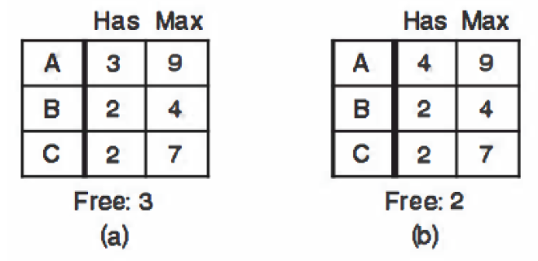

* In this example:
  + (a) is a safe state because it can be completed if the processes run in the order B, C, A
  + (b) is an unsafe state because after B runs, neither A nor C can run, resulting in deadlock

### Resource Allocation Graph Algorithm

* Add new edge, a **claim edge** (dotted line) to the graph, to represent that a process may request a resource some time in the future
  + When the process actually requests the resource, it becomes a solid request line
  + Upon release, the assignment edge becomes a claim edge

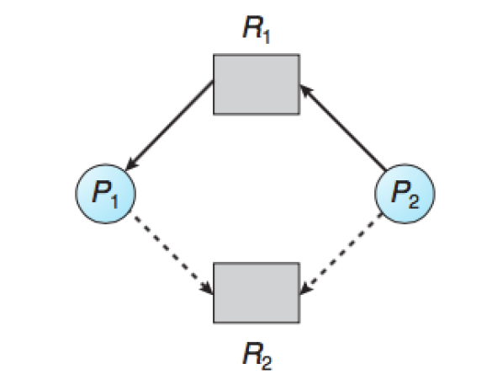

* A resource request will only be granted if converting the request edge to an assignment edge will not result in a cycle
* This is only applicable if all resource requests are known in advance and there is only one instance of each resource

### Banker’s Algorithm

* More generalized approach that allows for resources with multiple instances
* When the OS receives a resource request, it will evaluate the new state to determine whether it would transition the system to an unsafe state
  + If it will, then the request is blocked until it can be fulfilled without putting the system in an unsafe state
* Example:

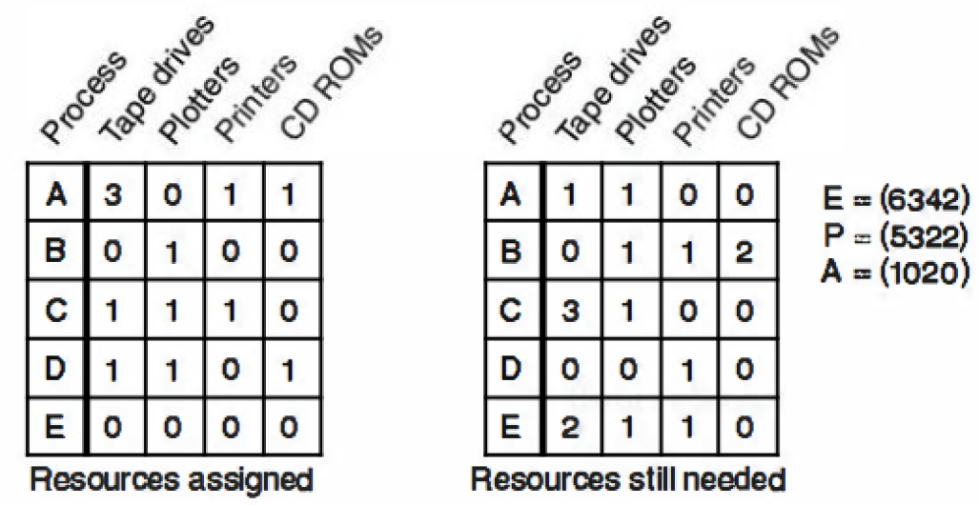

* To check if a state is safe:
  1. Look for a row in the matrix where the number of resources still needed is fewer than the number of available resources in A
  2. Assume that row gets the resources it needs, and add all its assigned resources to A
  3. Repeat above steps until either all processes finish – initial state is safe, or no process remains whose needs can be met – initial state is unsafe
* In practice, the banker’s algorithm is useless because processes rarely know the maximum resources they will need, the number of processes isn’t fixed, and available resources can disappear suddenly

## Summary of Avoidance

* Avoidance techniques require a fixed number of resources to allocate and a lot of knowledge about what requests a process may make
* Because it deals with worst-case scenarios, avoidance techniques can result in denial of requests that won’t actually lead to deadlock, reducing system performance for the sake of safety

### Other Recommendations

There are some other recommendations to make it more likely to avoid deadlock:

1. Minimize number of critical sections and their length – mutual exclusion should only be applied minimally where needed
2. All tasks should release resources/semaphores as soon as possible
3. Don’tt suspend tasks in the critical region
4. All critical regions must be error-free
5. Don’t allocate resources in interrupt handlers
6. Always perform validity checks on pointers in critical regions – segmentation fault or exception in a critical region can result in the lock not being released

# 17: Deadlock Detection and Recovery

## Deadlock Detection

* Basic strategy for deadlock detection is like deadlock avoidance but based on current resource allocation/requests
* Wait-for graph: simplified resource allocation graph for single-resource allocations/requests, that doesn’t include the resources and instead indicates which processes are waiting on (resources held by) others

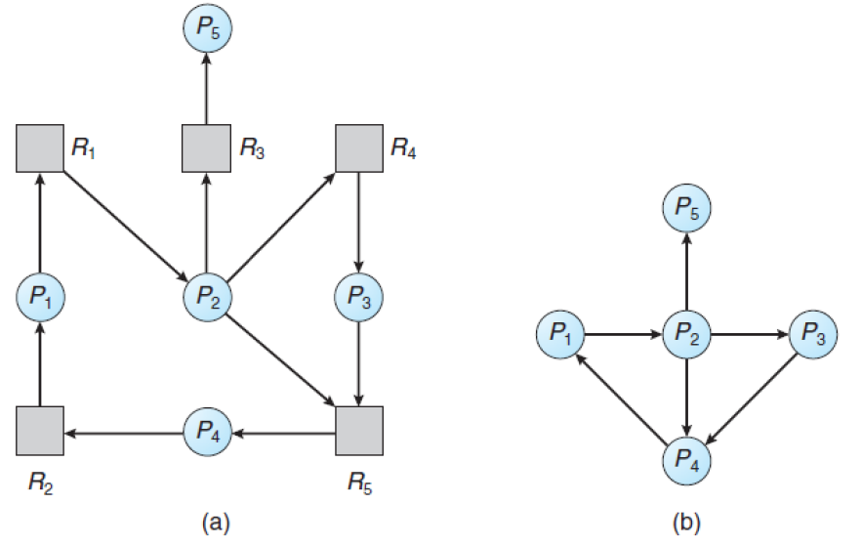

* We can then examine each possible path from a node in a wait-for graph to determine if a cycle exists

### General Deadlock Detection Algorithm

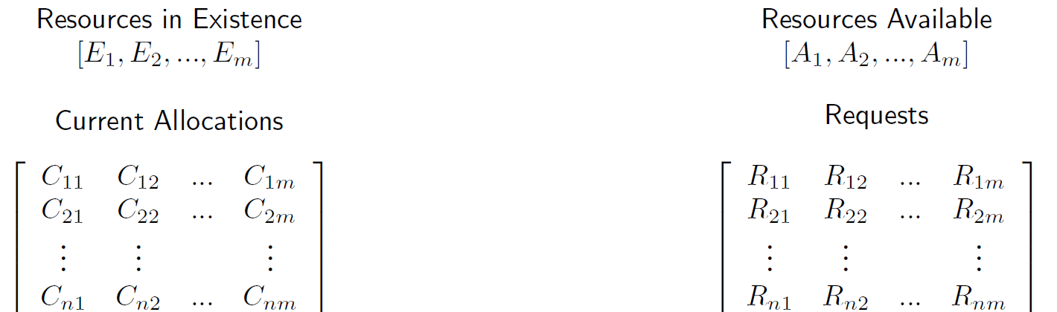

* + processes and $m$ resources
  + $E$ contains the total number of existing resources
  + $A$ contains the current number of available resources
  + $C$ contains what resources are currently assigned to each process
  + $R$ shows how many of each resource a process wants
* General algorithm is like banker’s algorithm:

1. Look for an unmarked process $P_{i}$ where its requests $R_{i}≤A$, the number of available resources
2. If a process is found, add its current allocations to $A$: $A+=C_{i}$ and mark the process as complete
3. If no process was found in step 1, terminate the algorithm

* Either all processes complete and no deadlock exists, or there is a set of processes that are deadlocked
* The runtime of this algorithm is $O(m×n^{2})$

### Deadlock Detection Example

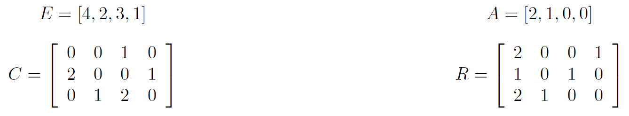

1. Process 3 is the only one that can run; $A =[2, 2, 2, 0]$
2. Process 2 is the only one that can run; $A =[4, 2, 2, 1]$
3. Process 1 can run; $A =[4, 2, 3, 1]$

Since all processes completed, there is no deadlock

## When to Detect Deadlock

* Deadlock detection is expensive to execute, so when how often should we run it?
  + Every time a resource is requested
  + Every time a resource request gets blocked
  + Periodically
* Depends on how often we expect deadlock to occur and how severe the consequences are
* Several sources suggest running deadlock detection when CPU utilization is low – a drop in CPU usage could indicate that many processes are blocked

## Deadlock Recovery

* Once deadlock is discovered, there are several ways to recover and “break” the deadlock
* An OS can implement some or all of them

### Robbery

* **Pre-emption**: OS takes resources from some processes and give them to another process, until the deadlock cycle is broken
* Recovery is only run when deadlock is discovered
* If the state of the resource cannot be saved/restored, pre-emption isn’t a good strategy

### Mass Murder

* **Terminate all processes involved in the deadlock**
* Guarantees that deadlock is broken, but once all processes are restarted, the circumstances for deadlock may occur again

### Murder

* OS chooses to **kill processes selectively**
* When the victim is killed, the deadlock detection algorithm is run again to see if deadlock has been broken; if not, the process is repeated until deadlock is broken

### Time Travel

* **Rollback**: return a process to a checkpoint, a saved state that is created periodically or before starting operations that require a lot of resources
* Rollback doesn’t always succeed – it might just move the process back a few steps on the same path that leads to deadlock, or it can avoid deadlock entirely
* After attempting rollback a few times, the OS should try something else

### Armageddon

* Reboot the system, **killing all processes** whether they are stuck or not
* Easy to implement, but most disruptive

## Victim Selection

* If we need to choose a process for one of the strategies, e.g. termination, some factors should be considered:

1. Priority of process
2. How long the process has been executing
3. How long is remaining in execution (if known)
4. What resources the process has – number and type
5. Future resource requests (if known)
6. If the process is user-interactive or in the background
7. How many times the process has been selected as victim

* These factors favour killing younger processes over older ones
  + It can be more expensive to restart an older process and get it back to the point before it was terminated
  + If an old process is constantly terminated, it may never get to run to completion
  + If killing process is aggressive, perhaps no processes will ever run to completion because as soon as it becomes the oldest one, it gets killed
* Keeping track of the number of times a process has been selected as victim prevents starvation of a particular process

## Miscarriage of Justice

* The deadlock detection algorithm tends to be very conservative because it assumes the worst case, where processes take resources and keep them until the end of their execution
* In practice, processes generally release resources as soon as they are finished with them
* We may end up detecting deadlock when there is none, and thus killing processes that aren’t actually deadlocked
* As long as the chosen deadlock recovery strategies don’t have unexpected side effects, then the correctness of the program isn’t affected

# 18: Concurrency & Synchronization in POSIX

## Concurrency with pthreads

* pthreads have routines for working with mutual exclusion (mutexes)
  + pthread_mutex_init: create a new mutex variable, of type pthread_mutex_t
    - pthread_mutex_t mutex = PTHREAD_MUTEX_INITIALIZER will initialize a mutex without setting attributes
    - By default, a mutex is unlocked when created
  + pthread_mutex_unlock: unlocks a mutex
  + pthread_mutex_lock: locks a mutex, blocking
  + pthread_mutex_trylock: locks a mutex, non-blocking
  + pthread_mutex_destroy: destroys a mutex – can fail if the mutex is locked, resulting in undefined behaviour
  + pthread_mutexattr_destroy: destroys mutex attributes initialized with pthread_mutexattr_init

### Condition Variables

* Allows synchronization to be achieved through the data values
* Condition variables are like “events”, or hardware interrupts
  + When an event occurs, we have the option to signal the thread waiting for the event to occur, or broadcast to all threads waiting for the event
  + If a thread signals a condition variable that an event has occurred, but no thread is waiting on that event, the event is “lost”
* In pthreads, condition variables are of type pthread_cond_t:
  + pthread_cond_init
  + pthread_cond_destroy
* Condition variables must be paired with a mutex
  + pthread_cond_wait: wait on a condition variable – should only be called when the mutex is locked
  + pthread_cond_signal: signals a condition variable
  + pthread_cond_broadcast: broadcasts to all threads waiting on a condition variable

### Monitors

* A condition variable can be used to create a **monitor**, a higher-level synchronization construct
  + Package up shared data and operations on that data, to avoid synchronization and concurrency problems
* Objective: prevent programmers from coding the synchronization directly, reducing likelihood of errors

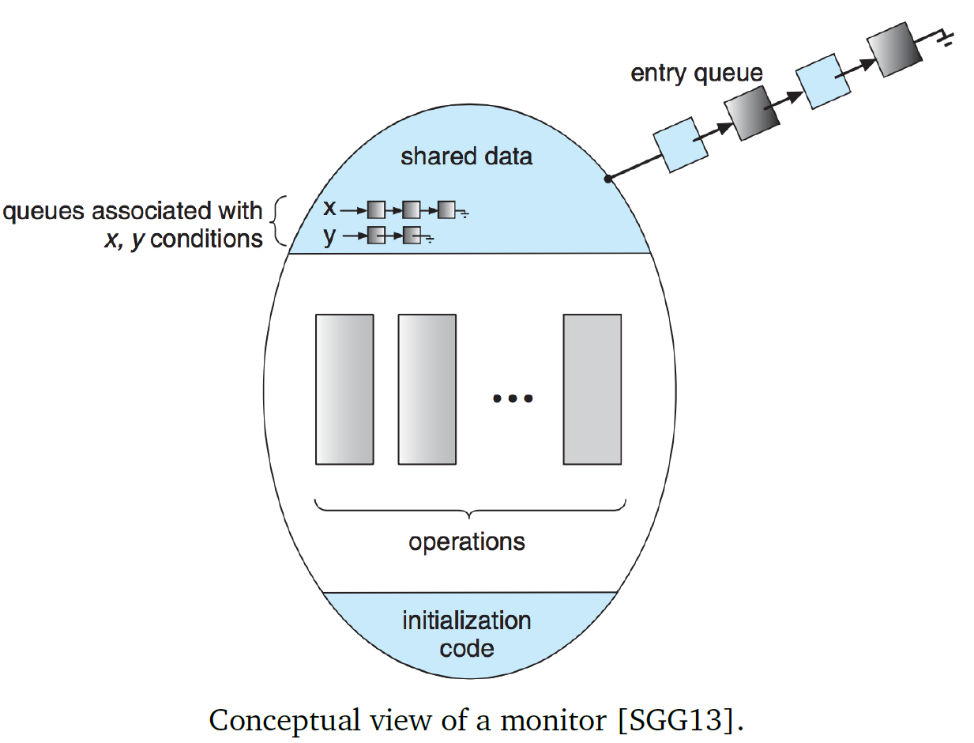

* Suppose there are two processes $P$ and $Q$, and a condition variable $x$
* If $P$ signals on $x$ while $Q$ is waiting, there are two options:
  + **Signal-and-wait**: $P$ waits until $Q$ leaves the monitor, or another condition
  + **Signal-and-continue**: $P$ continues, $Q$ waits for $P$ to leave the monitor, or another condition
  + Some systems compromise by making $P$ leave the monitor immediately after it signals
* Monitors are similar to the synchronized keyword in Java – automatic locking/releasing is intended to simplify writing of multithreaded code

## Concurrency Mechanisms in UNIX

* In UNIX, semaphores are general semaphores that contain some extra data:
  + Value of semaphore
  + Process ID of last process to operate it
  + Number of processes waiting on a value greater than the current value
  + Number of processes waiting for the value to be 0
* semctl manages semaphores en masse by executing the requested operation on all semaphores in a given set
* sem_op performs a list of provided operations one at a time, on each semaphore in a given set
  + sem_op **positive**: increment value of semaphore, wake up any processes waiting on it
  + sem_op **0**: if semaphore value = 0, do nothing; otherwise, block process until semaphore is 0 and increment the number of processes waiting for the value to be 0
  + sem_op **negative** (absolute value <= semaphore value): add sem_op to value of semaphore; if this makes the value 0, wake up processes waiting for the value to be 0
  + sem_op **negative** (absolute value > semaphore value): block process until semaphore value is increased, increment number of processes waiting for the value to increase

### Linux Kernel Concurrency Mechanisms

* **Atomic operations**: Linux kernel provides operations that are guaranteed to execute atomically, to avoid simple race conditions
  + Two types: those that operate on integers, and those that operate on bitmaps
    - atomic_t type is the only type that atomic operations can operate on, in order to prevent errors and hide some implementation details
* **Spinlocks**: way to implement constant checking to acquire a lock

spin_lock( &lock )

/* critical section */

spin_unlock( &lock)

* + If value is 0, the thread can lock it (set it to 1) and continue
  + If value is nonzero, it constantly checks the lock until it is 0
* **Reader-writer spinlocks**: goal is to allow multiple readers but give exclusive access to writers, like Readers-Writers problem
  + Implemented as 24-bit reader counter and an unlock flag

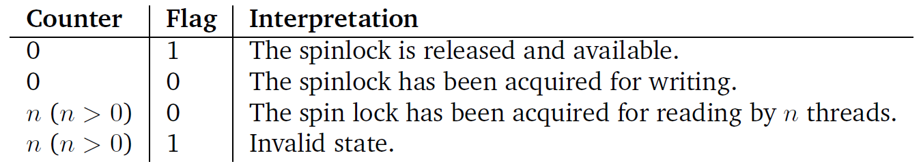

# 19: Memory

## Main Memory

* Executing a program means spending a lot of time interacting with memory
* Main memory is a shared resource between many processes
* Application developers tend to treat main memory as:
  + Unlimited
  + Entirety is at their program’s disposal
* Compared to the past, the amount of memory available today is huge
  + The reason Java and C have smaller-byte types like short was to avoid wasting memory in the past
* Today, we can use a lot more memory before we run out – but it still isn’t unlimited; so why do developers assume this?
  + Because the OS tends to manage shared resources of memory for programs

### No Memory Management

* Early mainframe and personal computers didn’t manage memory; programs would write directly to memory addresses
  + To write a program, needed to know the “start” address (after all the OS storage) and “end” address (the last available memory address) – these differed from machine to machine, making it harder to write programs that ran on different computers
* Coordination got more difficult as more and more programs were introduced into the system – if one program overwrote another’s changes, it would result in errors/crashes
  + Only one process is every in memory at a time, saving having to swap in/out the entire contents of memory to disk on every process switch
* The OS didn’t have protection either – errant memory accesses could lead to overwriting a part of the OS in memory, leading to crashes or corrupted system files
  + One solution: enforce **base** and **limit** addresses for each program – start and end addresses for the program’s memory; if a program tried to access memory outside that range, it would result in an error
* New problem: programs are written as if their instructions start at memory address 0

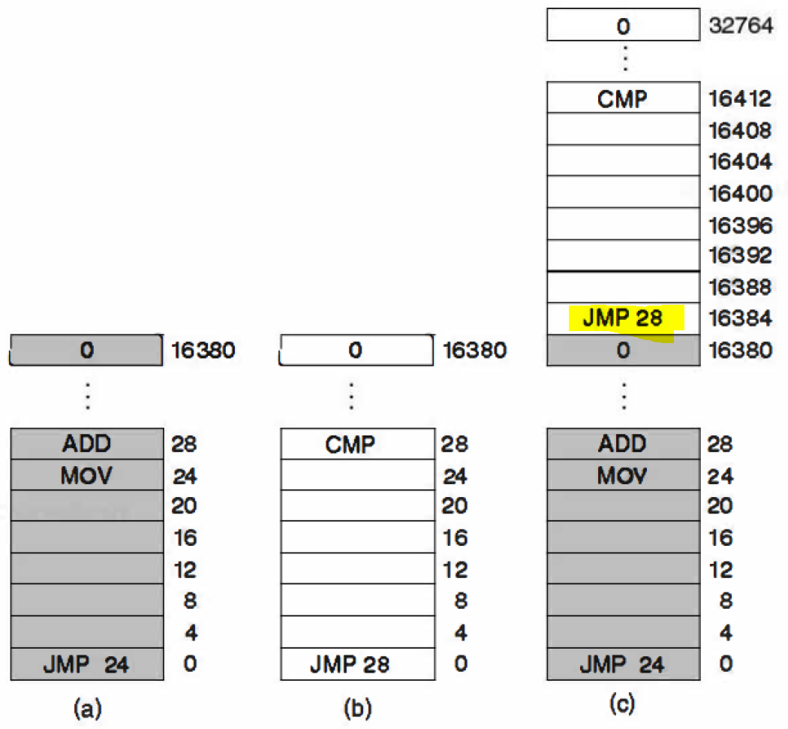

* + One solution was **static relocation**: add the base address of a program to all of its program addresses; problem was, how to tell the difference between addresses and plain integer variables?
* When is a variable assigned a memory location?
  + **Compile time**: if we are certain where a process will be loaded into memory, we can convert variables to correct address locations at compile time
  + **Load time**: when the code is to be loaded into memory, update addresses to correct ones; compiler must indicate which values should be updated
  + **Execution time**: if programs can move around memory during execution, binding needs to be done at run-time

### Address Space

* **Address space**: set of addresses that a process can use, independent of other address spaces (except in shared memory)
  + Telephone number area codes analogy

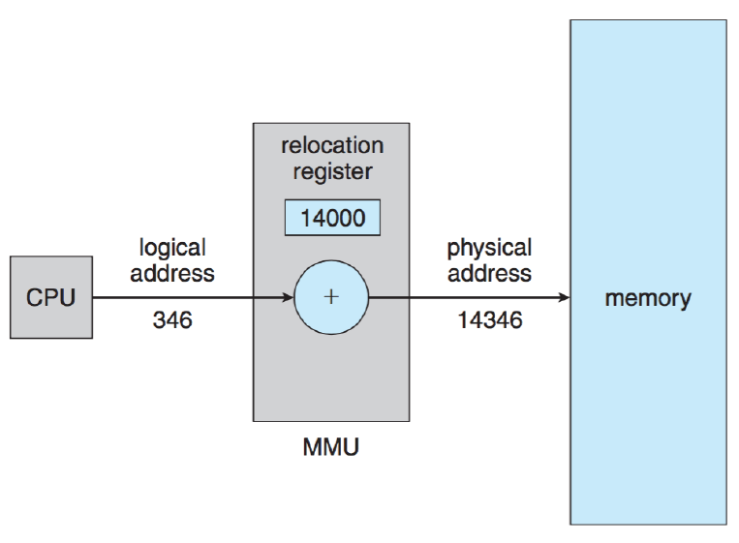

* **Logical address**: address generate by CPU
* **Physical address**: logical address + prefix of program’s “area code”, using **relocation register**
* Processes themselves don’t know physical address, only the logical one
  + Can relocate a process in memory if we update the relocation register
  + However, this adds an addition operation (or two, if using limit register) to every memory address

### Swapping

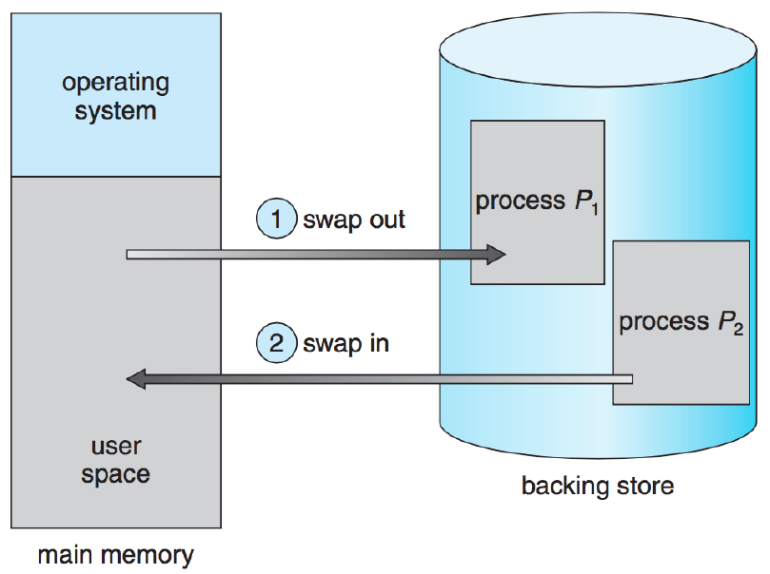

* **Swapping**: process of moving a process from memory to disk, or vice versa
  + To run, a process must be in main memory
  + If there are numerous processes, not all of them can fit in memory at the same time; logical to swap out blocked processes and swap in processes that are ready to run
* However, swapping to disk is extremely expensive, especially if processes are using large amounts (GB) of memory
  + Modern OSes do not perform swapping to/from disk because it’s so expensive
* When swapping a process back into memory, it doesn’t have to be in the same location as before; the relocation register will just update automatically with the new location

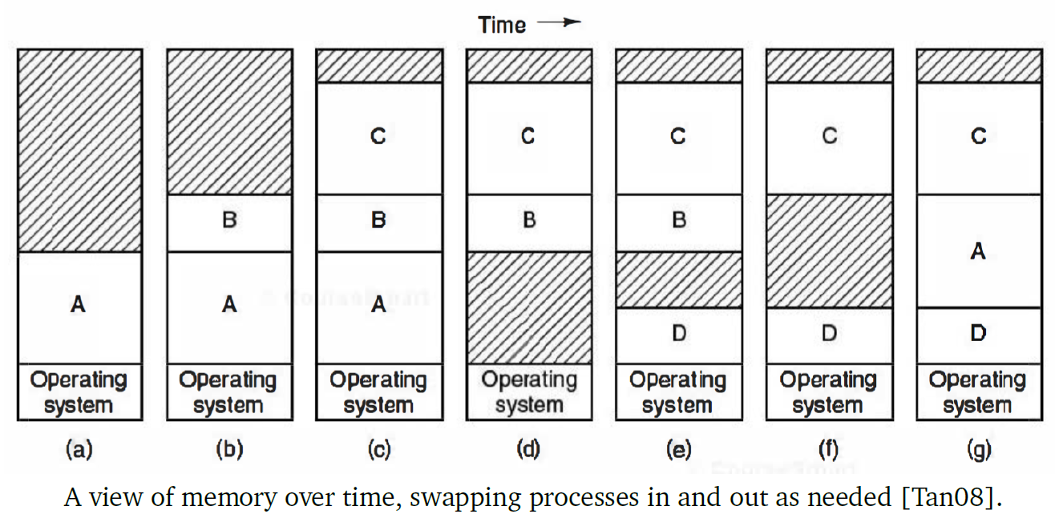

* + **(d)**: process D wants to run, but there is insufficient space; OS chooses to swap process A out
  + **(e)**: process D can now be swapped into memory
  + **(f)**: process A is ready to run again, so OS chooses to swap out process B
  + **(g)**: process A can be loaded into memory again

# 20: Dynamic Memory Allocation

## Dynamic Memory Allocation

* In C:
  + malloc() allocates a specified sized block of memory and returns its address
  + free() marks the specified block of memory as available – sometimes it takes awhile for that memory to be reused
    - OS keeps track of each allocated memory block’s size
    - It isn’t possible to return (deallocate) part of a memory block

### Fixed Block Sizes

* We could allocate only fixed block sizes of memory, but this could be wasteful
* **Internal fragmentation**: unused memory that is internal to a partition
  + The bigger the fixed block size, the more memory wasted by internal fragmentation
* Simple, but wastes a lot of memory due to internal fragmentation, so it may be suited for embedded systems
* Implementations:
  + Single block size – e.g. 1KB
    - Maintain linked list of addresses of all currently available blocks
    - When a block is allocated, remove its node from the linked list
    - When a block is freed, add a node with its address to the linked list
    - If linked list is empty, cannot satisfy memory request
    - Fast – allocates memory in $O(1)$ time
  + Multiple (fixed) block size options – e.g. 1KB, 2KB, and 4KB
    - Maintain one linked list for each different sized block
    - Fast – allocates memory in $O(1)$ time

### Variable Block Sizes

* For variable block sizes, we need to keep track of what memory blocks are allocated vs. free:

**Bitmaps**

* Divide memory into $M$ units of $n$ bits, then create an array of size $M$ to store the status of each unit
  + 0 = unit is unallocated
  + 1 = unit is allocated
* Memory overhead: $\frac{100}{n+1}\%$
* Finding a free block of $k$ bytes requires searching the bitmap for $\frac{8k}{n}$ zeroes

**Linked Lists**

* Information in the linked lists can be stored separately or as part of memory block
  + Start-up: linked list contains one node – all available memory is in one contiguous block
  + Allocation: add node to linked list containing start address, block length, and a bit indicating it is allocated
  + Deallocation: update node in linked list by setting bit to indicate it is unallocated
* Problem: could end up with lots of small contiguous pieces of freed memory



* Solution: need to **coalesce** (recombine) the split blocks



**Coalescence**

* Process of merging 2+ adjacent free blocks of memory into a single larger block
  + Can be done periodically, or whenever a block is freed
  + Solves the problem of contiguous bits not being able to be allocated
* Good idea to maintain doubly linked list, so that contiguous blocks can be merged more efficiently
* Even with coalescence, $N$ free bytes may exist in the system, but because they are spread out over many pieces, request for $N$ bytes can’t be allocated – **external fragmentation**

**External Fragmentation**

* One way to reduce external fragmentation is to increase internal fragmentation
  + E.g. free block contains 128 bytes, request for 120 bytes comes in; may not be worth it to split 128 into 120 + 8, as it is unlikely that request for 8 bytes will come in
  + Doesn’t help request for $N$ bytes, but minimalizes external fragmentation
* **Compaction/relocation**: move allocated sections of memory next to each other, allowing for a large contiguous block of free space
  + This is very expensive
* Various **allocation strategies** can help deal with external fragmentation

### Variable Allocation Strategies

* Given a memory request of $N$, how do we allocate it?
  + If there is no block of size $≥N$, we can’t satisfy the request
  + If there is only one block of size $≥N$, no decision-making occurs
  + If there is more than one block of size $≥N$, we need to decide which block to split, through 5 different strategies:

1. **First fit** – start from beginning of memory and check each block; split the first block of sufficient size and return the balance to the unallocated memory list Runtime: $O(n)$
2. **Next fit** – keep track of where the last block was allocated, and start the search after it; prevents external fragmentation concentrated at start of memory   
   Runtime: $O(n)$
3. **Best fit** – consider all blocks and split the smallest one of sufficient size; produces the smallest remaining unallocated block at the end  
   Runtime: $O(n)$ to check each block or keep blocks sorted in increasing size, possibly $O(n\log{n})$ if using an AVL tree or red-black tree
4. **Worst fit** – consider all blocks and split the largest one of sufficient size; remaining unallocated block is hopefully big enough to be useful  
   Runtime: $O(n)$ to check each block or keep blocks sorted in decreasing order
5. **Quick fit** (optimization) – If memory requests of a certain size are common, it might be more efficient to keep a separate list of blocks that are sufficient and close to that size so that requests can be satisfied more quickly
   * Example:

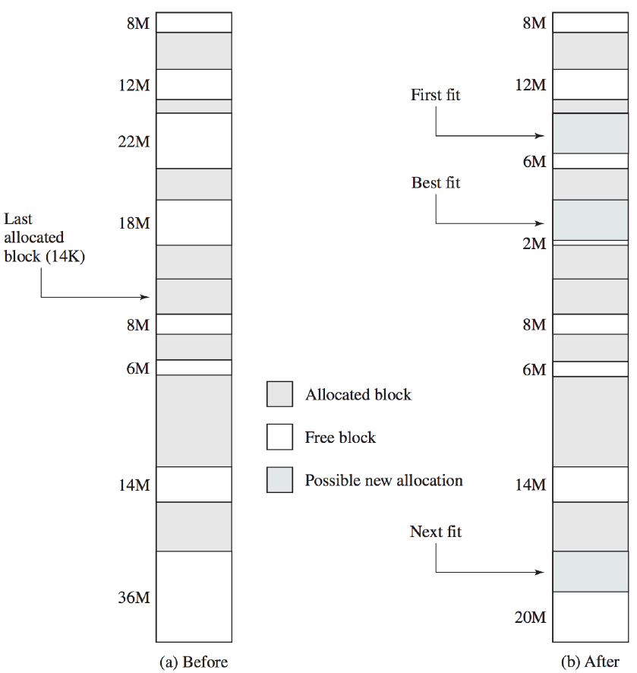

### Choosing a Strategy

* Worst fit tends to perform the worst in terms of both request fulfillment time and amount of wasted space
* First fit, next fit, and best fit are about equal in how well they utilize memory, but first fit is generally faster
  + Next fit tends to do allocations at the end of memory, resulting in the largest block being broken up quickly
  + Best fit tends to produce blocks that are too small to be useful
  + First fit litters beginning of memory with small fragments of memory

### Advanced Strategy: Binary Buddy

* Compromise between fixed and variable allocation
* Memory blocks are available in powers of 2; a block is of size $2^{K}$, where $2^{L}$ is the smallest block of memory that can be allocated, $2^{U}$ is the largest block of memory that can be allocated, and $L ≤K≤U$
* At the beginning, memory is a single block of size $2^{U}$
* If a request of size $N$ comes in:
  + If $2^{U-1}≤N≤2^{U}$, the entire block is allocated
  + Else, split the block into two “buddies” of size $2^{U-1}$; if $2^{U-2}≤N≤2^{U-1}$, then allocate one of the two $2^{U-1}$ blocks; else, repeat this subdivision process until the smallest block $≥N$ is allocated
* For subsequent allocations, look through data structure containing blocks (typically a tree) to find a block of appropriate size, or a block that can be subdivided to meet the allocation
* When two blocks split from the same parent are freed, they can be coalesced
* Example:

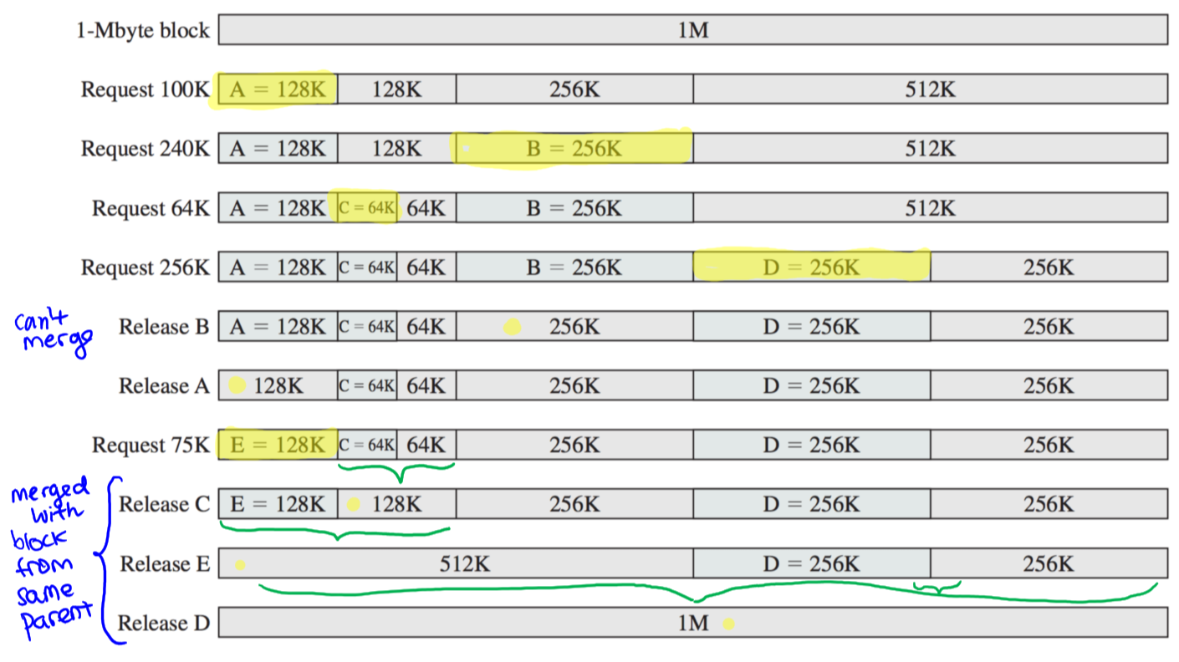

# 21: Memory: Segmentation and Paging

## Memory Segmentation

* Each element of the stack, heap, standard C library, and instructions is known as a **segment**
* The compiler is normally responsible for constructing the various segments
  + The code (instructions)
  + Global variables
  + The heap
  + The stack – one per thread
  + The standard C library
* We can think of memory as a tuple **<segment, offset>** instead of a pure address; thus, we need a way to map the tuples to memory addresses
* The mapping has a **segment table**, where each entry contains the base – starting address of the segment – and limit – length of the segment
  + Each memory access needs addition and comparison to check if the address is within the range

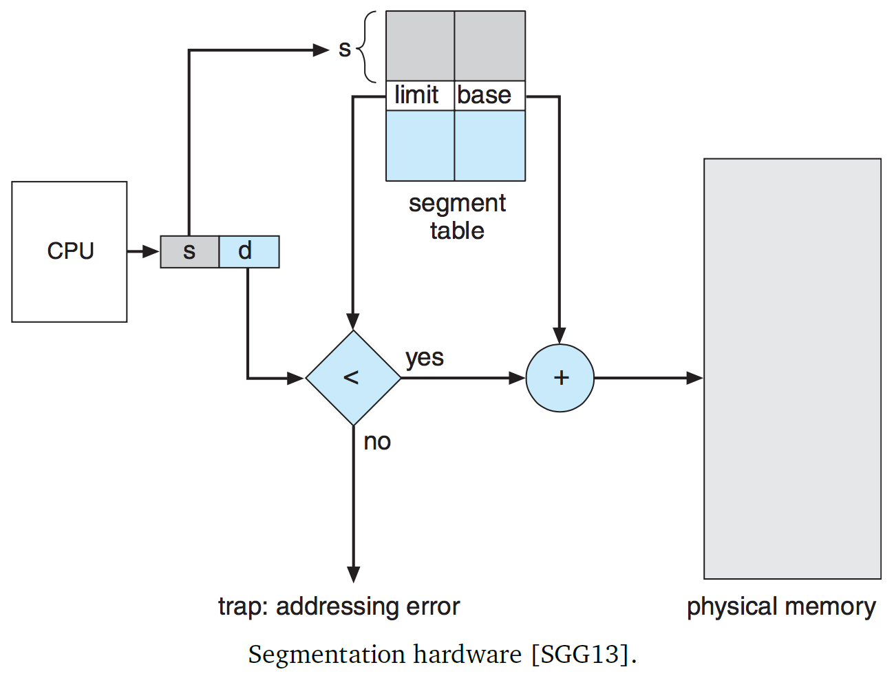

* Through segmentation, memory doesn’t have to be contiguous – different parts of a program can be allocated to different segments in different memory locations

## Paging

* Divide memory into small, equal fixed-sized chunks called **frames**
* Divide each process’s memory into chunks that are the same size as frames, called **pages**
* Assign pages to frames – each frame can be empty, or contain a single page
* When a process starts, it has some initial memory requirements (e.g. stack and global variables), so it needs a certain number of pages
* As memory is allocated/freed, the number of pages a process has will change
* A process can be swapped out to disk, but to run it must be swapped back in
* Pages separate logical addresses from physical addresses – programmers can pretend that the address space of a computer is $2^{64}$ bytes instead of the amount of memory in the physical machine

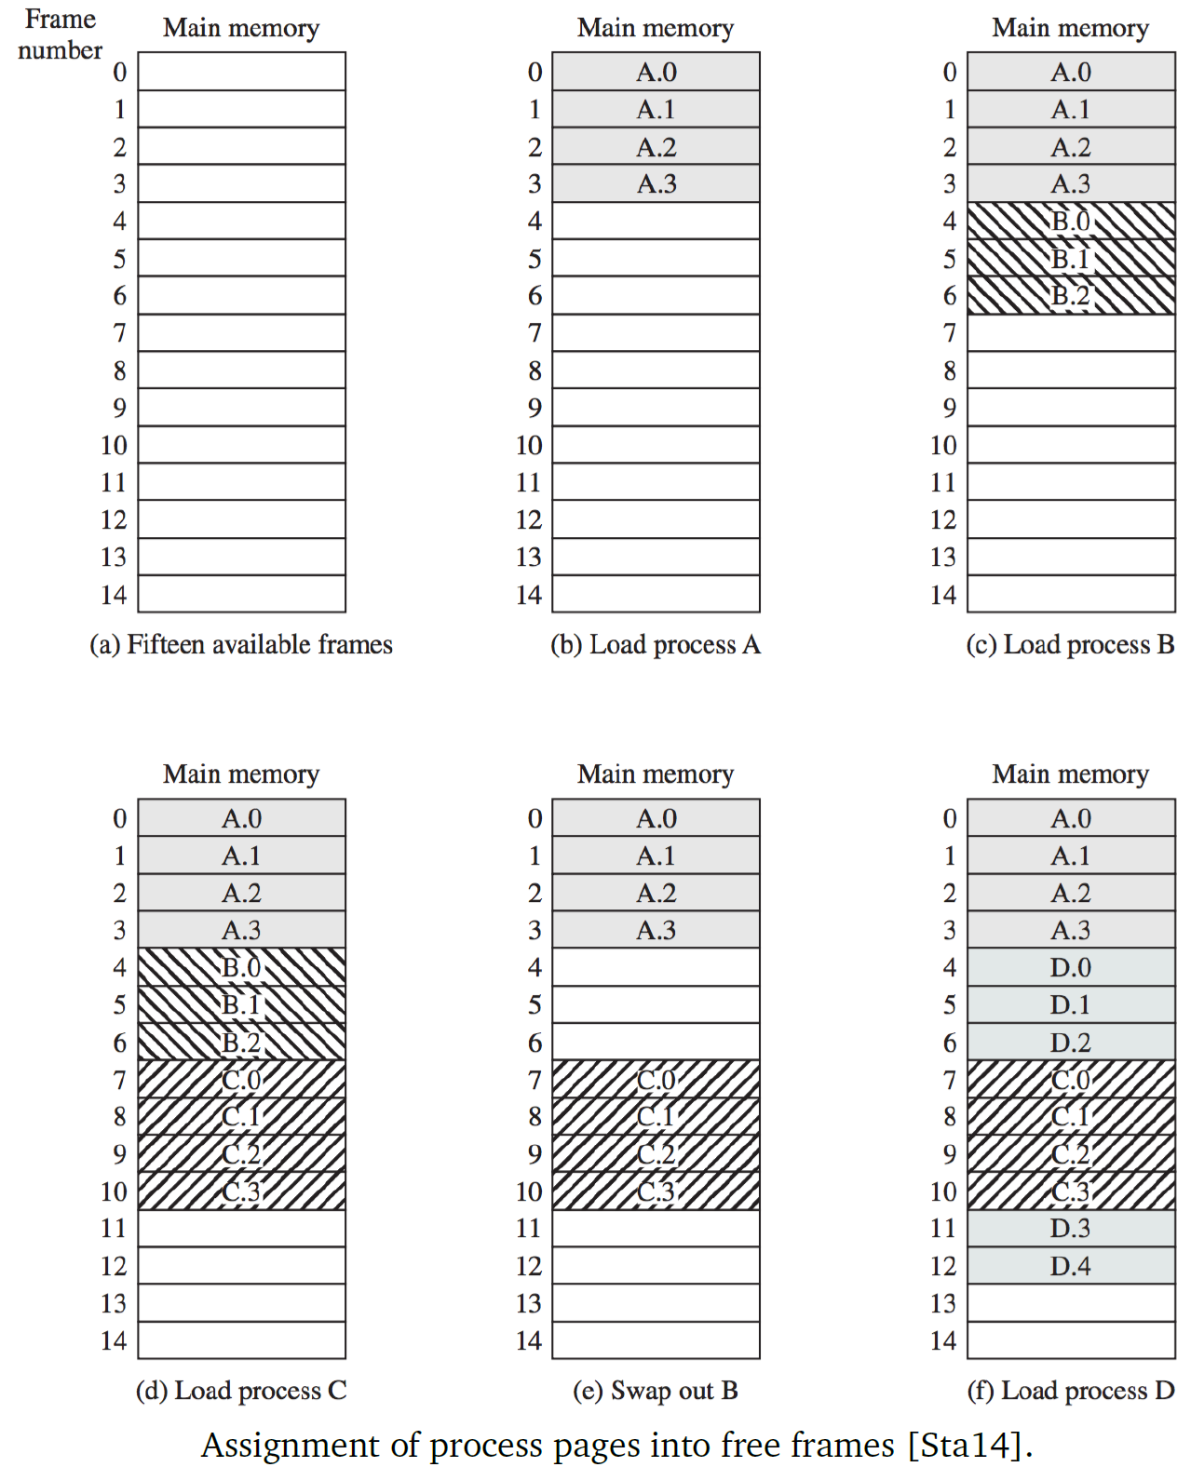

* A process’s pages do not have to be contiguous (or in order) – example above when loading process D
* Since pages don’t have to be contiguous, each process now needs a **page table** to keep track of which pages are located where in memory, as well as a list of free frames
  + Page tables map logical memory to physical memory

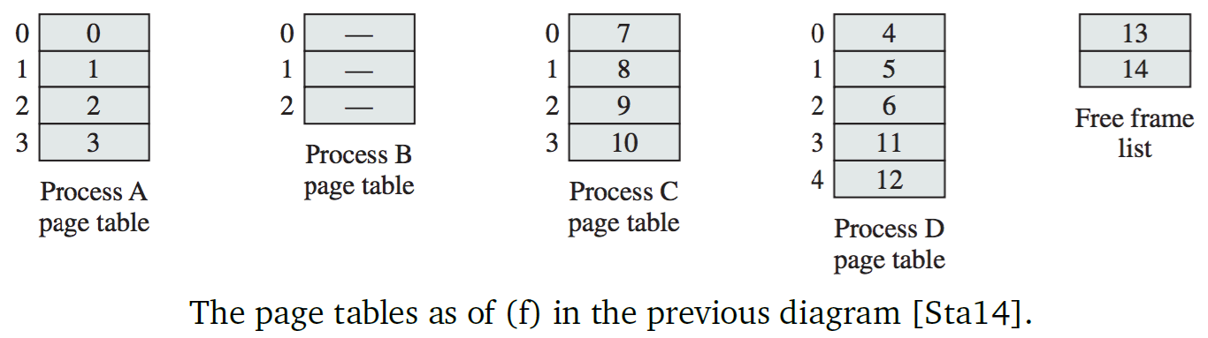

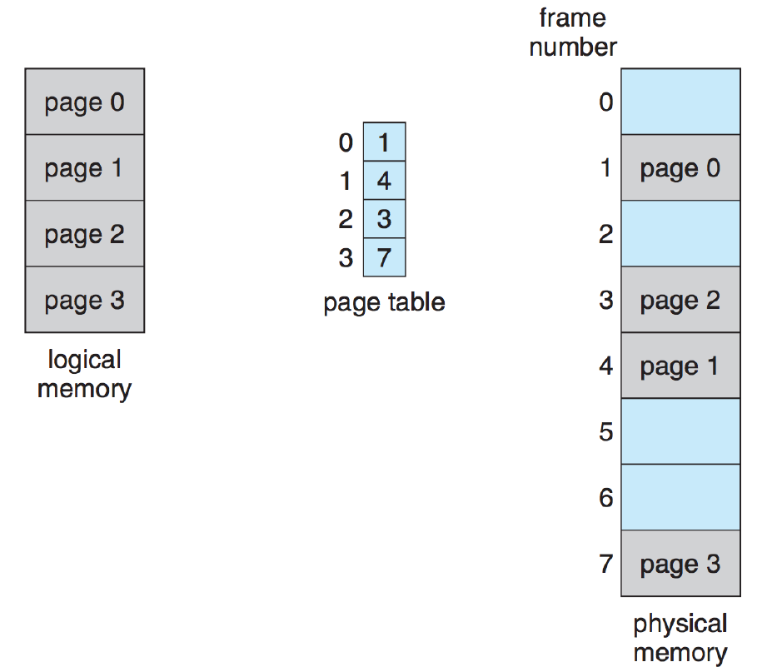

* For convenience, page size is usually a power of 2
  + If logical address space has $2^{m}$ bytes and page size is $2^{n}$ bytes ($n<m$), then $m-n$ bits of the logical address are the page number, and lower $n$ bits are the page offset

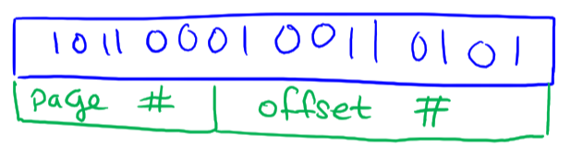

* External fragmentation is eliminated, since all pages are the same size, so compaction is also not necessary
* Some internal fragmentation will still exist, but not much – worst case: a full page is wasted, which isn’t very much in the grand scheme of things
  + The smaller the page size, the less memory wasted in internal fragmentation, but greater # of pages = greater overhead
  + Ideally, want page sizes such that when a page is swapped in/out of memory, it is done in a single read/write
  + In typical systems, pages are 4KB or bigger
* Paging offers protection: a program can’t access any address outside its memory space – no matter what address is generated, it must be inside the page table, and each page table only has entries for that process
* OS can manage memory for all processes, so it needs a **frame table** to list all frames and indicate which page of which process each frame holds

### Shared Pages

* With paging, it is possible to share common code
* If a program has duplicates open, or multiuser systems have different users opening the same program, memory consumption can be reduced if common parts of the program are shared between all instances of the program
* Any code can be shared as long as it is **re-entrant** (pure/stateless): code that doesn’t change when it is executed
  + Any function that accesses a global or static variable isn’t re-entrant

### Page Table Structure

* The simplest way to structure a page table is a standard table
* But page tables can be quite large – e.g. if a 32-bit system has 4KB ($2^{12}$) page sizes, the page table needs $\frac{2^{32}}{2^{12}}=2^{20}$ pages, which is over 1 million entries
* There are different strategies to structuring page tables

**Hierarchical Paging**

* Have multiple levels in a page table, so that it can be broken up and doesn’t have to be stored contiguous in memory
* Example: two-level system; for a page number $p$,
  + The first $k$ bits indicate **outer page**
  + The remaining $p–k$ bits indicate **inner page**
  + The displacement $d$ is calculated from the inner page

**Hashed Page Tables**

* Instead of an array, make the page table a hash table
* Have a hash function to assign pages to “buckets”; each bucket is implemented as a linked list
* Each element of the linked list is examined to find a corresponding page

**Inverted Page Tables**

* With 64-bit systems and 4KB page sizes, the page table $\frac{2^{64}}{2^{12}}=2^{52}$ entries; if an entry is 8 bytes then the table is over 30 million GB
* With inverted page tables, we have one entry per frame instead of one entry per page
  + Each entry keeps track of the process and page number it’s allocated to
  + This saves a huge amount of space
  + Drawback: it is no longer possible to find a physical page by looking at the address; instead, the entire inverted page table must be searched
    - This can be slow, but made faster with hardware

### Paging: Hardware Support

* Memory accesses require frequent addition and comparison operations
* Modern computers have hardware support to speed up these operations
* Simplest implementation of page table is using dedicated registers – registers are the fastest form of storage
  + When a process switch occurs, the registers are replaced with those of the process to run
  + If page table is kept in main memory, and a single register is used to point at the page table, this cuts down on number of registers needed
    - But, to access a page from memory, we need to first figure out where it is – requires accessing the page table in main memory
    - After that, need to look in the page table to find the frame where the desired page is stored
    - Thus, each read/write operation requires two memory accesses – super slow
* **Translation lookaside buffer (TLB)**: fast cache – a key-value pair where the key is the logical address and the value is the physical address
  + Comparison is done on all items simultaneously
  + Size of TLB is usually limited – around 32-1024 entries in size
  + Systems have evolved from having no TLBs to multiple-level TLBs
  + During a read/write operation, page number is checked against TLB
    - TLB hit: page number found in TLB, so frame number is immediately known
    - TLB miss: page number not found in TLB, so full page table must be searched – slower because reading from memory

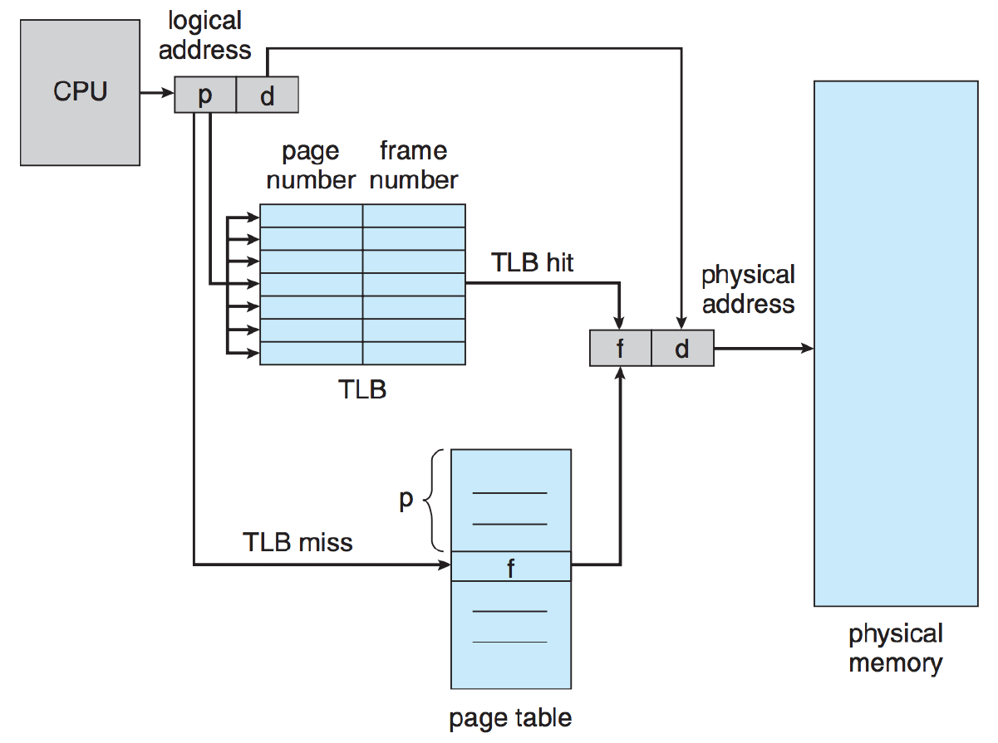

# 22: Caching

## Caching

* Caching speeds up operations because it takes less time to retrieve data from a cache than from main memory
* Caches don’t have to operate on pages, but they are typically blocks of a fixed size
  + **Line**: cache entry – we will assume each cache line maps to a page
  + **Cache hit**: requested page is found in the cache
  + **Cache miss**: requested page is not found in the cache, so we must load the page from memory (much slower operation)
  + **Hit ratio**: percentage of time that a cache hit occurs
  + **Effective access time** = $h × t_{c}+\left(1-h\right) × t_{m}$
    - $h$ = hit ratio
    - $t_{c}$ = time required to load a page from cache
    - $t_{m}$ = time required to load a page from memory
* Faster caches are more expensive, so caches are usually limited in size
* Caches for memory are often multileveled – Intel 64-bit CPUs have L1, L2, and L3 caches
  + L1 is the smallest and fastest
  + L3 is the largest and slowest
  + If there is a miss in L1, L2 is checked, and so on

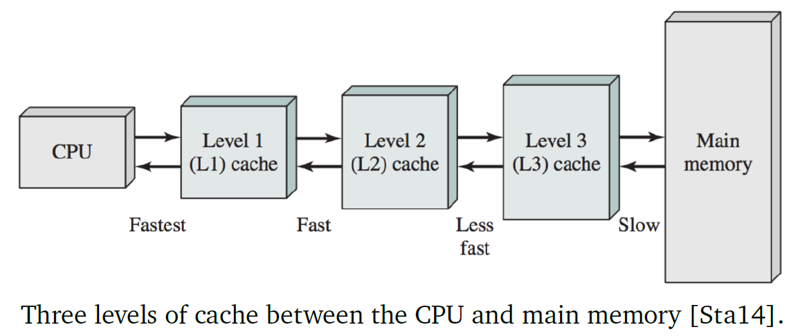

## Page Replacement Algorithms

* Whenever a page fault occurs (running program tries to access a memory page that is virtually mapped but not loaded in main memory), the OS needs to choose which page to evict from the cache to make space for the new one
* To intelligently select which pages to evict, we need to consider how data is accessed in a system:
  + 10% of source code is executed 90% of the time
  + **Temporal locality**: a memory location that was recently accessed is more likely to be accessed again in the future
  + **Spatial locality**: a memory location near one that was recently accessed is more likely to be accessed in the future
* Example: function that sums up all the integers in an array
  + Sum variable is accessed repeatedly – temporal locality
  + The array being accessed at index i means it is likely that the array at index i+1 will be accessed soon – spatial locality
* If a page has been altered in cache, it needs to be written to main memory; could be done immediately when page changes, or when page is evicted from cache
  + Second option means fewer memory accesses
  + If memory is shared, delay in updating main memory may not be tolerable
* If a page hasn’t been modified, it can simply be overwritten

**The** **optimal algorithm**

* Replace the page that will be used most distantly in the future – but this is impossible to implement
* This is generally used as a benchmark to compare other algorithms against

**Not Recently Used (NRU)**

* Computers collect page usage statistics, maintains two status bits for each page
  + $R$ bit is set when a page is referenced (either read or written)
    - $R$ bit is periodically cleared to distinguish pages that haven’t been recently referenced
  + $M$ bit is set when a page is modified (written)
* When replacement needs to occur, OS sorts pages in ascending order of precedence based on $R$ and $M$ bits:

1. Not referenced, not modified
2. Not referenced, modified
3. Referenced, not modified
4. Referenced, modified

* OS removes page from lowest-numbered class first, whenever possible

**First-In-First-Out (FIFO)**

* If there are $N$ frames, keep a counter pointing to the frame to be replaced (from $0$ to $N-1$)
* When a page needs to be replaced, replace the frame that the counter is pointing to, then Increment the counter (wrapping around to 0)
* However, if a page is referenced often, we want to keep it in memory instead of evicting it just because it’s been in the cache the longest

**Clock Algorithm (Second Chance)**

* Improves the FIFO algorithm by giving pages a “second chance” based on whether or not the $R$ bit is set
  + If $R$ bit isn’t set on the oldest page, it means that it hasn’t been used recently, so it is removed
  + If $R$ bit is set on the oldest page, clear the $R$ bit and move to the next-oldest page, repeating the process

**Least Recently Used (LRU)**

* Page replaced is the one that has been accessed the most distantly in the past
  + When a page in the cache is accessed, move that page to the back of the list
  + When a page needs to be replaced, the page at the front of the list is removed and the new page is put at the back of the list – easy to achieve with a doubly-linked list

**Not Frequently Used (NFU)**

* Similar to LRU, but implemented in software instead of hardware
* Each page is associated with a counter starting at 0, which increments each time the $R$ bit should be updated to 1
* When a page needs to be replaced, the one with the lowest-numbered counter is replaced
* Problem: counter never decreases, so a page that was accessed frequently in the beginning of the program but not needed anymore may never get evicted
  + Solution – aging: counters are shifted right by 1 before being incremented, and instead of adding 1, set the leftmost bit to 1
    - A page that hasn’t been referenced in a while has its value decrease over time
    - The one with the lowest-numbered counter is still the one that replaced
    - Lower level of precision compared to LRU approach

**Pre-Paging**

* OS takes some steps to guess which pages will be needed next, based on temporal or spatial locality – could reduce time that is spent waiting for a page in the future
* Situation where this may be useful is when a program is started or swapped into memory – instead of suffering multiple page faults (very slow), it may be better to load multiple pages into the cache to start with

### Choosing an Algorithm

* NRU: not very good performance
* FIFO: highly suboptimal
* Second chance: much better than FIFO, but just adequate
* LRU: best performer, but could be hard to implement
* NFU: approximation of LRU
* NFU + Aging: best approximation of LRU

## Local and Global Algorithms

* When a process switch occurs, we could dump the entire cache to make way for the next process to run, but this is likely a lot of unnecessary work
  + If P1 is suspended, P2 runs, then P1 runs again, some of P1’s pages could still be in cache and don’t need to be loaded again
  + Better to have multiple processes’ pages in the cache at a given time
* Should the page replacement algorithm care about which process a page belongs to?
  + Global replacement: replace page (e.g. least recently used) in all of the cache
    - Dynamically allocates cache space to different processes based on their needs, so the number of pages for each process can vary over time
  + Local replacement: replace page (e.g. least recently used) in the cache belonging to the current process
    - Gives each process roughly fixed numbers of pages in the cache
* In general, global algorithms work better, especially when processes’ memory needs change over time
* With local algorithms, we could be wasting cache space on processes that no longer need it
* To manage the complexity of how much of the cache should be allocated to each process, we could track the **page fault frequency** **(PFF)** – the number of page faults that occur
  + If PFF is above a certain threshold, it indicates that more cache space should be allocated to a process
  + If PFF is below a certain threshold, it indicates that less cache space could be allocated to a process
* PFF relies on assumption that the page replacement algorithm will result in fewer page faults if a process has more pages assigned in the cache; this is true for LRU, but not necessarily for FIFO

# 23: Virtual Memory

## Virtual Memory

* Even with paging and moving pages in/out of memory, programs that require more memory than the machine’s physical memory cannot run
* When many programs run on a multiprocessor system, the total sum of memory requirements could exceed the available memory, meaning the processor is idle while waiting on a ready-to-run process because it doesn’t have enough free memory frames
* Main problem: the process must be entirely in memory or on disk, but in most cases the entire program isn’t needed at any given time
* If we could execute programs that are only partly in memory, there would be three major benefits

1. Program is no longer constrained by the size of physical memory
2. Each program could use up less physical memory, allowing more programs to run concurrently
3. Less I/O is needed to swap user programs in/out

* Same principle as caching: main memory can be viewed as another level of the cache, and the disk as the last stop for data
  + Page fault: a page is referenced and not in main memory, so the page must be loaded from disk into main memory
  + If a page must be evicted in order to make space for the referenced page, a page replacement algorithm is necessary to select the “victim” page and write it out to disk

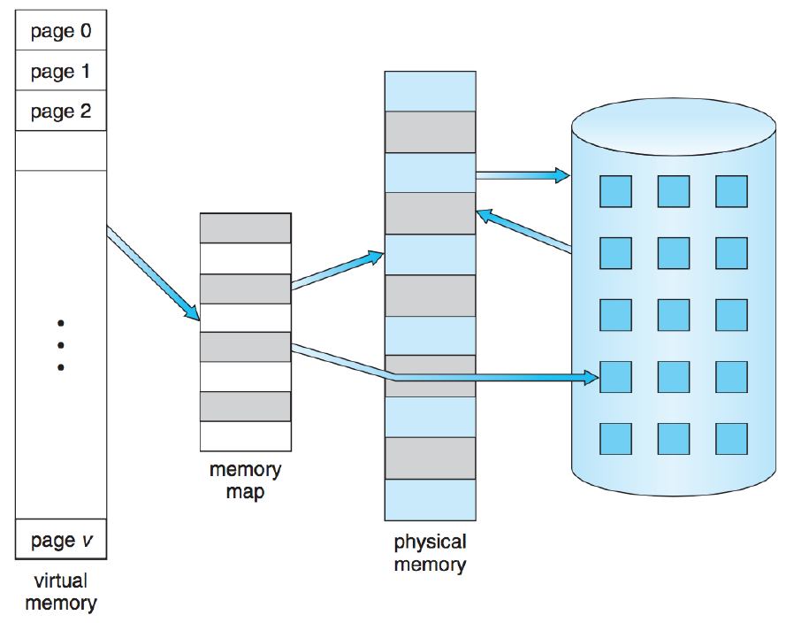

* Typical approach: demand paging – page is loaded into memory only if it is referenced/needed, to prevent unnecessary disk accesses (since they are very slow)
* Because the disk is so slow, **thrashing** can occur, where the OS spends most or all of its time swapping pages in/out of memory, so very little gets done
* With virtual memory, each memory reference is a six-step process:

1. Check validity of memory reference
2. If memory reference is invalid, terminate the program – segmentation fault; if it is valid, but the page referenced isn’t in memory, need to retrieve it
3. Find a free frame, by making one or evicting another page
4. Request a disk read to bring in the new page (and possibly a write to evict a page)
5. After disk read completes, update page table to show that new page is in main memory
6. Restart the instruction that referenced the page needed to be brought into memory

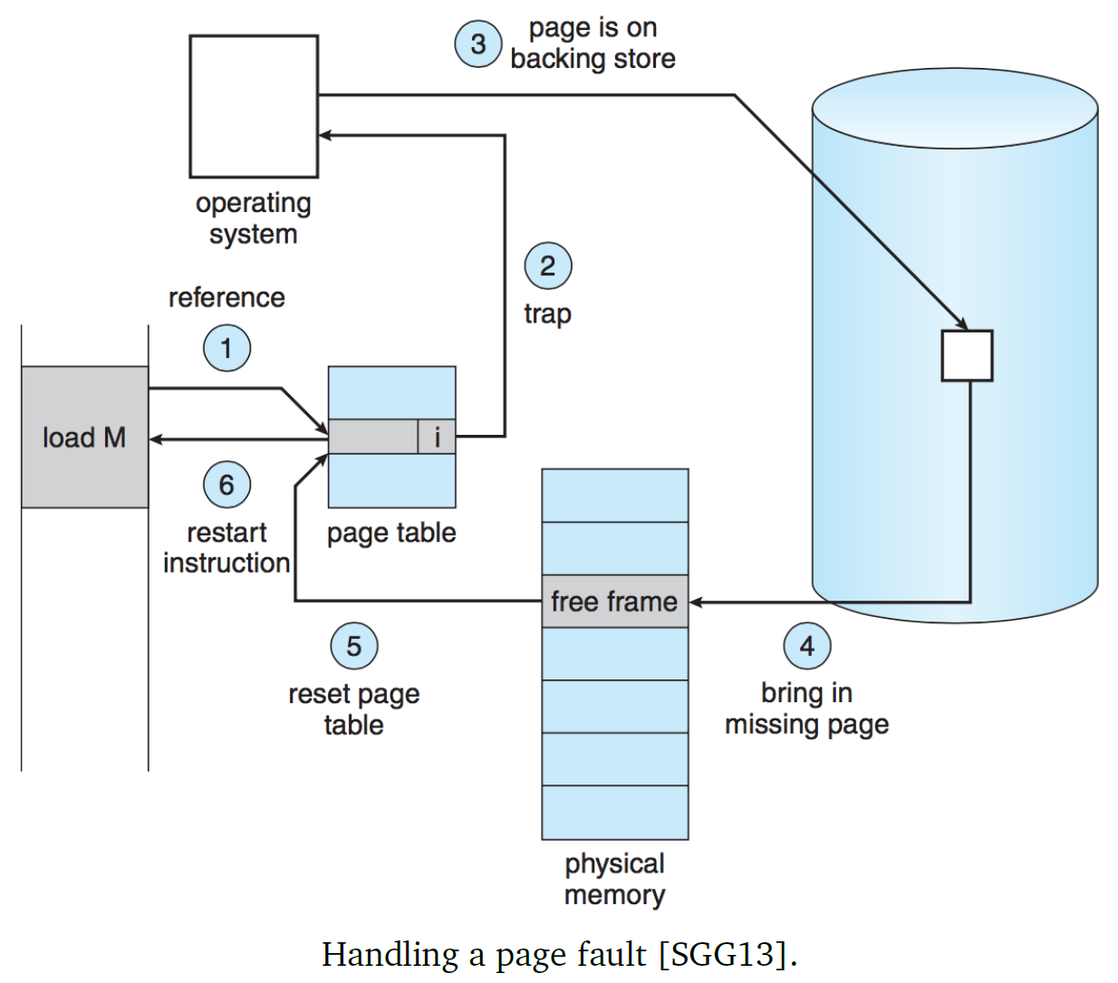

* Between steps 4 and 5, disk requires a significant amount of time to read the desired page and possibly write the page to be evicted to disk
  + During this time, the process is blocked by the I/O operations; in the meantime, the processor can (and should) work or something else
* Key requirement of the above workflow is the ability to restart any instruction following a page fault
  + Need to save the process state (including all registers) so that if a page fault occurs, we can restart the process exactly where it was
  + After the restart, the page is available in memory and accessible
* A page fault can occur during any memory reference, including fetching the next instruction and fetching operands to complete an instruction, so a little bit of work may need to be repeated, but the time it takes the CPU to re-execute instructions is miniscule
* Can every instruction be restarted without affecting the outcome? No
  + E.g. if an instruction modifies more than one memory location, the memory may straddle a page boundary, either at the source or destination
  + One solution: CPU tries to access the start and end addresses before the move begins; if one of the required pages isn’t in memory, page fault occurs before any data is changed
  + Another solution: use temporary registers to hold overwritten location, so that if page fault occurs, the temporary data can be restored and the instruction restarted without affecting correctness

## Virtual Memory Performance

* Recall the effective access time formula from earlier:

Effective access time $=h × t_{c}+\left(1-h\right) × t_{m}$

* We can modify the formula to replace $h$ with $p$, the likelihood that a page is in memory, and replace $t_{c}$ and $t_{m}$ with $t_{m}$ and $t_{d}$ (time to retrieve a page from disk), respectively

Effective access time $=p × t_{m}+\left(1-p\right) × t_{d}$

* If we combine caching and disk reading, we can get the true effective access time:

Effective access time $=h × t_{c}+\left(1-h\right)(p × t_{m}+\left(1-p\right) × t_{d})$

* We expect $p$ to be small if the paging algorithm is good
* What is $t_{d}$? To handle a page fault, there are many steps that must take place:

1. Send trap to the OS
2. Save user registers and process state
3. Identify interrupt as a page fault
4. Check that page reference is valid
   1. If so, determine location of page on disk
   2. If not, terminate
5. Determine where to put the page in memory (using replacement algorithm)
6. Check if the selected frame is currently filled with a page that has been modified?
   1. If so, schedule disk write to update the page to disk
   2. If not, go to step 11
7. Wait for disk write to be executed – CPU can do something else in the meantime
8. Receive interrupt once disk write is complete
9. If CPU did something else in the meantime, save the registers and state of the other process
10. Update page tables to reflect movement of replaced page to disk; mark destination frame as free
11. Issue disk read to transfer page to the free frame
12. Wait for disk read to be executed – CPU can do something else in the meantime
13. Receive interrupt once disk read is complete
14. If CPU did something else in the meantime, save the registers and state of the other process
15. Update page table to reflect newly read page
16. Restore state and resume execution of the process that encountered the page fault, restarting the interrupted instruction

* The slow step in the process is the time to load the page from disk (typically a few milliseconds)
  + Latency + seek time (moving head of disk to the location of the page) is the limiting component, and it is several magnitudes higher than any other costs in the system
  + Thus, $t_{d}$ dominates the effective access time
* If page fault rate is high, performance is awful; if performance of computer is reasonable, page fault rate has to be *very* low (order of 10-6)
* Solid state drives (SSDs) offer a huge performance increase because instead of milliseconds for disk reads, SSDs can produce the data in times that look more like memory reads
* Files tend to come with a lot of overhead for file creation/management; to avoid this, the system usually has a “swap file” – one giant file or partition on the hard drive – that the system deals with instead of smaller individual files

## Copy-on-Write

* UNIX systems use the **copy-on-write** technique when creating new processes using fork(), where the parent and child share the same pages but the pages are marked as copy-on-write
  + If exec() occurs immediately, new memory pages for the child are brought in and unnecessary work is avoided
  + If the child remains a clone of the parent, as soon as either parent or child attempt to modify a page, a copy of the page is made and the modification is applied to the new copy of the page
  + All unmodified pages remain shared, so that no unnecessary copying occurs
* Some versions of UNIX have a system call **vfork()**, which skips the copy-on-write procedure; instead, the parent process is suspended and the child process uses the memory space of the parent
  + Thus, any modifications that the child process makes will be visible to the parent when it resumes, which can be very dangerous
  + This is more efficient if the intention is to call exec() immediately and create a new memory space for the child

# 24: Virtual Memory II

## Allocation of Frames

* In a simple system, if there are a total of $n$ frames, we demand page all of them (i.e. initially all frames are empty, pages are read into those frames as needed, and from $n+1$ frames onwards we replace existing pages with new ones); when a process terminates, all of its pages are marked as free
* A few frames can be kept free at all times, for performance purposes
  + When a page must be replaced, the newly-read page can be written into the free frames, so that the old page can be written to disk when appropriate
  + This means that the read doesn’t have to wait for the write
* If we allocate different numbers of frames to different processes, we constrain the number of pages we can allocate
  + Maximum number of frames allocated to a process is the maximum frames in a system
  + Minimum number of frames allocated to a process depends on performance:
    - If our page replacement algorithm is decent, adding more frames will reduce the rate of page fault
    - The absolute minimum number of frames is determined by system architecture – the minimum number of frames needed to complete instructions
    - If the architecture allows referencing of indirect addresses, the referenced address could be on another page, and also reference an indirect address, and so on; resulting in worst-case the entire virtual memory needing to be in main memory (impossible)
      * Limiting levels of indirection to a manageable number could solve this problem
* If we don’t allocate the minimum or maximum frames to each process, there are several algorithms for allocating frames:
  + Assume $m$ frames total, $k$ frames reserved for OS, so $m-k$ frames available for processes
* **Equal Allocation**
  + If there are $n$ processes in the system, each process gets $\frac{m-k}{n}$ frames
  + If division results in remainder, the remainder can be kept as free frames for performance purposes
  + Flaw: different programs require different amounts of memory, so why should they get equal amounts?
* **Proportional Allocation**
  + Each process gets its share of frames depending on its needs
  + Let the virtual memory size of a process $p_{i}$ is defined by $s_{i}$ and the total virtual memory size $S=\sum{s_{i}}$
  + For each $p_{i}$, allocate $a_{i}=\frac{s_{i}}{S} × (m-k)$ frames
    - If $a_{i}$ is below the minimum number of frames, it gets increased to the minimum
    - If $\sum{a_{i}}$ exceeds the maximum number of frames, some frame allocations for larger processes must be lowered
  + With the above formula for $a_{i}$, no regard is given for priorities of processes – we could modify $a_{i}$ according to process priority so that higher priority processes have lower page fault rates and are thus able to execute more quickly
* **Local and Global Replacement**
  + Same idea as local/global replacement for caches:
    - Local replacement: algorithm only replaces pages belonging to that process
    - Global replacement: algorithm replaces pages anywhere in memory
  + Local allocation isn’t affected by allocation concerns
  + For global allocation, the number of allocated pages for each process changes over time; this means that over time, process that run more often will accumulate more pages in memory than are taken from them
  + It might make sense to prevent a process from falling below the minimum number of pages, or completely swap out to disk processes that no longer meet the threshold

## Thrashing

* **Thrashing**: when the OS spends so much time swapping pages in/out of memory that no useful work gets done
* In simple OSes, how many processes run at a time is controlled by CPU utilization – when CPU utilization is low, more work is assigned to it by starting or bringing more processes into memory
  + Global replacement policy is used, so any frame from any process can be replaced
  + If a process starts to have a lot of page faults, it starts taking pages from other processes; then, when it is the victim processes’ turn to run, they also start generating page faults – more and more memory read/writes are queued, so the CPU isn’t very busy
  + Fatal mistake: seeing that the CPU isn’t very busy, OS schedules even more processes to run
    - The new process needs a minimum number of pages to begin execution, so pages from other processes are replaced, which causes more page faults and more time spent paging, lowering CPU utilization… causing the CPU to start even more processes
    - This results in no work getting done

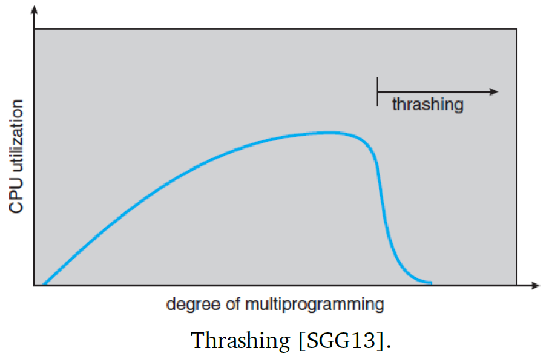

* This shows that CPU usage alone isn’t a good indicator of whether more or fewer processes should be running; *why* CPU usage is low must also be considered
* Using local replacement instead of global replacement could limit some of the damage; if process P1 is thrashing, it cannot affect other processes and thus will not cause a chain of fighting over who has how many pages
  + But if P1 spends all its time paging to/from disk, other processes still have to spend time waiting for the disk to be free
* We could decide to start/suspend programs based on not just CPU usage, but also the number of page faults that occur in a given period of time – too many page faults indicate that there is too much going on
  + But this solution is reactive, which means time is still wasted in thrashing
* Knowing how many pages a process needs and when it will need them would help, but there isn’t a good way of figuring this out, so some educated guessing is required
  + Process memory accesses tend to obey temporal and spatial locality
  + If we think of different parts of the program as different localities that can sometimes overlap, we should give each process enough frames for its locality
    - If we provide insufficient pages, it will result in thrashing
    - When the process leaves its locality, some page faults will occur, but this is unavoidable

### The Working-Set Model

* A potential solution to thrashing is the **working-set model**:
  + Retain the last $n$ pages in memory, as they represent the locale of a program
  + Assuming that most memory accesses are local, the most frequent $n$ pages are the most frequently used – the working-set window ∆
    - The working set contains recently-used pages
    - If a page hasn’t been accessed recently, it is dropped from the working set after ∆ time units since its last reference
  + The size of the working set will change over time, anywhere from 1 to ∆ pages
* Example: the window is defined as 10 accesses, so any page that was accessed in the last 10 requests is part of the working set
  + If the next 10 memory accesses are all in page $k$, then after those accesses the only page in the working set will be $k$
* If ∆ is too small, the working set won’t encompass the entire locale; if ∆ is too large, it will encompass multiple locales
  + Underestimating the locale size will result in more page faults
  + Overestimating the locale size will mean fewer processes are allowed to run
* If the working set of each process is summed up, we get the total number of frames that every process combined would like to have
  + If this number exceeds $m-k$, at least one process won’t have as many frames as it needs and thrashing will occur
* Once a value of ∆ is determined, the OS will monitor the working set of each process and use it to figure out if the system is currently overloaded
  + If overloaded, the OS will pick a process to suspend in order to prevent thrashing
  + If underloaded (i.e. frame supply exceeds demand), more processes can be started
* The page fault rate of a process tends to vary over time
  + As a program starts up, it tends to have a bunch of page faults
  + Once its locale is established, the page fault rate will drop
  + When moving from one locale to the next, the page fault rate will increase again, then drop when the process settles into the new locale

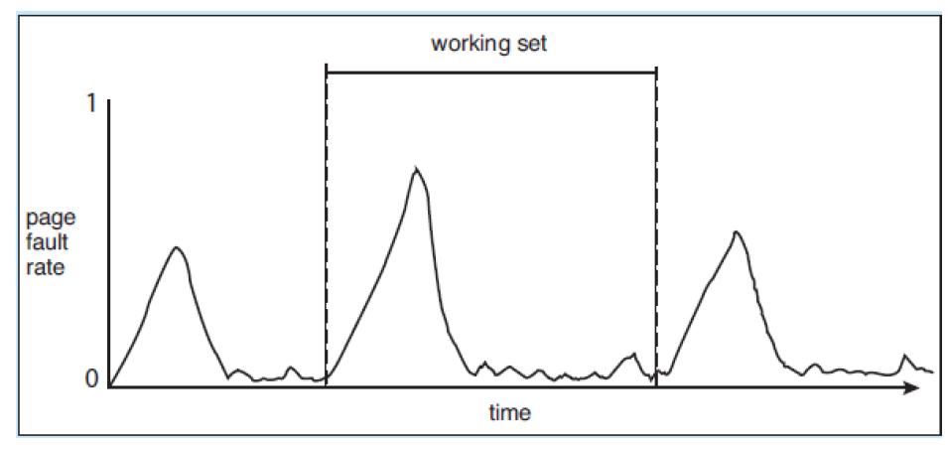

# 25: Uniprocessor Scheduling

## Uniprocessor Scheduling

* Given multiple processes in a system, we need to make some decisions about when different processes run

**Long-Term Scheduling**

* Responsible for determining which programs run at all
  + Controls how many jobs the system accepts to do at once
  + Controls transition from “new” to “ready to run” states
  + When one process exits, the long-term scheduler may decide to start a new one
* Long-term scheduling doesn’t occur very much on desktop systems – user generally controls how many processes are run at a given time
* Mobile OSes can be aggressive – e.g. if memory is running low, Android can suspend or kill processes to make way for new ones

**Medium-Term Scheduling**

* Responsible for swapping programs to and from disk
* Swapping a process out to disk means it won’t be run in the near future (isn’t needed by the short-term scheduler), but is likely to run before too long
* Swapping a process into memory returns it to the short-term scheduler’s domain

**Short-Term Scheduling**

* Responsible for what processes are running right now – often runs after certain things occur
* For co-operative multitasking, short-term scheduling only takes place under two circumstances:
  + Currently executing process yields to CPU
  + Currently executing process terminates (voluntarily or with error)
* For pre-emptive multitasking, the OS (not the running process) decides when it is time to switch processes
  + Processes can still yield to CPU or terminate
* Dispatcher will run when a process gets blocked, such as on an I/O operation, semaphore/mutex, or page fault – scheduler decides what process runs next
* After handling an interrupt, a scheduling decision also occurs – do we return execution to where we left off or do we go somewhere else?
* System calls (e.g. fork) and signalling semaphores may provide good opportunities to switch processes
* During time slicing, clock-generated interrupts cause the short-term scheduler to run and choose a process to run, so that different processes can seemingly run concurrently

### Process Behaviour: Rate Limiting Step

* Processes tend to alternate between computing periods and I/O requests
  + CPU Burst: CPU does a lot of work
  + I/O Burst: CPU waits on I/O
* **CPU-Bound**: processes that spend most of their time computing – how fast the CPU can execute code is the limiting factor
* **I/O-Bound**: processes that spend most of their time waiting for I/O – having a faster CPU won’t make a difference in how long it takes to execute a program

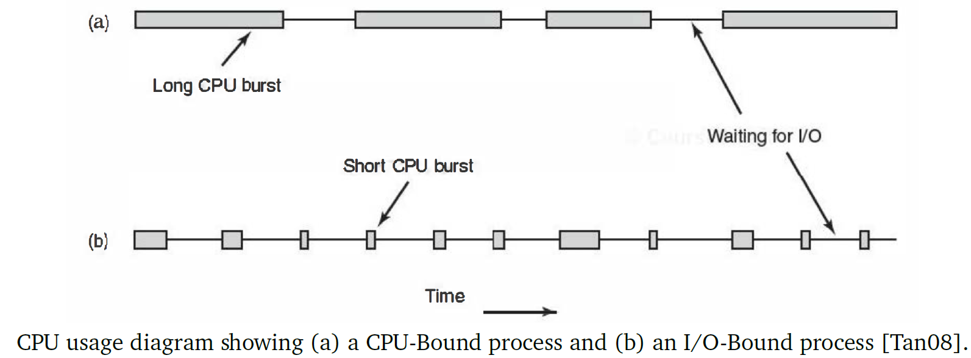

* I/O-Bound programs tend to have short CPU bursts
* Over time, CPUs have gotten faster at a much higher rate than I/O
  + New CPUs are released every few months, while I/O standards take years to change
  + Thus, programs tend to be I/O bound
* Long-term schedulers may attempt to balance CPU-Bound and I/O-Bound tasks to get best resource utilization, so they need to know which processes are which kind
* If disk requests are common, when the disk is idle short-term schedulers should immediately schedule a process that is likely to issue a disk request, so that the disk is kept as busy as possible

## Scheduling Criteria

* Scheduling goals depend on system criteria:
  + Real-time systems that are supposed to respond to events within a certain amount of time, depend heavily on scheduling
  + Some systems’ goal may be to maximize CPU usage (e.g. supercomputers), or ensure that users feel like the system answers them quickly when they issue a command
* There are nine evaluation criteria for making scheduling decisions:

1. **Turnaround time** – amount of time between starting a process and when it finishes; includes execution time + time spent waiting for resources
2. **Response time** – time between making a request and receiving a response

* A process can start producing output while completing the request

1. **Deadlines** – real-time systems have deadlines to meet, which could be very important depending on the application
2. **Predictability** – it is desirable to run processes in fairly consistent amounts of time
3. **Throughput** – scheduling policies should try to maximize the number of processes that complete within a given amount of time
4. **Processor utilization** – how much of the time the CPU is busy; for supercomputers where processing time is very valuable, priority may be given to keeping the CPU busy
5. **Fairness** – ensure that processes receive at least a basic level of fairness, to prevent starvation
6. **Enforcing priorities** – higher priority processes should probably run the most often, but should be balanced with fairness (i.e. not always be the one selected)
7. **Balancing resources** – ideally, we want to balance resource usage to keep both CPU and I/O busy; the more information we have about what sort of I/O processes require, the more informed we can be when choosing processes to run

### Scheduling Algorithm Goals

* The priorities of different goals depend on the system:
* **All systems**
  + Fairness
  + Priorities
  + Balancing resources
* **Batch systems (non-interactive)**
  + Throughput
  + Turnaround time
  + CPU utilization
* **Interactive systems**
  + Response time
  + Predictability

### The (Ab)use of Priorities

* Each process’s priority is typically an integer – in UNIX, lower number is higher priority; in Windows, higher number is higher priority
* Priority value can be used to make decisions about resources – if P1 and P2 both want resource R1 and P1 has higher priority than P2, choose to assign the resource to P1
* Users can have a say in priority, but in a limited way
  + This can often be misused
  + For instance, long CPU-Bound tasks should be given lower priority to complete it faster; users assigning them higher priority kills system performance and makes users unhappy
* In some systems, the highest-priority non-blocked system will always run;
  + This is good at making sure that higher-priority processes have right-of-way, but terrible for ensuring fairness and preventing starvation
  + Scheduling isn’t just about finding the highest-priority thing to do

# 26: Scheduling Algorithms

## Scheduling Algorithms

* There are many scheduling options:

1. Highest Priority, Period
2. First-Come, First-Served
3. Round Robin
4. Shortest Process Next
5. Shortest Job First
6. Smallest Remaining Time
7. Highest Response Ratio Next
8. Multilevel Queue (Feedback)
9. Guaranteed Scheduling Lottery

* The OS can maintain some data about processes to help in making scheduling decisions:

1. Time spent waiting to run
2. Time spent executing
3. Total execution time
   * First two criteria can be measured, but third must be supplied or estimated by user
     + Desktop OSes don’t ask users to estimate process execution times, but supercomputers or batch jobs may do so

### Highest Priority, Period

* Have one priority queue for each priority level
  + If a task isn’t blocked, put it in its appropriate priority queue
  + If a task’s priority changes, move it to its new priority queue
* This method is vulnerable to starvation – low-priority tasks may never get a chance to run, if there is always a higher-priority one
* It doesn’t fulfill the short-term scheduling criteria of response time and fairness, but can be suitable for life-and-safety-critical systems

### First-Come, First-Served

* Whichever process requests the CPU first gets the CPU first
* Single priority queue – processes line up at the back, whichever process is at the front gets dequeued and is ready to run
* If a process finishes or gets blocked, the next process in the queue is selected to run
* The average waiting time of processes can vary depending on their order:  
  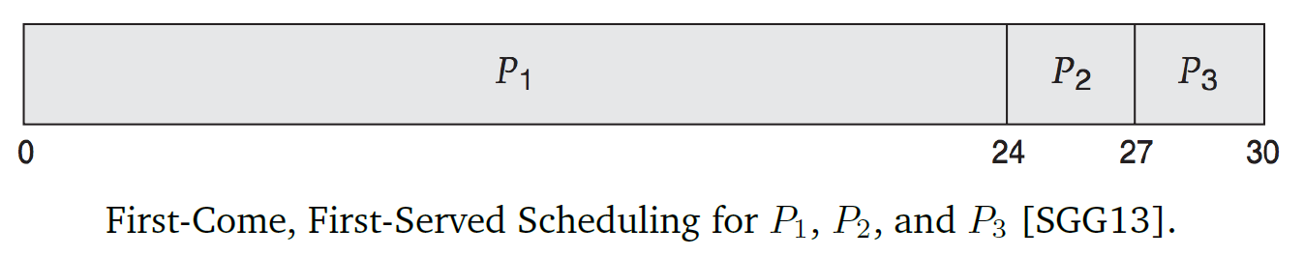
  + Total time needed to complete all three processes is 30 time units
  + Average completion time is $\frac{24+27+30}{3} =27$ time units
* However, this could be improved:  
  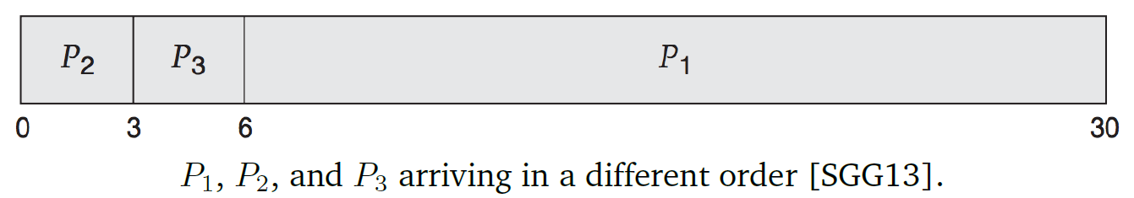
  + Total time needed to complete all three processes is still 30 time units
  + Average completion time is $\frac{3+6+30}{3}=13$ time units
* FCFS tends to favour CPU-Bound processes compared to I/O-Bound; while CPU-Bound processes are running, I/O-Bound processes must wait in the queue, which can lead to inefficient use of resources – we could be keeping the disk busy at all times
  + E.g. If a disk write completes and a disk read is waiting, we want to issue the read straight away so that the disk is constantly in use
  + With FCFS, I/O devices tend to suffer idle periods
* FCFS by itself is non-pre-emptive (CPU won’t switch processes until there is a reason to do so), which can lead to processes monopolizing the CPU

### Round Robin

* **Time slicing**: every $t$ seconds, a timer generates an interrupt that prompts the short-term scheduler to run
* Time slicing + FCFS = Round Robin
* How long should $t$ be?
  + If $t$ is too long, processes may seem unresponsive while waiting on other processes, or short processes might wait a long time for their turn
  + If $t$ is too short, system will spend too much time handling the interrupts and running the scheduler, instead of actually executing processes
* We could make an estimate for $t$ based on system patterns; for example, if we know that processes typically run for $r$ time units before being blocked, we should make $t$ slightly larger than $r$
  + If $t$ is smaller than $r$, a lot of processes will get interrupted
  + If $t$ is larger than $r$, many processes will not encounter the time limit and hopefully execute a useful amount of work before being blocked by I/O or for some other reason
* Round Robin tends to favour CPU-Bound processes over I/O-Bound processes, because I/O-Bound processes tend to spend less time using the CPU
  + I/O-Bound processes will run for a short time, get blocked by I/O, then goes back to ready queue once I/O is finished; thus, CPU-Bound processes will get more CPU time
* **Virtual Round Robin** addresses this issue: works like regular Round Robin, except that processes that get unblocked by I/O get higher priority

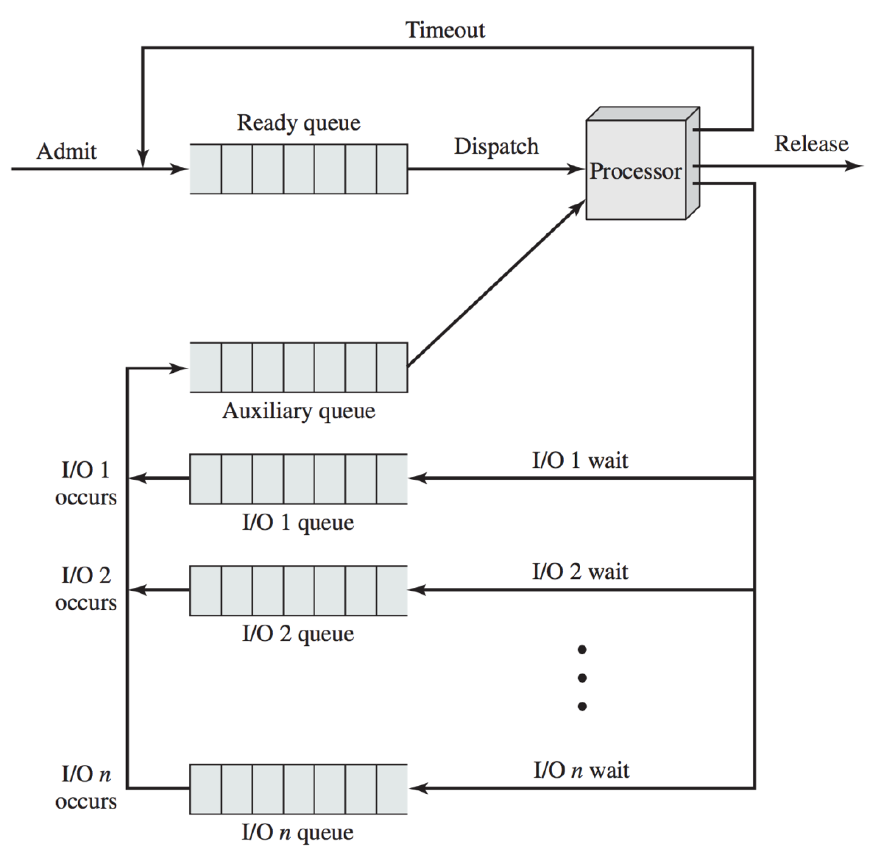

* + Store I/O-unblocked processes in an auxiliary queue; scheduler picks from auxiliary queue whenever it isn’t empty; otherwise it picks from the regular queue
  + If a process runs over the time limit, it goes into the regular ready queue
  + If a process is selected to run from the auxiliary queue, it runs up until the as-of-yet-unused fraction of a time slice

### Shortest Process Next

* If some information is available about total execution time of a process, priority could be given to short processes, to get faster turnaround times and better responsiveness
* Drawback: longer processes might be waiting for unpredictable amounts of time
* Batch job processing used this form of scheduling, asking programmers for process estimates:
  + If estimate was too low, process got terminated early
  + If estimate was too high, the job may never be scheduled to run, or have to wait a very long time
* The OS never asks for execution time estimates; it might be easier to make decisions based on the length of CPU bursts

### Shortest Job First

* Choose the process that is likely to have the smallest CPU burst
* Example: 4 processes, with burst times P1 = 6, P2 = 8, P3 = 7, P4 = 3  
  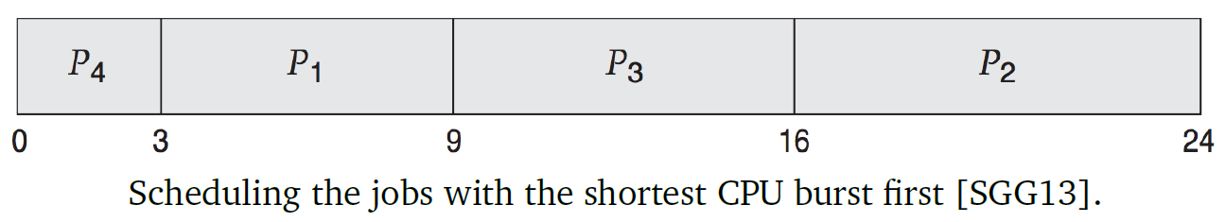
  + Average waiting time is $\frac{0+3+9+16}{4}=7$ time units
  + This algorithm is optimal for providing the shortest waiting time for processes, much better than FCFS approach
* In order to predict CPU burst times, we can gather data with the formula:
 $$S_{n+1}=\frac{1}{n}\sum_{i=1}^{n}{T_{i}}$$

 $T_{i}$ + is the burst time for the ith instance of the process
  + $S_{i}$ is the predicted burst time for the ith instance, where $S_{1}$ is a guess for the first value
* Instead of summing it up each time, we could just update the value:
$$S_{n+1}=\frac{1}{n}T_{n}+\frac{n-1}{n}S_{n}$$

* We could use exponential averaging to give more weight to recent values (instead of equal weighting of $\frac{1}{n}$):
 $$S_{n+1}=αT_{n}+(1-α)S_{n}$$

 + The larger the value of $α$, the more that recent values are heavily weighted
* If we choose $S_{1}=0$, new processes are given priority to get started
* There is still a chance that longer processes will starve, if there is a constant stream of shorter processes

### Shortest Remaining Time

* When a new process is scheduled or an old one is unblocked, the scheduler evaluates if it has a shorter remaining execution time than the currently executing process
  + If yes, the CPU will switch processes to the new/unblocked one
  + If no, the CPU will continue executing the current process
* There is still a chance that longer processes will starve; we could choose $S_{1}=0$, like in the previous case, so that new processes will always pre-empt running ones
* Advantage: no longer require time slicing; instead of timed interrupts, other interrupts such as user launching programs or hardware interrupts will prompt the scheduler to run
  + System spends less time handling interrupts, so performance will increase

### Batch and Interactive

* The scheduling algorithms described above are more suitable for batch processing systems than for desktop systems

# 27: Scheduling, Idling, Priorities, and Queues

## Scheduling Algorithms (Continued)

### Highest Response Ratio Next

* **Normalized turnaround time**: ratio of turnaround time (time waiting + time executing) to service time (time executing)
  + The relative waiting time is more important, since we can tolerate longer processes waiting a relatively longer amount of time
  + The goal of HRRN is to minimize the normalized turnaround time for processes as well as the average across all processes
* **Response ratio**: $R=\frac{w+s}{s}$
  + $w$: waiting time
  + $s$: service time – guess
* When it is time for the next process to run, choose the process with the highest response ratio
  + New processes will have response ratio 1, since they haven’t spent any time waiting yet, so they are less likely to be selected
  + Shorter jobs (small $s$) are likely to be scheduled quickly
  + $w$ factors in age of a process, i.e. how long it’s been waiting to run, so processes that have been waiting longer will rise in priority over time – this means that processes won’t starve
* However, we need some way of estimating $s$

### Multilevel Queue (Feedback)

* For the most part, the algorithms we’ve looked at so far treat processes equally (except for highest priority); this may not be ideal for situations where processes behave differently
  + E.g. laptops run many processes, some of which are foreground/interactive, and some of which are background
  + We could apply different scheduling algorithms for the different process types
* **Multilevel queue** breaks the ready queue into several different queues
  + A process can only be in one of the queues, and it is assigned based on its properties (e.g. priority, memory needs, foreground/background, etc.)
  + Different queues can be scheduled using different algorithms
* Using multiple queues also involves choosing which queue to select from next, depending on goals
  + Could make some queues higher priority over others
  + Could have time slicing amongst queues (evenly balanced or proportional)
* Example: Compatible TimeSharing System (CTSS) on the IBM 7094
  + Multiple queues with different priorities; highest priority had 1 time slice, next highest 2 time slices, next highest 4 time slices, etc.
  + If a process ran up to its time limit, it got bumped down to a lower priority class (with a longer time slice)
  + One-way movement – process can only move down, not up
* This scheduling algorithm is also called **feedback**
  + We don’t have any information in advance about how long various processes will take
  + Priority is assigned based on how much CPU time the process has taken up so far – processes that have used up a lot of CPU get lower priority

### Guaranteed Scheduling

* Promise users something, then fulfill that promise
  + E.g. promise that $m$ processes or $n$ users get an equal share of CPU time ( $\frac{1}{m}$ or $\frac{1}{n}$ respectively)
* Requires system to keep track of how much CPU time each process has received since its creation, and compare that to the ideal (time since creation / $n$)
  + Scheduling algorithm then chooses process with lowest score, attempting to keep all values as close to 1.0 as possible

### Lottery

* Every process gets a given number of “lottery tickets” for each resource (e.g. CPU); when it is time to select a process, a lottery ticket is chosen at random, and the selected process gets the resource
* If a process has a fraction $f$ of the total tickets, it can be expected to get $f\%$ of the resources
  + More important processes can be given more tickets, while less important processes fewer tickets
  + Cooperating processes can also be allowed to exchange tickets
* When a process is created or terminated, the total number of lottery tickets or their distribution may change
* This method has a lot less overhead than guaranteed scheduling, since we don’t have to keep track of how much of a resource a process has received
* If the system is sufficiently random, over time the resource allocation will tend towards the processes’ ticket proportions (e.g. if A has 20%, B has 30%, and C has 50% of the total tickets, CPU will give resources at an approximate 20:30:50 ratio)

## The Idle Task

* If there is nothing to do, the scheduling algorithm won’t produce a new process to run
* Implementations of idle threads can vary across different systems, including:
  + Repeatedly invoking scheduler until there is a process to run
  + Useless addition
  + Repeated NOP operations
  + With nothing to do, the CPU can be told to stop or switch to a low power state
* Idle thread has no dependencies on anything else, and is always ready to run
* Why have the idle thread?
  + Prevents need for special cases in schedulers
  + Provides accounting information about how much time the CPU is idle
* Saving power by shutting down parts of, or the entire, CPU is good for saving energy
* The CPU can also complete some housekeeping/accounting tasks when it is idle (e.g. collecting statistical data, defragmenting the hard drive, etc.)

## Bumping the Priority

* **Priority inversion**: when a high priority process is waiting on a low priority process
* Example: high priority process P1 is blocked on a semaphore, while low priority process P2 is in its critical section
  + Since P2 is low priority, it can take a long time for P2 to selected to run again and exit its critical section; thus, P1 could be blocked for a long time
  + In the meantime, processes with lower priority than P1 but higher than P2 could run, but having P1 wait on lower priority processes is bad
* **Priority inheritance**: temporarily bump up priority of P2 to that of P1, so that P1 can resume execution as soon as possible
  + i.e. if a higher-priority process is waiting on a resource held by a lower-priority process, the lower-priority process temporarily inherits the priority of the higher-priority process so that it may finish faster
  + After the lower-priority process finishes, its priority returns to normal and the previously-blocked higher-priority process can then be selected and continue

# 28: Multiprocessor and Real-Time Scheduling

## Multiprocessor Scheduling

* There are three major types of multiprocessor systems:

1. **Distributed**: collection of relatively autonomous systems that interact
2. **Functionally Specialized**: system has a lot of specialized chips working on a specific area
3. **Tightly Coupled**: set of processors that share a common main memory and are under the control of the OS

* Interactions between various processes (how they interact) can be measured in granularities
  + The finer-grained the parallelism, the more attention needs to be given to how to schedule a process in the multiprocessor system

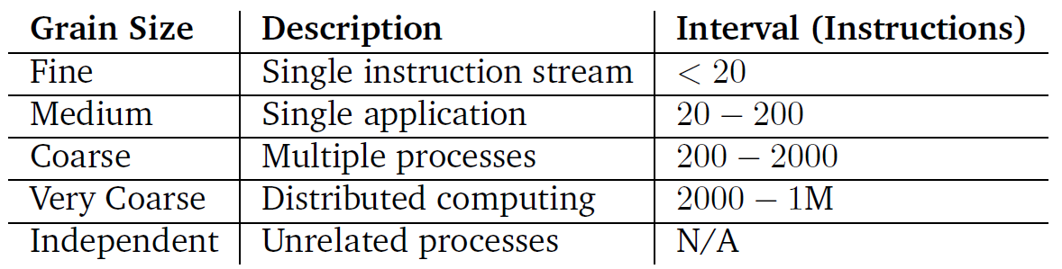

* If choosing asymmetric multiprocessing, there is one boss processor that is responsible for assigning work and managing kernel data structures
* If choosing symmetric multiprocessing, need to make use of mutual exclusion and other synchronization techniques to prevent errors in managing process execution

## Processor Affinity

* If every processor has its own cache, then **processor affinity** is desired, where we keep executing a process on the same processor, if possible
  + After executing for some period of time on a processor, a process will have a bunch of data stored in that processor’s cache
  + If it begins executing on a different processor, all its data is in a different cache so there would be a lot more cache misses
* Soft affinity: OS tries but cannot guarantee that a process will only run on a given processor
* Hard affinity: a process will only run on a given processor/set of processors
* If a system has **non-uniform memory access (NUMA)**, the CPU can access some parts of memory faster than others
  + In this case, processor choice should be based on where the process’s memory is located
  + The memory allocation routine should also pay attention to where to allocate requests, in order to keep program code close together in memory

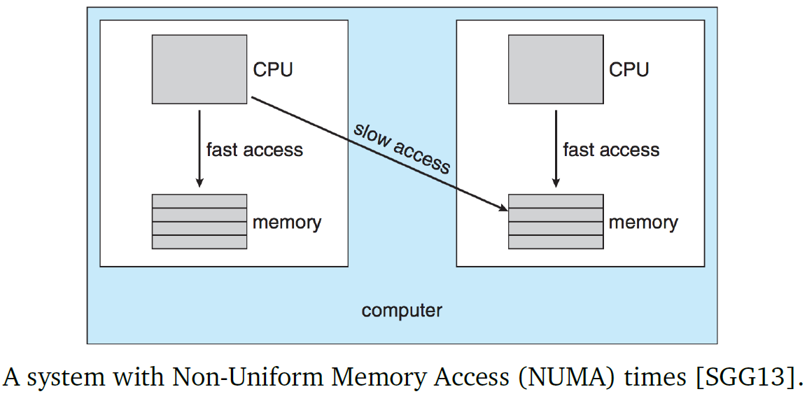

## Load Balancing

* **Load balancing**: ensure that processor workload is balanced across the different processors in the system
* Load balancing is typically only necessary if each processor has its own queue of processes to run; if they all share a common queue, then a free processor can just pick the next process from the queue, and load balancing happens on its own
* There are two ways to redistribute load:
  + **Push migration**: a task periodically checks how busy each processor is, and moves processes around to balance them out
  + **Pull migration**: a processor with nothing to do takes a process from the queue of a busy processor
* Load balancing can conflict with processor affinity
  + If a process has hard affinity for one processor, it can’t be migrated to another processor
  + If a process has soft affinity for one processor, it can be moved but this is not ideal; it should only be moved when there is no other option

## Multicore Processors

* Multicore processors contain multiple processor cores on a single chip; multiple processor exist to the OS
* **Memory stall**: when the CPU must wait a lot of time for memory (e.g. if there is a cache miss so a read operation has to go to memory)
* Periods of CPU computation and memory stalls tend to alternate, though the length of time for each can vary significantly

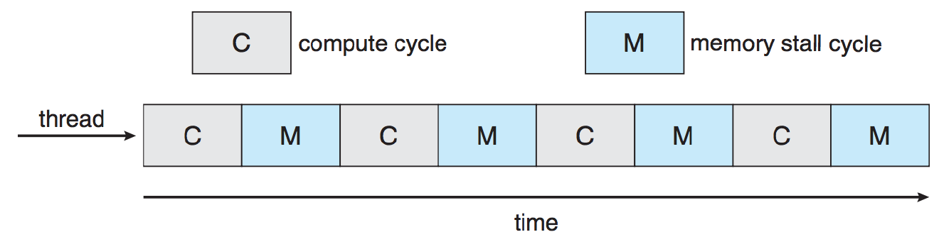

* During a memory stall, the processor core may have nothing to do
* **Hyperthreading**: two threads are assigned to each core; if one encounters a memory stall or gets blocked, switch to the other thread with limited penalty

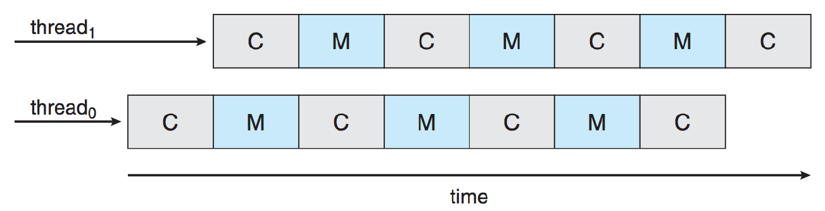

* For coarse-grained multithreading, then when one thread/process gets blocked, the processor will switch to another thread/process, flushing the instruction pipeline; this is expensive
* For fine-grained multithreading, the cost to switch between the two threads is small

## Real-Time Scheduling

* **Real-time systems** are systems that are supposed to respond to events within a certain amount of real time – there are deadlines, and consequences for missing deadlines
  + Hard real-time tasks have deadlines that must be met in order to prevent an error/damage to the system, or in order for the result to make sense
  + Soft real-time tasks have deadlines that aren’t strictly mandatory, but do degrade the quality of the result
* For hard real-time tasks, there are two scenarios where it might not complete before its deadline:
  + It is scheduled too late
    - The system will likely reject the request to start the task or just never schedule the task to run
  + When it started, it was possible to complete the task, but it is no longer possible to meet the deadline (e.g. due to higher priority tasks running)
    - Execution of the task will likely be terminated partway, so that no additional effort is wasted on a task that can’t be completed
* Most desktop OSes aren’t suitable to real-time systems, because they make few/no guarantees about service

### Timeline Scheduling

* **Periodic** processes/tasks repeat at regular intervals
* If a periodic task has two attributes: the period $τ_{k}$ (how often the task runs) and the computation time $c_{k}$ (the worst-case execution time), we can calculate the long-term average processor utilization of periodic tasks $U$: $$U=\sum_{k=1}^{n}{\frac{τ_{k}}{c_{k}}}$$ 
  + If $U>1$, it means that the system is overloaded – there are too many periodic tasks and we cannot guarantee that the processor can execute all tasks and meet deadlines
* If the only tasks in the system are periodic, then a fixed schedule can be created to accommodate all of them
* However, a system generally also has non-periodic tasks:
  + **Aperiodic**: tasks that respond to events that occur irregularly – no minimum time interval between two events
    - Hard to predict when events will occur, so these tasks rarely have hard deadlines; thus, they should be scheduled so that they don’t prevent tasks with hard deadlines from meeting their deadlines
  + **Sporadic**: aperiodic tasks that have deadlines to meet; in order for this to happen, need to guarantee a minimum $τ_{k}$ between event occurrences
    - Sporadic tasks can overload the system if there are too many of them; if this is the case, decisions must be made about which tasks to schedule and which ones will not meet their deadlines
* The unpredictability of non-periodic tasks makes it impossible to make a schedule
* If we have pre-emptive scheduling, there are two alternatives to ensure all tasks meet their deadlines

### Earliest Deadline First

* Choose the task with the soonest deadline; if there is a tie, use random selection
* This algorithm ensures that if there is a way for all tasks to meet their deadlines, it will be found
* If a task is executing and another one with a sooner deadline appears, pre-emption means that the current task can be suspended and the new task scheduled
  + Periodic tasks can be pre-empted for aperiodic/ sporadic tasks

### Least Slack First

* Slack: how long a task can wait before it must be scheduled in order to meet its deadline
* Schedule tasks with the least amount of slack first, as they are the most in danger of missing their deadlines and should thus have priority

# 29: Scheduling in UNIX, Linux, & Windows

## Traditional UNIX

* Traditional UNIX scheduling involves a multilevel feedback system with Round Robin within each of the priority queues
  + Time slicing is implemented, by default, as 1 second long (very long)
  + Priority is based on process type and execution history
* **Processor utilization** for a process $j$ in an interval $i$ is calculated as: $$CPU_{j}\left(i\right)=\frac{CPU_{j}\left(i-1\right)}{2}$$
* **Priority** for a process $j$ at an interval $i$ is calculated by the formula: $$P_{j}\left(i\right)=B_{j}+\frac{CPU_{j}}{2}+N_{j}$$  
  + $B_{j}$ is the base priority of the process $j$
  + $N_{j}$ is the “nice” value of process $j$, a way to allow users to reduce the priority of a process
* The values of $CPU$ and $N$ are restricted to prevent processes from migrating outside of its specific category
  + The categories are, from highest to lowest priority:

1. Swapper – move processes to/from disk
2. Block I/O device control – e.g. disk
3. File manipulation
4. Character I/O device control – e.g. keyboard
5. User processes  
   * The hierarchy tries to make efficient use of I/O devices, so it tends to penalize processor-bound processes at the expense of I/O-bound devices
     + This is effective because processor-bound processes can run when I/O-bound processes are waiting on I/O operations, but when I/O operations are complete we want to start the next one right away so that the I/O device isn’t waiting

## Linux

* Linux has two scheduling modes, Real-Time and Non-Real-Time (normal)

### Linux Real-Time Scheduler

* Operates based on scheduling classes, and there are three classes that processes can be assigned to:
  + SCHED_FIFO: First-In First-Out, Real-Time threads
  + SCHED_RR: Round Robin Real-Time threads
  + SCHED_OTHER: Non-real-time threads
* In each class, threads can have different priorities relative to each other, where lower number = higher priority
  + Real-time priorities are between 0-99 while normal priorities are between 100-139

**SCHED_FIFO**

1. A system will only interrupt a FIFO thread if one of the following is true:
   1. Another FIFO thread of higher priority becomes ready
   2. The current FIFO thread gets blocked
   3. The current FIFO thread yields to the CPU (sched_yield)
2. If a FIFO thread is interrupted, it is placed in the queue associated with its priority
3. If a FIFO thread becomes ready and it is higher priority than the currently-executing thread, the current one gets pre-empted in favour of the higher-priority one; if two or more threads have the same higher priority, the one waiting longer gets chosen

**SCHED_RR**

* Follows FIFO rules, except with time slicing
* If a Round Robin thread has executed for an entire time slice, it is suspended and the real-time scheduler will select a real-time thread of equal or higher priority
* Example:   
  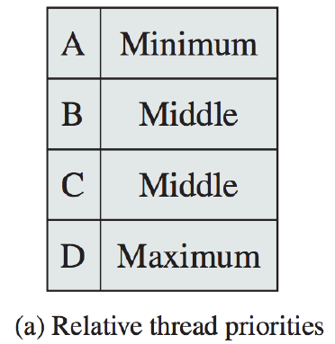
  + FIFO: D 🡪 B 🡪 C 🡪 A
  + Round Robin: D 🡪 B 🡪 C 🡪 B 🡪 C 🡪 A

**SCHED_OTHER**

* Threads in this category will only execute if no other threads in the Round-Robin or FIFO queues are ready at the moment

### Linux Non-Real-Time Schedulers

* Linux introduced a scheduling algorithm called the $O(1)$ **scheduler**, because it executes in $O(1)$ constant time under all circumstances
  + This improved over the previous traditional scheduling algorithm, which ran in $O(n)$ time
  + Worked better for SMP systems because it introduced processor affinity and load balancing
* Then, Linux introduced the **Completely Fair Scheduler (CFS)** algorithm

**The Traditional Linux $O(n)$ Algorithm**

* Since it was an $O(n)$ algorithm, performance decreased as the number of processes increased
* Did not work well in SMP systems because its design included:
  + A single run queue
    - Good for load balancing, but no processor affinity
  + A single run queue lock
    - One mutual exclusion protects manipulation of the run queue
    - Results in processors waiting on one process to modify the queue, which may take a non-trivial amount of time due to the $O(n)$ runtime
  + Inability to pre-empt running processes
    - Lower-priority tasks could continue executing while higher-priority tasks waited
    - Only when a process got blocked, a time slice expiration, or an interrupt could cause the scheduler to re-evaluate

**The $O(1)$ Scheduler**

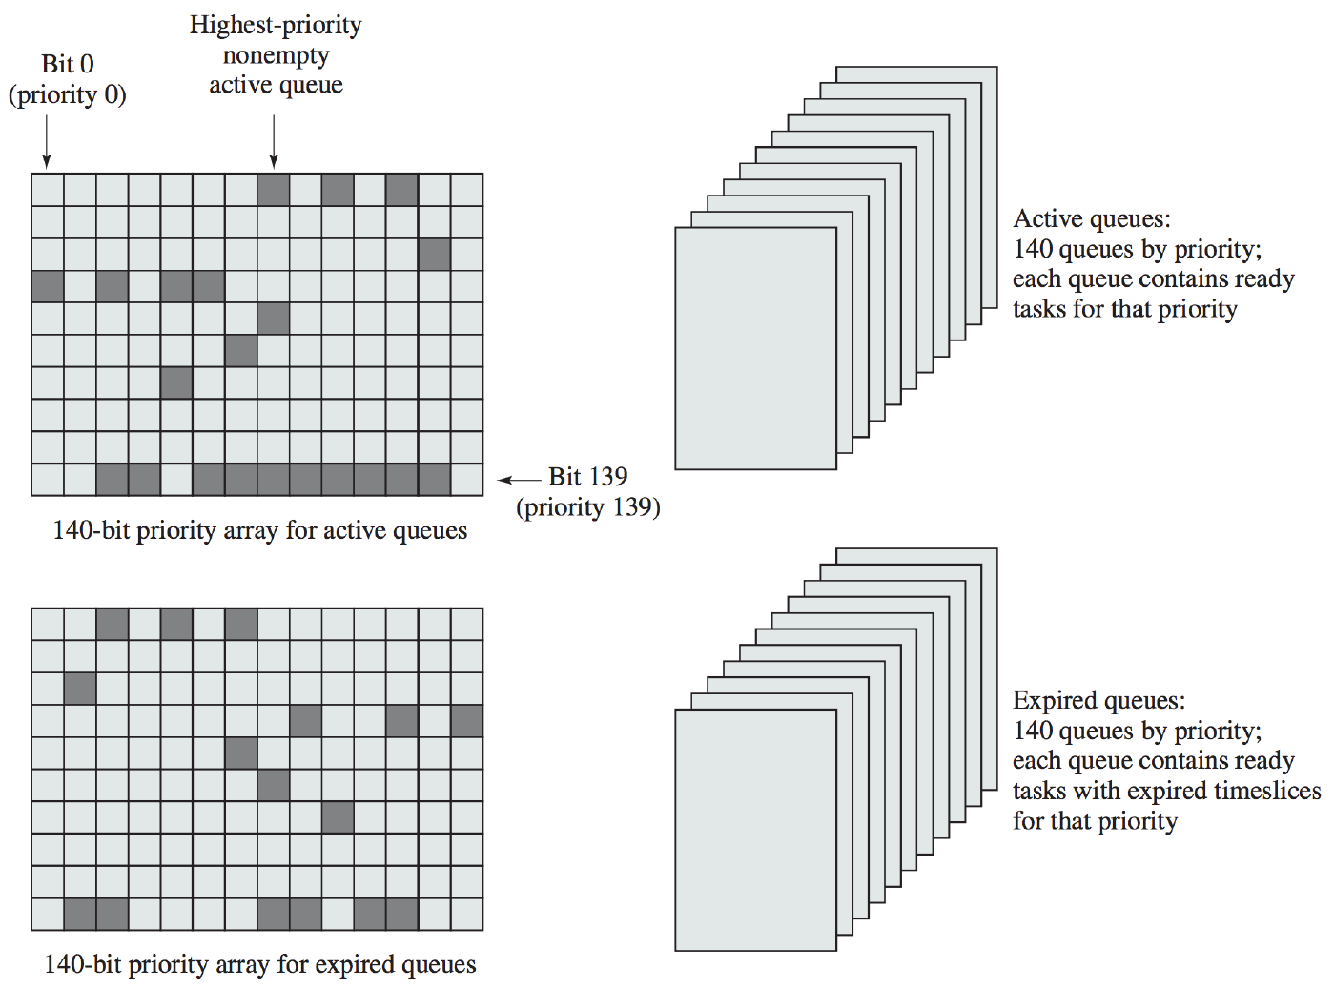

* Kernel maintains two data structures for each processor:  
  struct prio_array {  
   int nr_active; // number of active tasks

unsigned long bitmap[BITMAP_SIZE]; // priority bitmap  
 struct list_head queue[MAX_PRIO]; // priority queues

}

* + There is one queue per priority level, so MAX_PRIO = 140 is both the highest priority and the number of queues
  + The bitmap provides one bit per priority level, so with 140 levels and 32 bit words, BITMAP_SIZE = 5
    - It indicates which queues are empty
  + There is an active queue and expired queue structure
* Initially, there are no tasks in any of the queues, so all the bits in the bitmap are 0
* If a process is created and enters the ready queue, it is placed in the appropriate priority queue; if that queue was previously empty, its bit in the bitmap gets set to 1
  + If the process doesn’t finish its entire time slice before it gets pre-empted, it goes back in its ready queue again
  + If the process runs to the end of its time slice, it gets placed in the expired queue
* All scheduling takes place from the active queues; the highest priority queue is chosen, and within each queue tasks are scheduled in Round-Robin fashion
* When the active queue becomes empty, it swaps with the expired queue, and scheduling continues
* An issue with this scheduler is that it doesn’t provide good performance for interactive processes

**The Completely Fair Scheduler (CFS)**

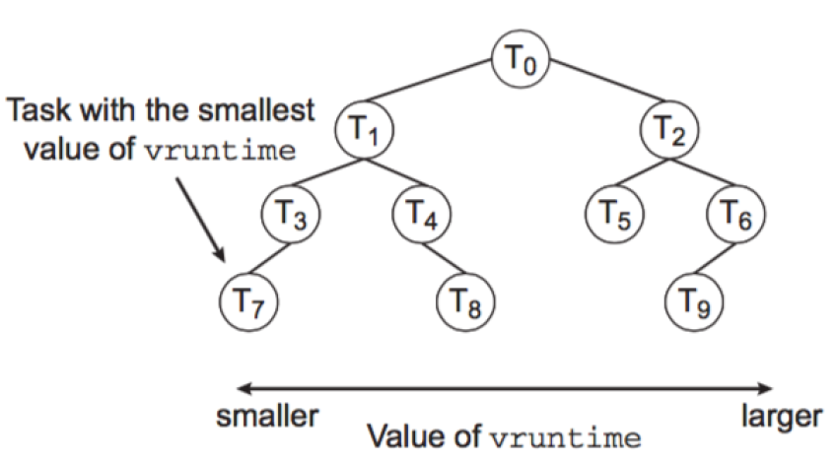

* Uses a red-black tree for the ready queue, and processes are inserted based on linear ordering of their execution times (not $O(1)$)
  + **Leftmost node** in the tree has spent the least time executing, and so will be scheduled next
  + Since red-black trees are balanced, the time to retrieve the leftmost node is $O(n\ln{ n})$, but caching could improve access speeds
  + If a task gets blocked, it isn’t inserted into the queue again
  + If a task is pre-empted or reaches the end of its time slice, it is added back to the queue with its updated execution time
* The CFS scheduler assigns a proportion of CPU processing time to each process based on its nice value – between -20 and +19, where lower number is higher priority
* There is no specific time slice length; instead, the CFS has a **target latency**, a time interval where all tasks should get to run at least once; CPU time is handed out based on the target latency
* Virtual runtime (vruntime) is a way of keeping track of how long tasks have been executing for
  + There is a decay factor, meaning that more recent history is weighed higher
  + Higher-priority processes’ history decays faster than lower-priority processes
  + Tasks with a positive nice value have a larger virtual runtime than their physical runtime, while tasks with a negative nice value will have virtual runtimes smaller than their physical runtime
* Tasks that spend a lot of time using the CPU will normally get a lower priority than a task that spends a lot of time waiting for I/O
  + User-interactive processes get to execute fairly quickly, making the system appear responsive to users
* CFS also added **group scheduling**, the ability to designate a number of processes as belonging in a group
  + Allows processes that spawn lots of threads/processes to be grouped together, so that the scheduler treats the entire group equally with other processes, and then treats processes fairly within a group

### Windows

* The Windows scheduling routine, known as the **dispatcher**, is a pre-emptive, priority-based algorithm that ensures the highest priority thread runs next
  + A thread runs until it is pre-empted, blocks, terminates, or its time slice expires
  + If a higher-priority thread is unblocked, it pre-empts a lower-priority thread
* Windows has 32 priority levels, with higher number = higher priority:
  + 0 – memory management
  + 1 to 15 – regular
  + 16 to 31 – real-time classes
* The dispatcher maintains a queue for each priority level, and goes through them from highest to lowest until it finds something to do
* There are six user-settable priority classes:

1. Real-time
2. High
3. Above normal
4. Normal
5. Below normal
6. Low

* A process is usually in the Normal class; unless the process is in the real-time class, there are a number of relative priorities within each class  
  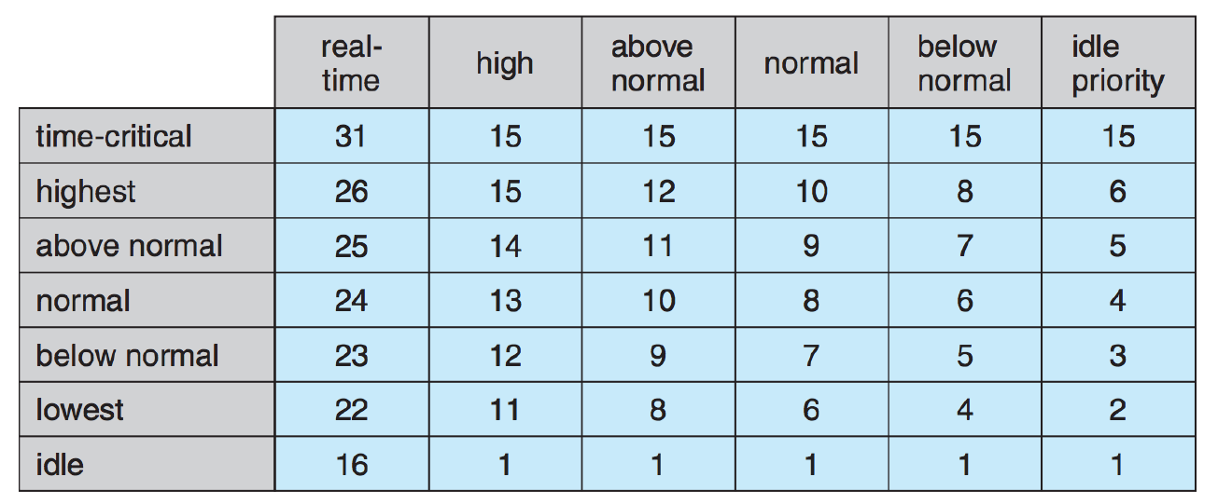
  + If a process reaches the end of its time slice or a thread is interrupted, its priority moves to the (lowest) base priority of its class
  + If a process is temporarily blocked, its priority is temporarily boosted; the amount that it is boosted by is based on the event it is blocked on
* The OS also gives priority to the process running in the active foreground window, by boosting its priority and increasing the length of its time slice

# 30: Input/Output Devices & Drivers

## Input/Output Devices

* There are an uncountable number of I/O devices and they are all different; in particular, there are dramatic speed differences between various typical PC devices
  + E.g. Gigabit Ethernet operates at data rates of 109 bps, while keyboards operate at under 102 bps
* Disk I/O, in terms of magnetic hard disks, has a huge impact on system performance

### Application I/O Interface

* Ideally, general-purpose OSes want to accept new hardware devices without editing/reinstalling/recompiling the code
* Instead, want to provide a uniform interface for devices to interact with, and abstract away hardware details
  + In early days, the only hardware that needed to be supported by a computer was hardware that it shipped with; these days, any hardware should be able to connect to standard interfaces
* **Device drivers**: plugs into an OS and tells it some information about the device’s hardware; translates OS commands to hardware instructions
  + However, hardware designers often made poor drivers
  + The problem was made worse by Windows’ decision that drivers would run at kernel level – meant that, in the event of programming errors, the driver could invoke a system call to launch a BSOD
* Device drivers connect to the kernel’s I/O subsystem to mediate between the kernel’s I/O subsystem and the hardware device controller

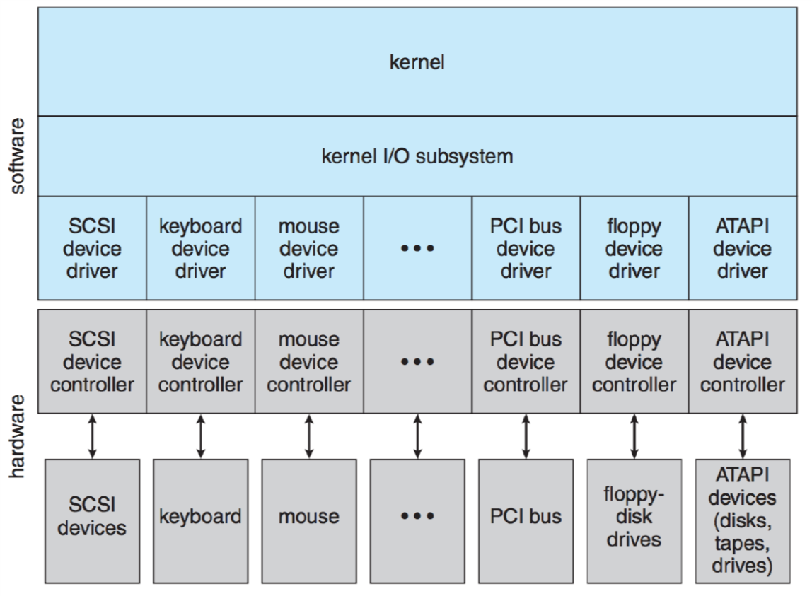

* The interface provides a standard way of interacting with the hardware device, but devices can differ in many dimensions:
  + **Data transfer mode**: character-level vs. block-level
  + **Access method**: sequential access (read from/write to locations in order) vs. random access (read from/write to any point)
  + **Transfer schedule**: synchronous (predictable response times) vs. asynchronous (unpredictable response times)
  + **Dedication**: shareable (allow concurrent threads) vs. dedicated (one thread can use it at a time)
  + **Device speed**: many differences in transfer speeds
  + **Transfer direction**: input only, output only, or capable of both
* Goal: keep as much detail away from the OS as possible; however, devices are typically grouped into categories so that appropriate system calls can be issued
* OSes also have an escape system call that allows them to communicate directly to a device driver and issue commands that OS designers haven’t created a system call for
  + In UNIX, the ioctl system call

### Block and Character I/O

* **Block device interfaces** are used for block-level devices such as hard disks
* Any device supports read and write commands, as well as seek if it is a random-access device
  + OS can use these commands without worrying about the commands issued to the actual hardware
* To abstract further, we can have a memory-mapped file so that applications can just read from/write to “memory”, and the OS handles the reading/writing of correct blocks
* **Character device interfaces** are used for character-level devices such as keyboards
* It supports get and put system calls; libraries and other structures may exist to work on an entire line at a time
  + Good match for devices that produce small and unpredictable amounts of data

### Buffering

* OS can improve the performance of both block- and character-level devices through buffering
* **Buffers** are an area of memory that stores data being transferred (between device and memory or device and device)
  + Good way to handle speed mismatches between devices, allowing waiting for a certain amount of data from a character-level device (e.g. keyboard) before writing to a block-level device (e.g. disk) all at once
* Since writing isn’t instantaneous, **double buffering** (one buffer for data being produced, another for data being consumed) decouples the producer and consumer of data, thus overcoming the speed differences

### Network Devices

* Different from devices attached directly to the system; instead of read, write, and seek commands, uses **sockets**
* Client-server model of communication: server “opens a socket”, client “plugs in” when it wants to connect to the server; then, packets of data can be exchanged between client and server
  + To support servers with multiple clients, socket interface includes the select function, which provides information about which socket has packets waiting to be receive or available to send to

### Spooling and Reservations

* **Spool**: a buffer for a device that can only serve one device at a time (e.g. a printer)
  + Allows OS to centralize all communication to the device, to ensure that one task is finished before then next one can begin

### I/O Protection

* Recall user mode instructions vs. kernel mode instructions, which are restricted so that only the OS can access them
* Likewise, want the OS to mediate all user accesses to I/O devices, to ensure that requests are valid – minimizes errors and problems
  + If it is, allow to proceed
  + Otherwise, terminate the process with an error
* Safety is increased in exchange for reduced performance
  + However, in certain instances where high performance is necessary, direct access may be allowed without going through the kernel (e.g. a game accessing a graphics card’s memory)

### Kernel I/O Data Structures

* Kernel must keep track of what I/O devices are being used by which processes, as well as the general state of each I/O device
* In open-file tables for each process, the kernel stores pointers to important functions and information

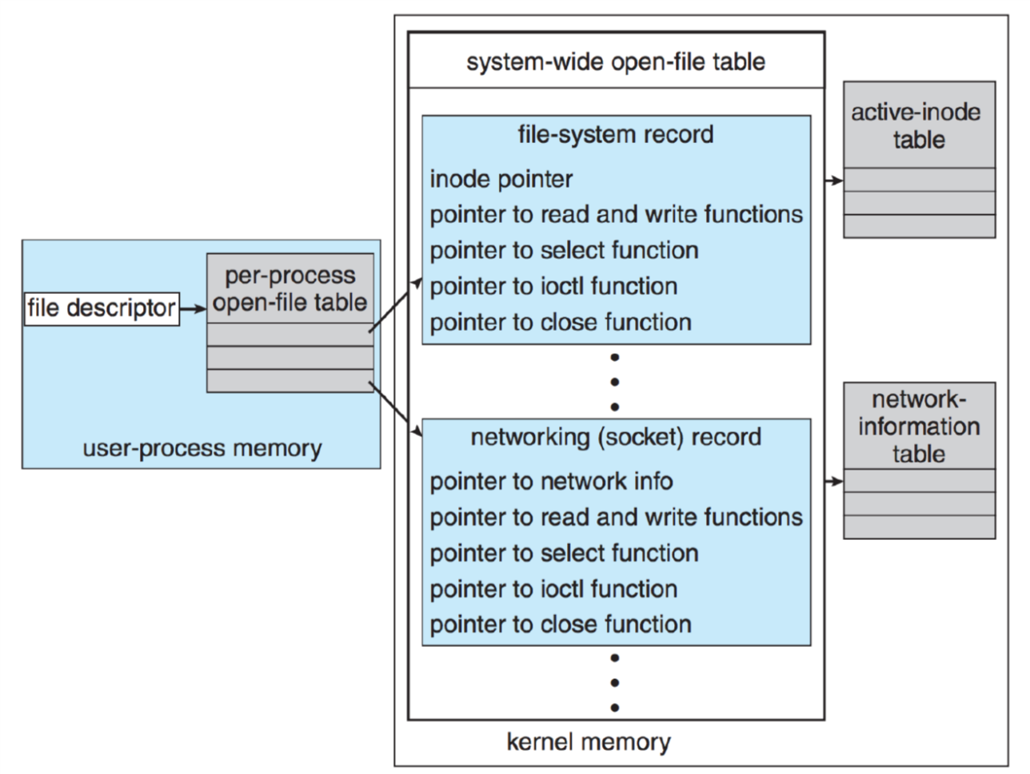

### I/O Scheduling

* Sometimes, the OS wants to schedule I/O requests in an order other than first-come first-served, in order to maximize efficiency and prevent wasted back-and-forth time
* To do so, the OS maintains a data structure of requests, and rearranges them to be accomplished most efficiently
* It may also take priority into account and schedule I/O requests of a high-priority process even though it isn’t nearby to other requests

## Transforming I/O Requests to Hardware Operations

* Reading from a file system on disk takes a number of steps
  + First, the file system must associate the desired file with a set of disk block representing the file
  + Then, read commands can be issued to get the block into memory

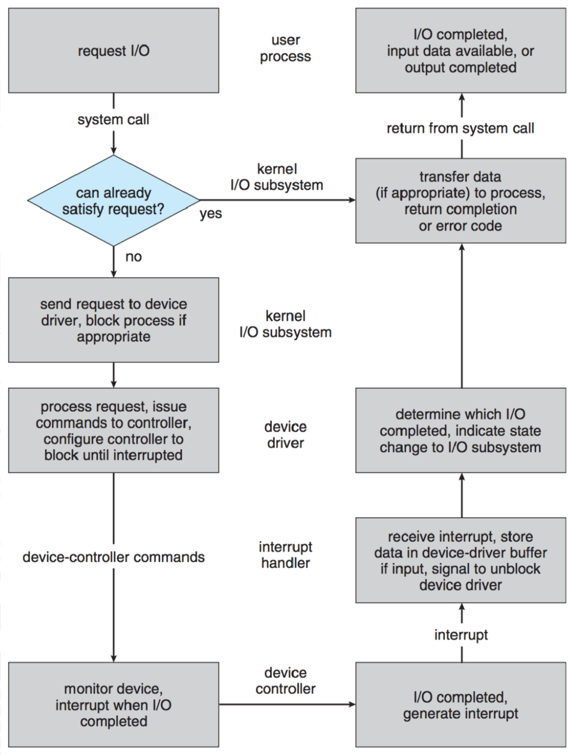

1. User issues read command (assuming file is already open)
2. System call validates parameters; if the data is available in a cache or buffer, return it immediately
3. Otherwise, the process gets blocked waiting for the device, and the I/O request is scheduled; I/O subsystem notifies the device driver when the operation is about to occur
4. Device driver allocates a buffer to receive the data; device is signalled to perform I/O operation
5. Device controller operates the hardware to do the work
6. Device driver may poll, wait for an interrupt, or wait for the DMA to signal that the operation is finished
7. Interrupt handler receives interrupt and stores data, then it signals device driver to indicate that the operation is done
8. Device driver identifies the operation that just finished, determines the status, and notifies I/O subsystem that it is done
9. Kernel transfers the data to the address space of the requesting process and unblocks the process
10. When scheduler chooses the process, it resumes execution

# 31: Disk Scheduling

## Disk Scheduling

* To the CPU, magnetic hard disks are very slow devices, so we want to avoid going to disk whenever possible
* Due to the physical nature of how disk drives work, there is a delay to moving to new locations and reading the data there
* Thus, we want an efficient schedule of reading and writing to disk, to maximize efficiency, by avoiding going back-and-forth

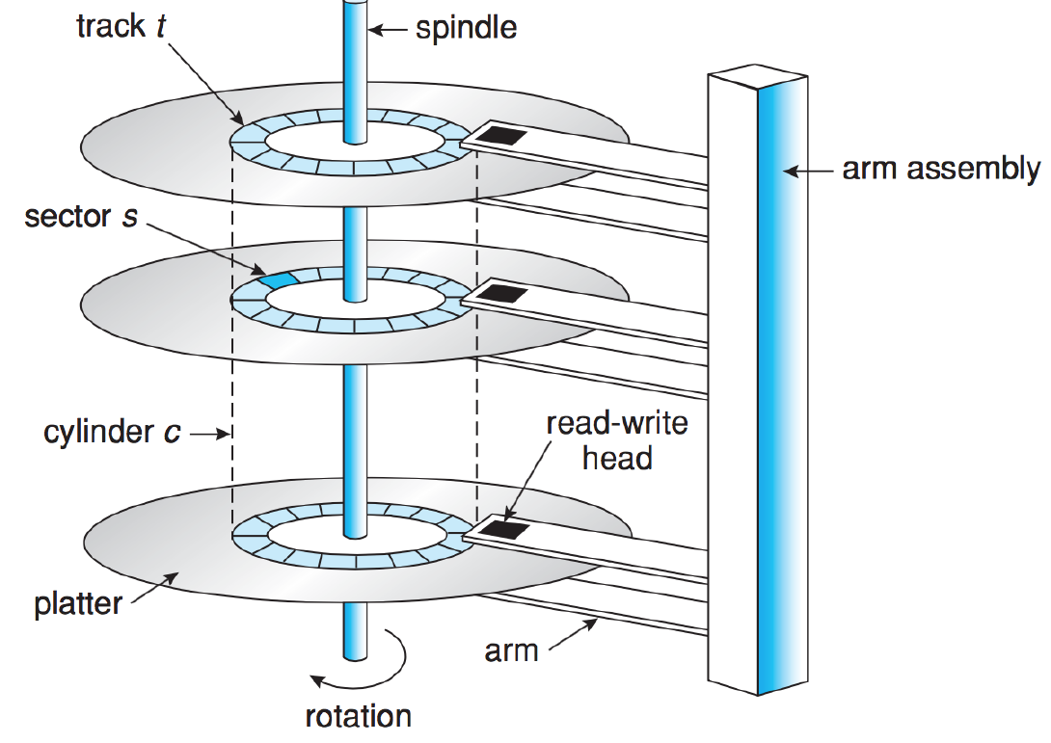

* A read-write head is suspended a small distance from the surface of each platter, and reads the data directly beneath it
* The platter is divided into circular tracks, which are then divided into sectors (blocks); each column consists of a set of vertically-stacked tracks
* Disk performance is broken down into two values:
  + **Transfer rate**: speed at which data can be moved between disk and computer
  + **Random-access time**: how long it takes to get to a piece of data
    - **Seek time**: how long it takes to move the disk arm to the right location
    - **Rotational latency**: how long it takes to rotate the platters to the right location
* **Total average access time** for a disk operation: $$T_{a}=T_{s}+\frac{1}{2r}+\frac{b}{rN}$$  
  + $T_{s}:$ average seek time
  + $r:$ rotational speed (revs/sec)
  + $b:$ number of bytes to be transferred
  + $N:$ number of bytes per track
* Example: Consider a disk with average seek time ($T_{s}$) of $4 ms$, rotational speed of $7500 RPM$, and 512-byte sectors with 500 sectors per track. We want to read a file that is 2500 sectors (1.28 MB).
  + If data is sequentially organized, the file occupies sectors on 5 adjacent tracks
    - To read first track, it will take: $$T_{a}=4 ms+\frac{1}{2×\frac{7500 RPM}{60}}+\frac{500 sectors}{\frac{7500 RPM}{60}×500 sectors}=16 ms$$ 
      * $4 ms$ seek time
      * $4 ms$ rotational delay
      * $8 ms$ to read 500 sectors
    - Each additional track will take $12 ms$: $4 ms$ rotational delay + $8 ms$ to read 500 sectors
    - Thus, the total time is $16 ms+\left(4 × 12 ms\right)=64 ms$
  + If the data is randomly organized:
    - Average seek time and rotational delay times don’t change
    - Reading one sector takes $0.016 ms$, so each read of a sector will take a total of $4 ms+4 ms+0.016 ms=8.016 ms$
    - There are 2500 sectors total, so the total time is $2500 ×8.016 ms=20 040 ms$– over 20 seconds
  + This example demonstrates how the order in which sectors are read from disk makes a huge difference
* **Bandwidth**: the total number of bytes transferred divided by the total time between the request for service and completion of transfer
  + Measures how much data is effectively transferred in a period of time
* When a process reads to/writes from disk, the system call contains:
  + If the operation is a read or write
  + Disk address for transfer
  + Memory address for transfer
  + How much data (# of sectors) to transfer

### First-Come, First-Served

* Fair and simple algorithm, but makes no attempts to group, organize, or rearrange requests
* Example: total movement = 640 cylinders

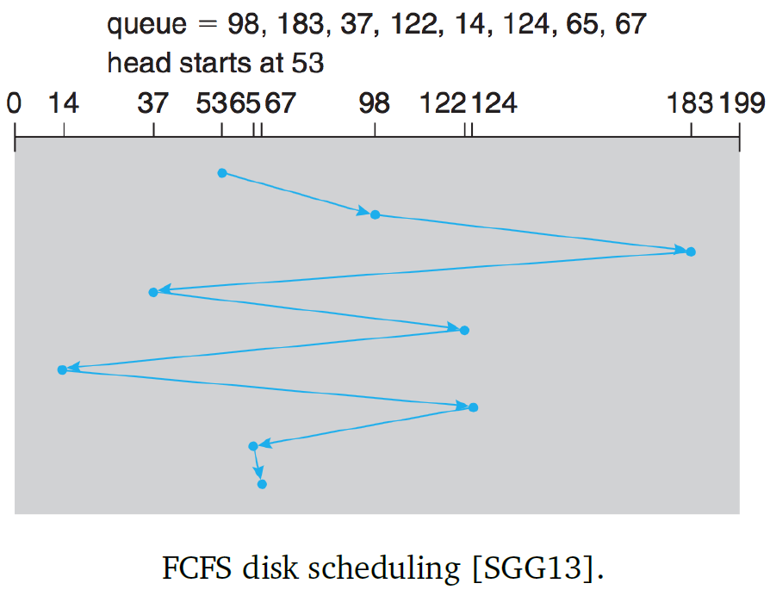

### Shortest Seek Time First

* Always choose the request with the lest seek time from the current head position
* However, this algorithm is prone to starvation – if enough short seek time requests arrive during execution, longer seek time requests will be put off, potentially indefinitely
* Although it provides some spatial locality by carrying out requests located near one another relatively quickly, it isn’t the optimal algorithm
* Example: total movement = 236 cylinders

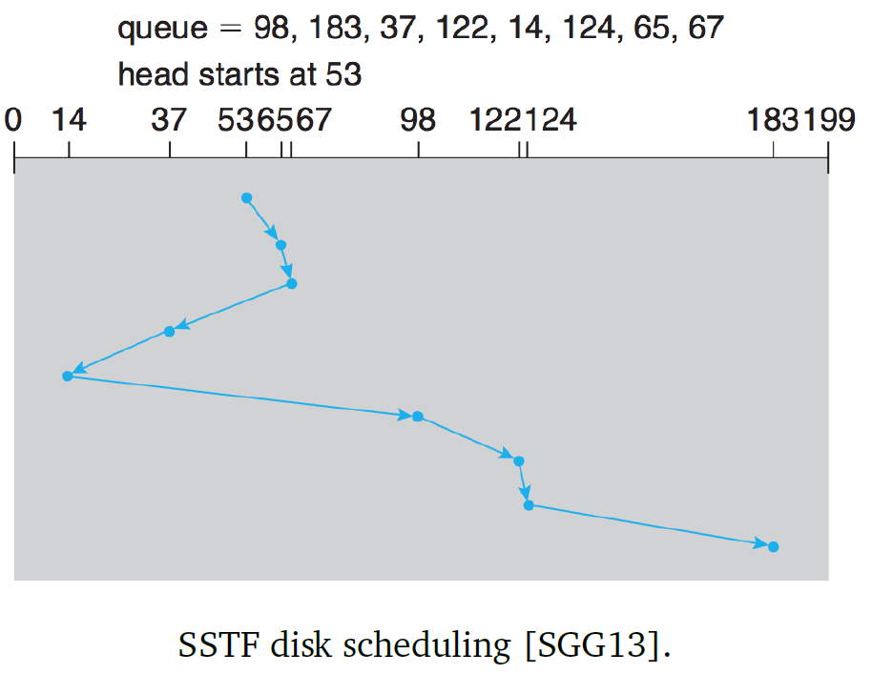

### SCAN Scheduling

* Move in one direction at a time, until we reach the end of the disk; then, reverse direction
  + If a request arrives just in front of the head, it will be serviced right away
  + If a request arrives just behind the head, it will need to wait until the head reverses direction and comes back
    - Hence, this algorithm doesn’t make use of spatial locality – if there are multiple accesses in the same area, they are likely to be spread out at least part of the time
* Example:

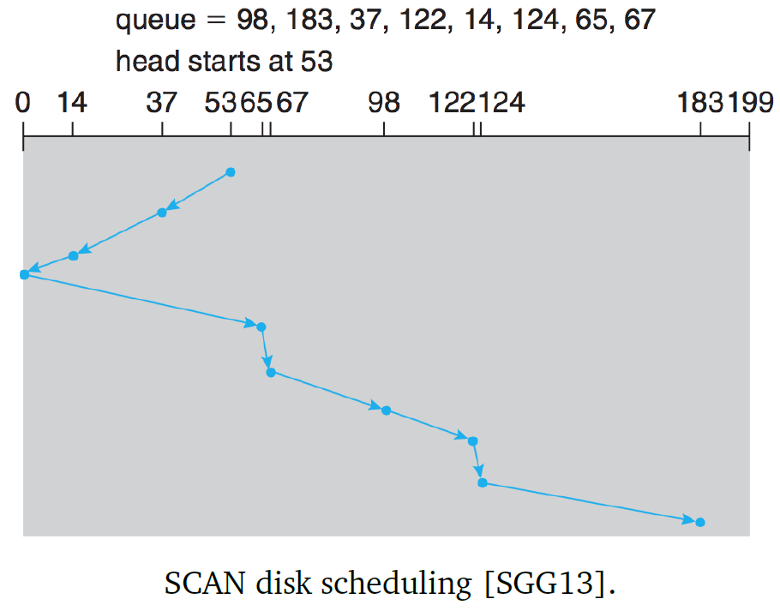

### C-SCAN (Circular SCAN) Scheduling

* Designed on the basis that when the disk head reaches one end of the disk, there is likely to be more requests on the other end (if they were nearby, they would have been serviced already)
* Instead of reversing direction and servicing requests along the way, jump back to the start of disk and start servicing requests from the beginning
  + If the amount of time it takes to scan from start to end of disk is $t$, the expected service interval for sectors at the periphery is $2t$ when using the SCAN algorithm
  + The C-SCAN algorithm reduces the interval down to $t+s_{max}$, where $s_{max}$ is the maximum seek time
* Example:

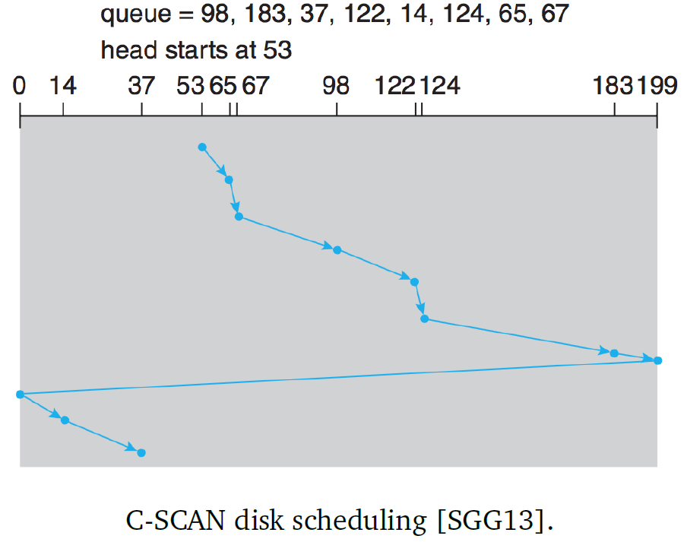

### LOOK/C-LOOK Scheduling

* Instead of going to the end of disk, go until the final request and then reverse direction (LOOK) or go back to the start (C-LOOK)
* Example (C-LOOK):

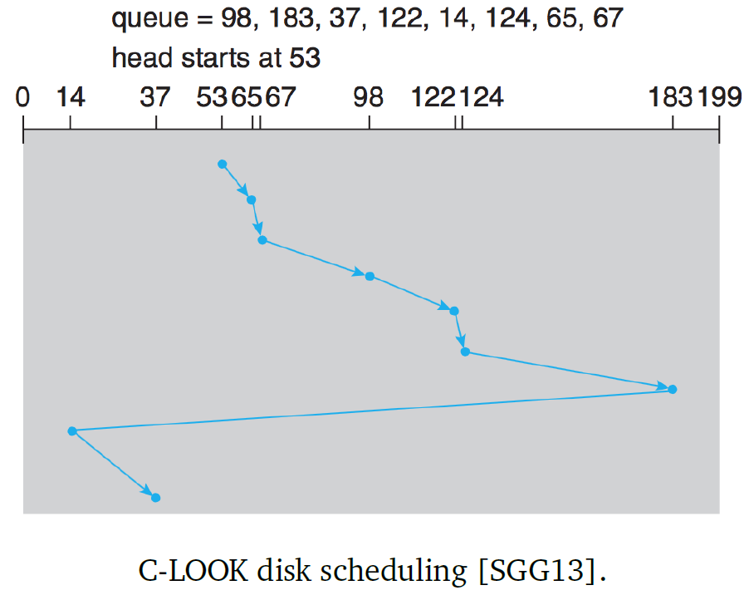

## Some More Details about Scheduling Algorithms

* Modification of SCAN algorithm to help prevent starvation:
  + Two queues for requests, similar to double-buffering
  + While one queue is being emptied, the other one gets filled
    - This means a request won’t wait indefinitely; of the length of the queue is $C$, any read/write will wait at most $C$ accesses
  + The larger the value of $C$, the more the behaviour resembles the SCAN algorithm
  + The smaller the value of $C$, the more the behaviour resembles the FCFS algorithm
  + Performance and fairness are trade-offs when deciding the value of $C$
* The scheduling algorithms mentioned above only consider seek time, not rotational latency
  + It is hard for the OS to improve rotational latency through scheduling, since it is based on how the disk physically places logical blocks
  + Thus, the hard disk controller takes on some scheduling options, so that it can account for rotational latency as well as seek time
* In some cases, the OS has other goals that take precedence over highest performance; thus, the OS needs to manage the reads/writes and not just leave it up to the disk controller
  + E.g. in real-time systems, higher-priority processes shouldn’t be waiting for lower-priority processes’ disk accesses

# 32: File Interface

## File Systems

* File systems provide organization of files in a directory structure, as well as maintaining metadata about files
* Files are logical ways of organization data (bytes – 1s and 0s)
* They typically have attributes:
  + **Name**: symbolic (human-readable)
  + **Identifier**: unique identifier
  + **Type**: information about what type of file it is
  + **Location**: what device (i.e. hard disk) the file is stored on
  + **Size**: the current, and possibly maximum, size of the file
  + **Protection**: access-control information
  + **Time, Date, User ID**: other useful data for protection/security and usage monitoring
* Directories are also files; they contain information about what files are in what locations, and they too are stored on disk

### File Operations

* The OS provides operations for users to work with files:
  + **Creating a file**: find a place to put the file, allocate the space and mark the file as allocated, and place the file in its appropriate directory
  + **Writing a file**: system finds the file and puts data in it – can replace existing contents or append to existing contents
    - A pointer keeps track of where the next write will take place, and is updated after each write
  + **Reading a file**: requires determining where in memory the next block of the file should be put
    - A pointer keeps track of where the next read will take place
  + **Repositioning within a file**: seek – reposition the pointer of the current location
  + **Deleting a file**: find the file, mark its allocated space as free, and delete the file from the directory
    - If the data hasn’t yet been overwritten, it may be possible to recover the data
  + **Truncating a file**: erase the contents a file but keep all of its attributes (metadata); reset file length to 0 and mark its data area as free
* The six operations can be combined to do most other options (e.g. copying and pasting files)
* Aside from creation and deletion, the other operations can only operate on files that are open
  + When a file is opened, the program gets a reference to it
  + The OS keeps track of which files are currently opened by which processes
  + If the open mode allows multiple processes to open the file simultaneously, the OS needs to maintain a system-wide table and a per-process table that contains references to the system-wide table; when the last process closes an opened file, the OS can remove it from the table
* Some OSes support file locks, which work like mutual exclusion; when a file is locked by one process, other processes cannot use or delete it

### File Types

* File extensions are hints to the user and the OS about what type of file it is
* In most OSes, any program can open any arbitrary file; the file type just suggests what program it should be opened by
* OSes also typically allow setting a default program for a specific file type

### Access Methods

* When the system wants to read a file, it is usually read into main memory
  + **Sequential access** is the simplest method: information in the file is processed in order, one section after another
    - Mostly consists of read and write operations
    - Going backwards can be allowed by reversing one section at a time or resetting back to the beginning
  + **Direct access** is when any part of the file can be accessed at any time
    - No restrictions on order, and no need for the program to seek to the right place
    - Directly seek or read any arbitrary block
* The OS typically hides the physical block information of the file by using a relative block number; to programs, the first block of the file starts at 0, regardless of where the block is located on disk
* Disk systems operate on equal-sized blocks, but the logical size of the file probably doesn’t fit exactly into one or multiple blocks
  + Thus, multiple logical records are often packed into one block
  + Some internal fragmentation will occur – e.g. if a file is 21KB and each block is 4KB, the fifth block will contain 1KB of the file and 3KB internal fragmentation

### Directories

* A directory is a symbol table that translates file names into their directory entries
* Directories typically support the following operations:
  + **Search**: find a file, or find some contents of a file
  + **Add a file**
  + **Remove a file**
  + **List a directory**: list the files in the directory and the contents of the directory entry
  + **Rename a file**: change the user-friendly name, and possibly the file’s position in the directory if it is sorted by name
  + **Navigate the file system**: go to parent directories, child sub-directories, etc.
* Simple directories don’t have subdirectories, but most common directories are tree-structured
  + There is a root directory, and every file on the system has a unique path
* Absolute path: the full file name
* Relative path: the path from the current directory – the system works out the full file name
* **Deletion**: the OS can choose to only allow deletion of directories if they are empty, or automatically delete the directory and its contents
  + Most modern OSes just move deleted files/folders into a deleted files directory (e.g. Recycling Bin, Trash Bin)
* File systems also support **sharing of files**, where there is one copy of the file but it has more than one name; in UNIX, this is done through links, which is basically a pointer to a file
  + **Symbolic links (symlinks)** are references by file name, i.e. they are just a “shortcut” to a file; if the file is later deleted, the symlink will point to nothing, and any later uses will result in errors
  + **Hardlinks**: creating a second pointer to the underlying file in the file system; if the file is later deleted, the file remains on disk until the last hardlink is removed
    - File structure maintains a count of how many hardlinks reference a file, and only deletes the file when the count is 0

### File Permissions

* To protect users from one another, and maintain confidentiality/integrity of data, files usually control access to the following operations:
  + Read
  + Write
  + Execute
  + Append
  + Delete
  + List (view attributes of a file)

**UNIX-Style Permissions**

* Each file has an owner and a group; a set of permissions can be assigned to the owner, the group, or everyone
* Permissions are represented as 10 bits, where 1 indicates true and 0 indicates false
  + 1st bit: directory bit – indicates if the file is a directory
  + Next three bits: read, write, and execute permissions for the owner
  + Next three bits: read, write, and execute permissions for the group
  + Next three bits: read, write, and execute permissions for the everyone
* Effective permissions are determined by the user; owner precedes group, which precedes everyone
* In human-readable form, permissions are presented by a dash if the bit is zero, d if the file is a directory, r w and x for read, write, and execute access
  + Example: -rwxr----- indicates that the file isn’t a directory, the owner has read, write, and execute permissions, the group has read permissions only, and everyone else has no permissions
* Permissions can also be written in octal (base 8), where r=4, w=2, and x=1
  + Example: -rwxr----- becomes 740 – owner has rwx (4+2+1), group has r (4), and everyone else has no permissions (0)
* The downfall to this approach is that there are only three groups for whom we can specify permissions

**Access Control Lists**

* In SELinux (Security Enhanced Linux) and NTFS (Windows NT File System), files are protected by access control lists (ACLs)
* Each file can have as many security descriptors as needed for specific users or groups, and the permissions aren’t restricted to read-write-execute
  + Default deny: only users that are explicitly granted access can access the file
  + Default permit: everyone can access the file, expect for users whose privileges are explicitly denied
* ACLs also have the idea of **inheritance**, which UNIX-style permissions don’t
  + If a directory has ACLs and object inheritance is enabled, then any object created in the directory inherit the same ACLs
  + However, existing files that are moved into a directory with ACLs will retain their original ACLs

# 33: File System Implementation

* There are many layers in file system design; the further down the list, the closer to the hardware and so the less abstraction:
  + **File System** – the user interface, intended for the convenience of users and application programmers
  + **I/O Control** – device drivers and interrupt handlers to transfer data; writing bit patterns in I/O controller memory outputs hardware instructions to the hardware controller
  + **Basic File System** – physical blocks on the disk, identified by numerical physical addresses, e.g. drive 0, cylinder 12, track 7, sector 2
    - Also contains any buffers and caches that appear on the hard disk
  + **File Organization Module** – translates logical block addresses to physical block addresses; keeps track of free space (unallocated blocks)
  + **Logical File System** – manages metadata, such as file system structure, directory structure, and file structure
    - File data is managed in a file control block (FCB); in UNIX, called an **inode**
      * Stores information including ownership, permissions, and locations of file contents

## Disk Organization

* File systems need to keep track of:
  + Total number of blocks
  + Number of + locations of free blocks
  + Directory structures
  + Files themselves
* At least one disk in the system contains information to boot up the OS – generally put in the first block
  + At start up, the BIOS starts and transfers control to the first block – usually the boot loader
* Disks can be split into several different partitions; a partition table indicates what part of the disk belongs to what partition
* Several structures are in memory for performance reasons:
  + **Mount Table** – information about each mounted volume (disk or partition)
  + **Cache** – directory information for recently accessed directories
  + **Global Open File Table** – for each open file, a copy of its FCB
  + **Process Open File Table** – references to the Global Open File Table, sorted by process
  + **Buffers** – places to hold data read from/to be written to disk, before/after the disk operation
* It is the logical file system’s job to create new files and allocate a new FCB (or reuse an existing one); a typical FCB looks like this:

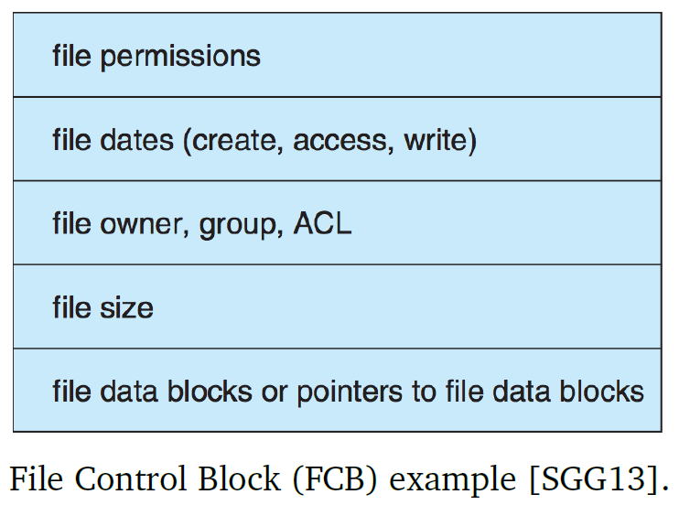

* When a user application wants to use a file, it uses the open system call and provides the human-readable file name
  + The file system checks the **global open file table** to see if the file is already open
    - If it is open for exclusive access, return an error
    - If it is open for non-exclusive access, make a reference to it in the **process open file table**
  + If the file isn’t open, it is retrieved
    - When it is found, its FCB is copied into the global open file table and a reference is added in the process open file table
  + The open system call returns a pointer to the file table, which the application can then use to perform file operations
    - The reference is known as a file descriptor in UNIX and a file handle in Windows
* The process open file table can also contain some additional information about the file, such as the next read/write section, access mode, etc.
* When closing a file, its entry in the process open file table is removed, and if it is the last reference to the file, the file can also be removed from the global open file table; metadata may also be updated

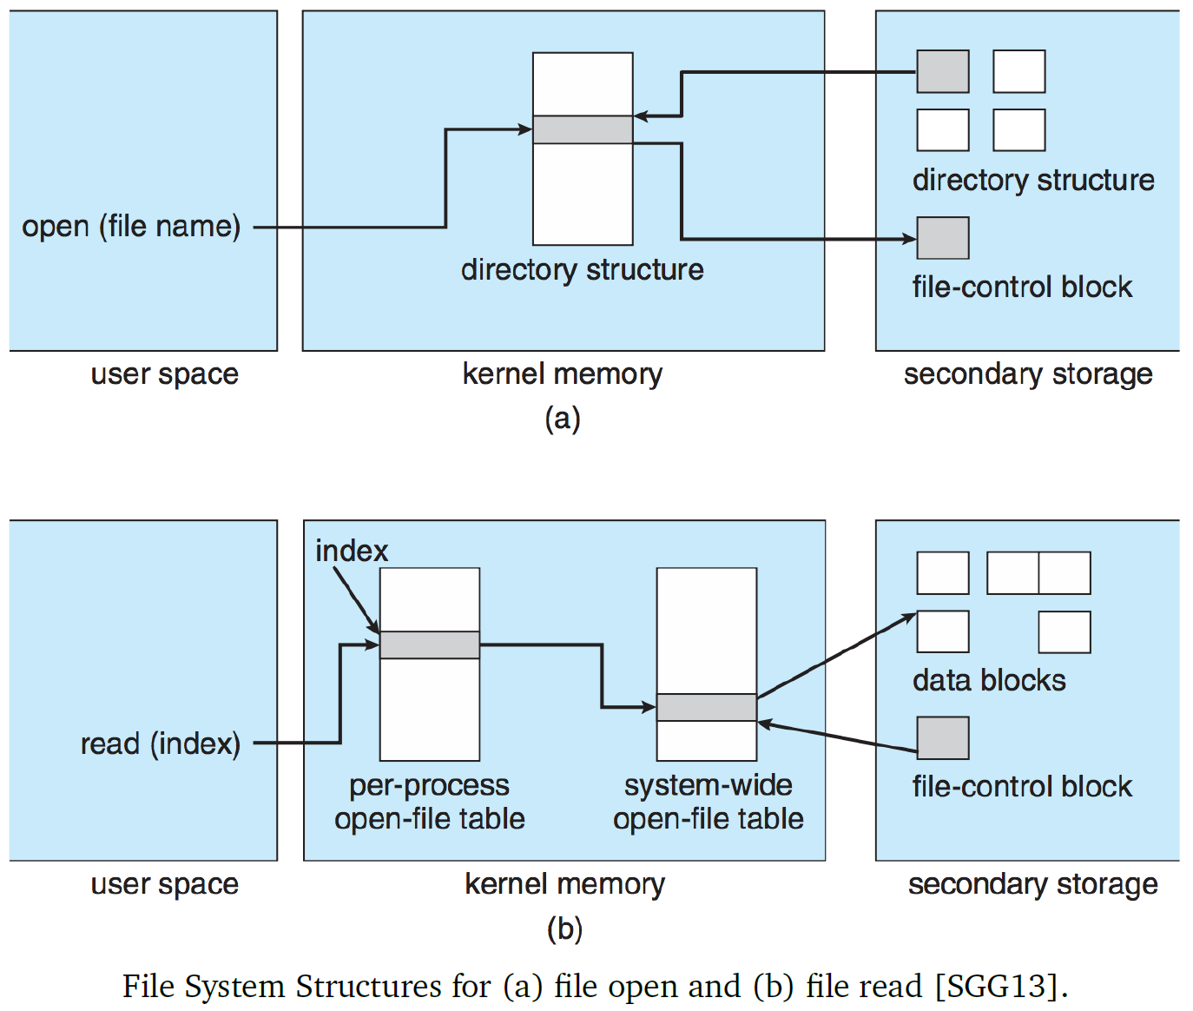

### Spotlight Search (Aside on Metadata)

* Mac OS X’s Spotlight search runs quick queries over the metadata of the system
* It updates the metadata related to files during file creation and modification
* The metadata is added to the Spotlight index, which can be queried very quickly
  + Since the data is prepared in advance, it makes searching operations much faster
* When should metadata be updated?
  + The longer the times between updates, the higher chance of user requests getting out-of-date data
  + The faster the updates, the more processing time is spent on updating metadata

### Virtual File System

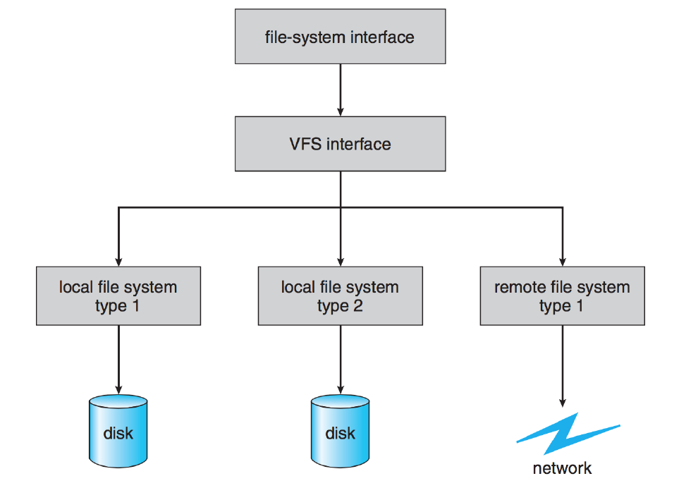

* A lot of different file systems can operate identically from the user’s perspective, due to an additional layer of abstraction known as the **virtual file system (VFS)**
* The VFS has two main purposes:

1. Separate file system operations from their actual implementations, so that operations can be done regardless of implementation
2. Provide a way to represent a file uniquely throughout a network

* The file representation structure is called a **vnode**, which is similar to inode except that inodes are only unique throughout a single file system
* The VFS distinguishes between local and remote files
* In Linux, the VFS architecture contains four main objects:

1. **inode** – an individual file
2. **file** – an open file
3. **superblock** – the file system
4. **dentry** – a directory entry

* For each object, there are a set of defined operations (functions); thus, the VFS abstracts away much of the underlying file system implementation

### Directory Implementation

* Directories are not much more than a set of files; they can be implemented in many different ways
* **Linear list**: simplest option
  + File creation: search the directory to see if a file with the matching name exists; if not, insert a new entry in the list
  + File deletion: search the list for the matching file and remove it; if it is the last reference to the file, free up the file’s space
  + Disadvantage is that it takes a long time to search linearly through the list, especially if file contents are included
* **Hash table**: compose hash based on file name, but this is also unsatisfactory
* **B**-**tree**:
  + Each node occupies one block, so each node can contain a lot of information
  + Order file and directory information linearly, but a block doesn’t have to be full
  + If a leaf node gets full, split it into two half-full blocks
  + If we keep the tree balanced, then searching for an item takes around the same time wherever it is
* B-tree characteristics:
  + A tree is made up of child nodes (with no children) and leaves (with no children)
  + Each node contains at least one key identifying a file record, and more than one pointer to child nodes/leaves
  + Each node has a maximum number of keys
  + The keys in a node are stored in non-decreasing order
* A B-tree of degree $d$:
  + Every node has at most $2d-1$ keys and $2d$ pointers to children
  + Every node other than the root has at least $d-1$ keys and $d$ pointers to children
  + All leaves are at the same level
  + A non-leaf node with $k$ pointers contains $k-1$ keys
* Searching in a B-tree:

1. Start at the root node
2. If the key is in the current node, it is found and the algorithm terminates
3. If the key is less than the smallest key in the node, follow the leftmost pointer and go to step 2
4. If the key is greater than the largest key in the node, follow the rightmost pointer and go to step 2
5. If a key is between two keys in a node, follow the pointer between them and go to step 2

* Inserting in a B-tree:
  1. Search the tree for the key – ends up at the node where it should be located
  2. If this node has fewer than $2d-1$ keys, insert the key into this node in the correct order and the algorithm terminates
  3. If this node is full, split the node around the median key into two nodes with $d-1$ keys each; if the new node is less than the median key, insert it in the left-hand child node, else insert it in the right-hand child node
  4. Promote the median key into its parent node, and repeat step 3 if necessary
  5. If the process of promotion reaches the root node and the root is full, splitting and promotion occurs and the height of the tree increases by 1
* Insertion Example:

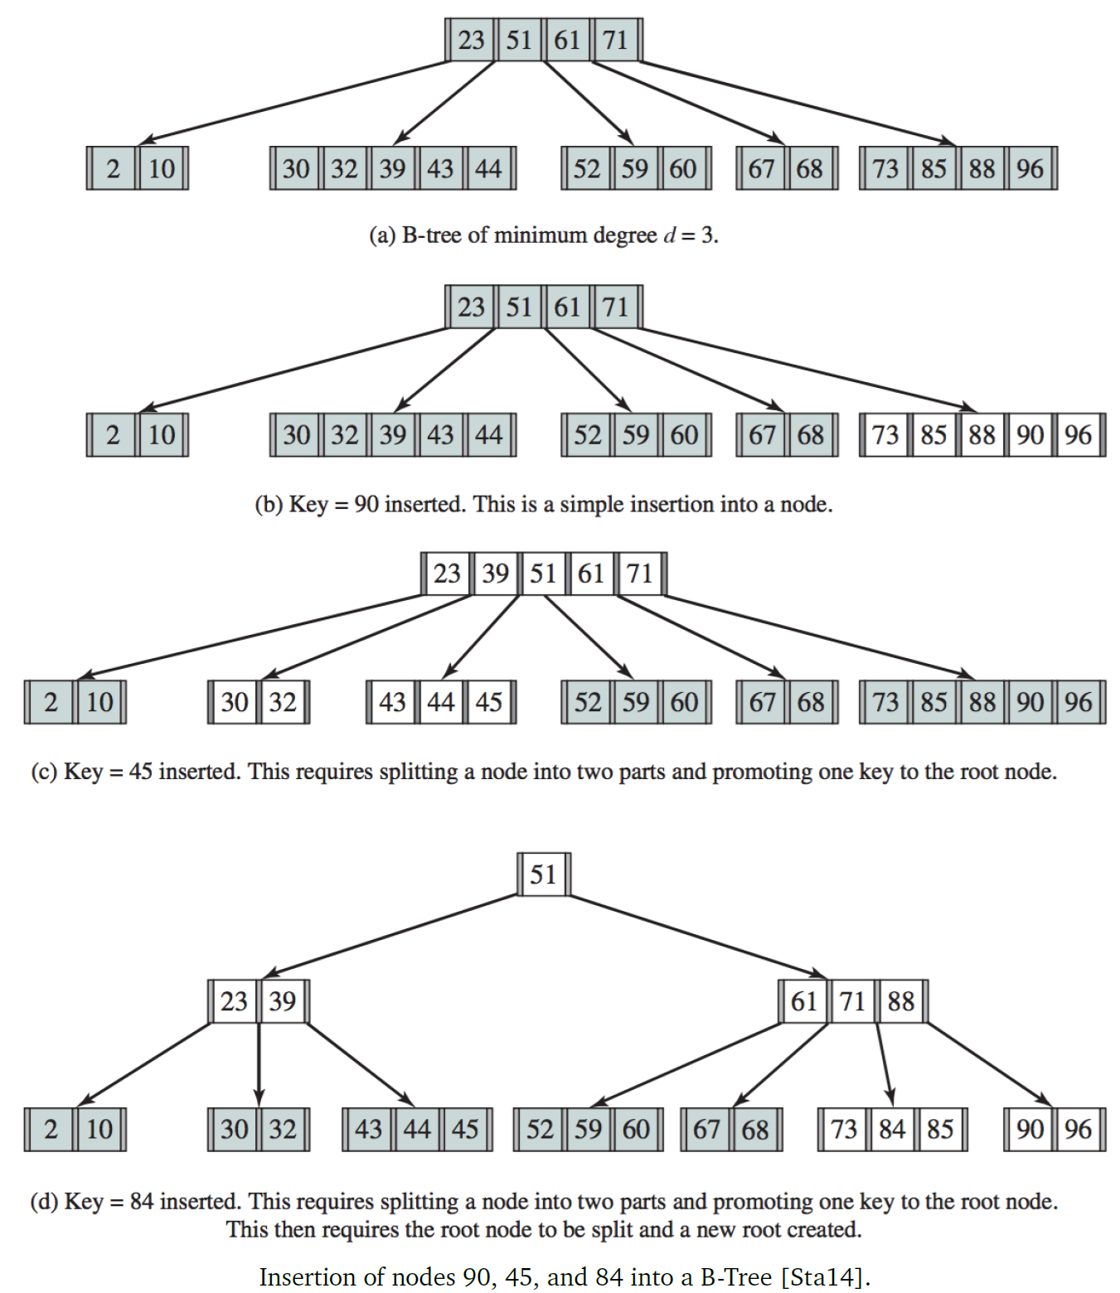

# 34: File Allocation Methods

## File Allocation Methods

* Like memory allocation, there are strategies to allocate disk space to files: contiguous, linked, and indexed

### Contiguous Allocation

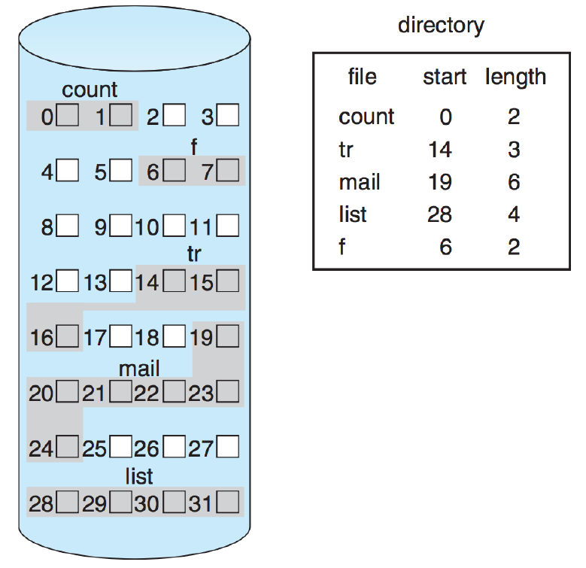

* Each file occupies a set of contiguous blocks on disk
  + E.g. if a file starts at block $b$ and takes up $n$ blocks in size, the file occupies blocks $b$, $b+1$, … , $b+(n-1)$
  + This is advantageous when accessing blocks for the file, because no head movement is required to move from block $b$ to block $b+1$, so seek time is non-existent to minimal (if need to move to another cylinder)
* Need to maintain values of $b$ and $n$ for each file
  + To access a block $i$ at some offset from the start of the file, adding the base address $b+i$ gets the address
  + Checking if the access is valid just requires checking $i<n$
* However, there a few problems; if we need a memory block of size $N$:
  + Can we find a block of size $N$ or greater?
  + How do we choose between multiple free blocks?
  + External fragmentation and some internal fragmentation on the last block in the file
  + We don’t know how much space a file will take up if it is newly created
    - Allocate too little space, and may need to move the file and reallocate it
    - Allocate too much space, and significant space can be wasted for small files
  + Like in memory allocation, compaction (moving allocated blocks around to create larger free blocks for allocation) can be done on disk, but it is very computationally expensive and takes a long time

### Linked Allocation

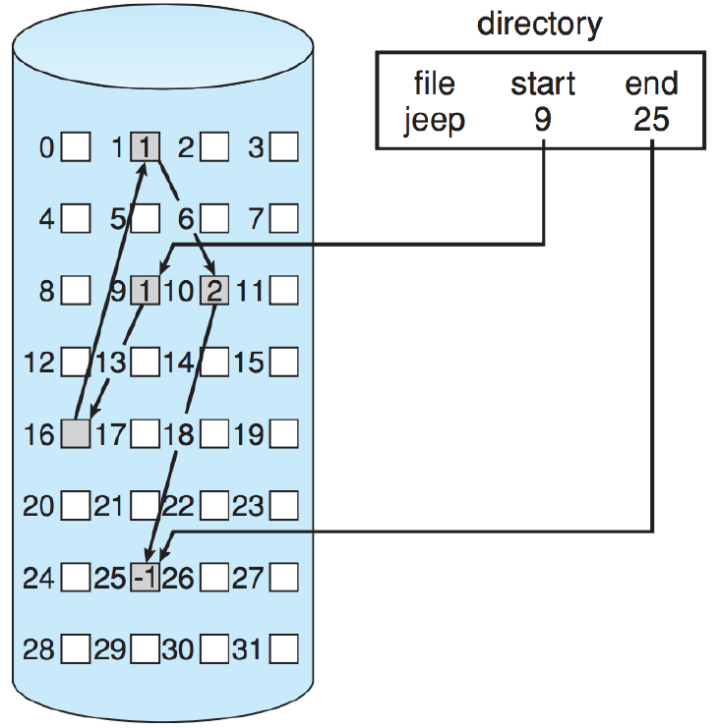

* Maintain a linked list of blocks per file, and the blocks can be anywhere on disk
* Directory listing for the file has a pointer to the first and last blocks (head and tail of the linked list)
* New files are created with size 0 and null head/tail pointers; new blocks are added to the linked list as needed, meaning compaction and relocation are no longer issues
* However, accessing a block $i$ in a file requires following $i$ pointers (can no longer be computed directly)
* A possible solution to following/maintaining so many pointers is to group blocks into **clusters** of a few (e.g. 4) blocks – this wastes less memory on pointer overhead and improves disk access time since there is less seeking back and forth to various disk locations

**File Allocation Table**

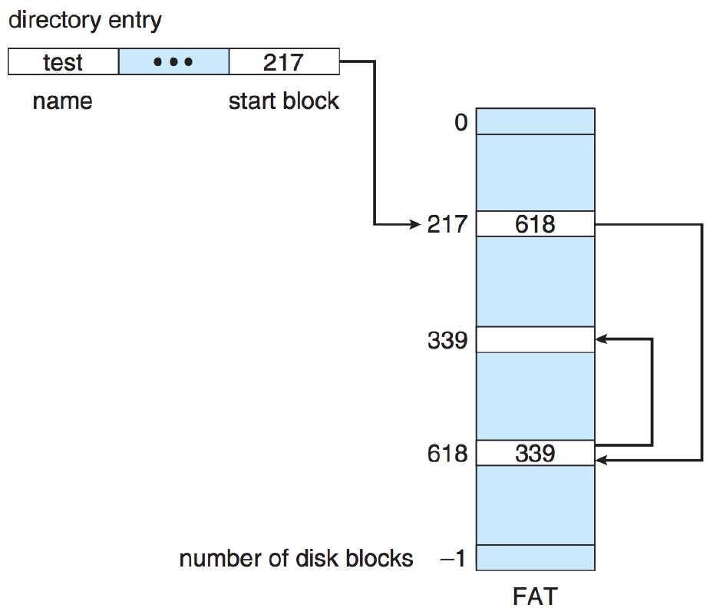

* A variation of linked allocation is File Allocation Table (FAT), of which FAT32 is still used today for formatting USB drives so that the data can be readable across different operating systems
* FAT allocation scheme:
  + At the beginning of the disk, there is a table that maintains file allocation data
  + The table is indexed by block number, with one entry per block
    - The first block of each file is its directory entry, and the FAT entry corresponding to that block contains the index of the next block number
    - The chain continues until the last block for the file, which has a special end-of-file value
    - Free entries are numbered 0; thus, to allocate a new block, look for a 0-valued entry and replace the previous end-of-file value with the address of the new block
* The FAT should be cached in memory to prevent the disk from seeking back and forth often

### Indexed Allocation

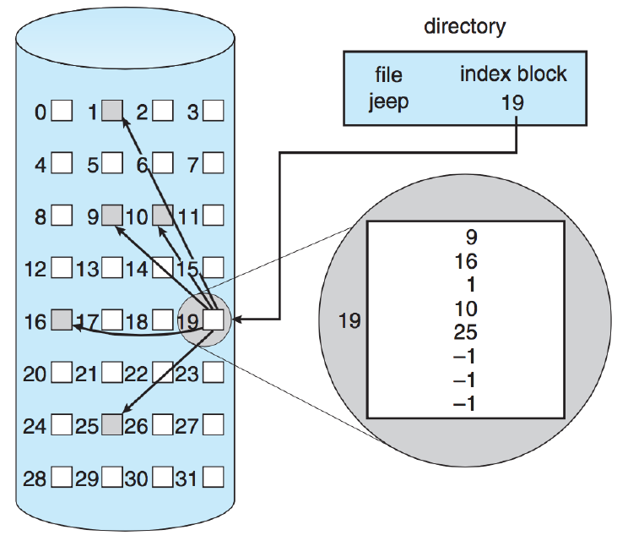

* The main problem with pure linked allocation is that accessing the middle of files takes following and retrieving a lot of pointers to different blocks
* Indexed allocation takes all the pointers and puts them in an index block – the first block of the file contains all the pointers
  + To find block $i$, go to index $i$ of the index block and find the corresponding entry
  + All pointers to blocks start off as null; adding new blocks means adding its corresponding entry into the indexed table
* Like many previously-examined systems, requires deciding how big the size of an index block is
  + If a file only needs 1-2 blocks, an entire block is allocated to hold just 1-2 pointers
  + If the index is small, what if we need more pointers than can fit in one block?
    - **Linked scheme**: index blocks are the same size as disk blocks, and several index blocks can be linked together – the last entry in each index block is either a null pointer or a pointer to the next index block
    - **Multilevel scheme**: variation of linked scheme, with multiple levels – first level block points to second level block, and so on; levels continue for as many as needed for the maximum file size
    - **Combined scheme**: used in UNIX; keep the first 15 pointers of the index block in the inode structure
      * The first12 point directly to file data
      * The 13th is an index block containing the addresses of blocks with data
      * The 14th points to a double indirect block – addresses of blocks containing the addresses of blocks with data
      * 15th points to a triple indirect block

**Structure of an inode**

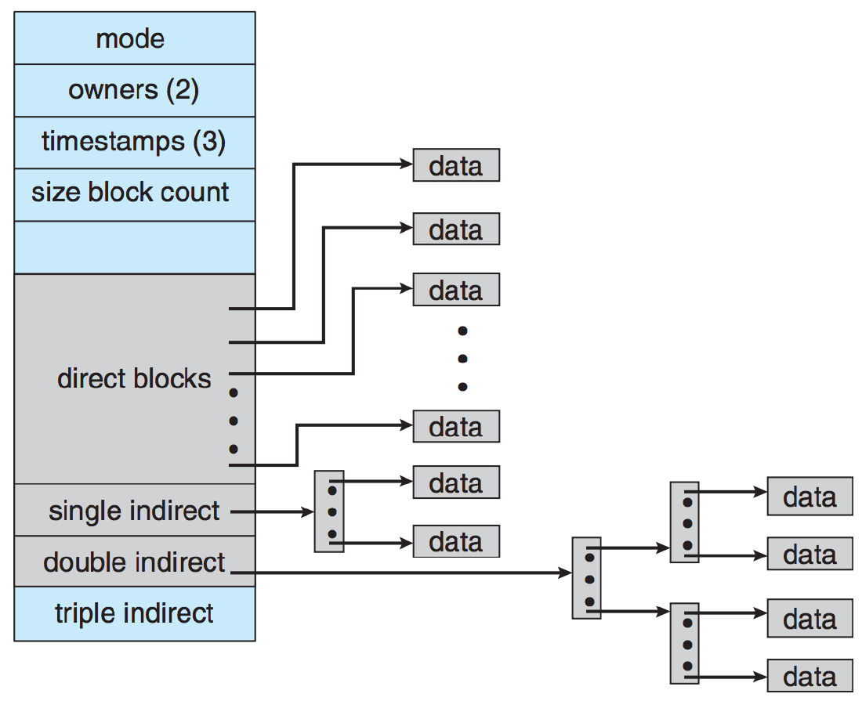

## Other Disk Issues

* Like with memory, the system needs to **keep track of the free space** available
* There are a few approaches:
  + Bit vectors – memory structure where each bit represents a block, free = 1 and allocated = 0
    - The larger the disk, the more overhead needed to store the bit vector
  + Linked lists – head points to first free block, traverse the linked list to get to the next block
  + Grouping – the first free block stores the addresses of $n$ free blocks; the first $n-1$ addresses are actual free blocks, address $n$ points to another block of $n$ free blocks
    - For a large number of free blocks, able to find them quickly instead of traversing the list one block at a time (many disk accesses)
    - Counting improves this slightly – also store the number of contiguous free blocks after each address
    - Entries can be stored in a balanced tree for efficient operations
* The efficient use of a disk depends on disk-allocation and directory algorithms
  + UNIX inodes are pre-allocated, which improves system performance because UNIX algorithms keep file data near the inode when possible, to reduce seek time

## Consistency Checking and Journaling

* Errors, crashes, or power failures can lead to loss of or inconsistent data in a file system; since directory structures, inodes, pointers, FCBs, etc. are all data structures, their corruption can cause serious problems
* Many OSes check periodically for inconsistent data – takes a long time while the entire disk is scanned and inconsistencies are attempted to be fixed (e.g. a file that contains 12 blocks but its linked list only contains 5 blocks)
* To prevent the problem, one approach is atomic operations – operations either succeed completely or not at all
* Transactions: before making any changes, list the things we plan to do, then do the things and complete the transaction
* **Journaling**: all metadata changes are written to a log file; then, the log entries are carried out and a pointer is updated as each change is made, to indicate which log entries have been completed
  + When an entire transaction is complete, it is removed form the log file
  + If the system crashes, and the log file contains transactions, that means they were not completed and so the operations should still be carried out from where they left off
  + If a transaction is aborted, walk backwards through the log entries and undo any completed operations
* This ensures that, even if some data loss occurs, the system remains in a consistent state

### Example: NTFS (Windows File System)

* NTFS is the default file system for Windows; it supports large disks and files, and journaling
* NTFS has several different storage levels:
  + **Sector**: smallest physical storage unit on a disk (usually 512 bytes)
  + **Cluster**: one or more contiguous sectors, grouped in a power of 2 – fundamental unit of allocation
    - Allows the file system to be independent of the size of physical sectors on the disk
  + **Volume**: a logical disk partition consisting of one or more clusters
    - Contains file system information, collection of files, and free space
    - Logical volume can be part of a physical disk, an entire disk, or span multiple disks

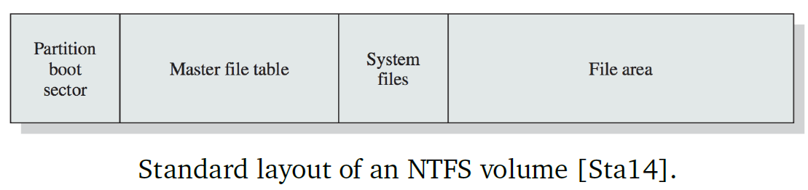

* Master File Table (MFT) contains information about all files and folders
* System filesare a block that contains important system information
  + **MFT2**: mirror of first few rows of the MFT, in case the original gets damaged
  + **Log File**: journaling transaction log
  + **Cluster Bitmap**: bitmap that shows which clusters are in use
  + **Attribute Definition Table**: NTFS attribute types that the volume supports

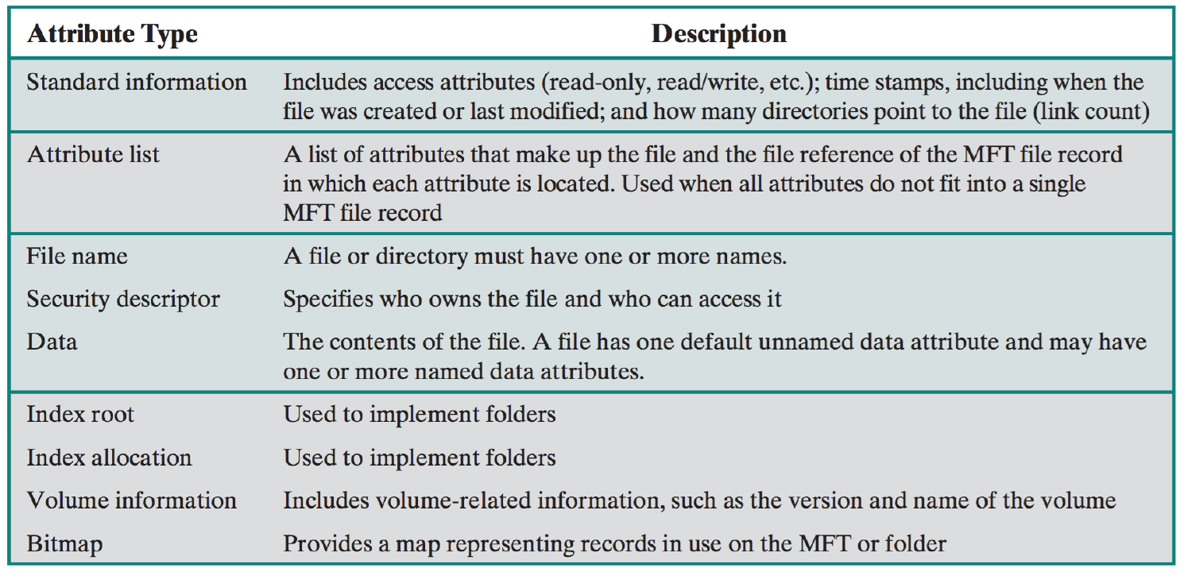

* NTFS uses journaling to ensure that the file system is in a consistent state at all times (user data can still get lost) – a service maintains a log file that can be used for recovery in the case of a system crash or restart

1. Record log file change(s) in the cache
2. Modify the volume in the cache
3. Cache manager flushes the log file to disk
4. After the log file is flushed to disk, the cache manager flushes the volume changes to disk

# 35: Virtualization

## Virtualization and Virtual Machines

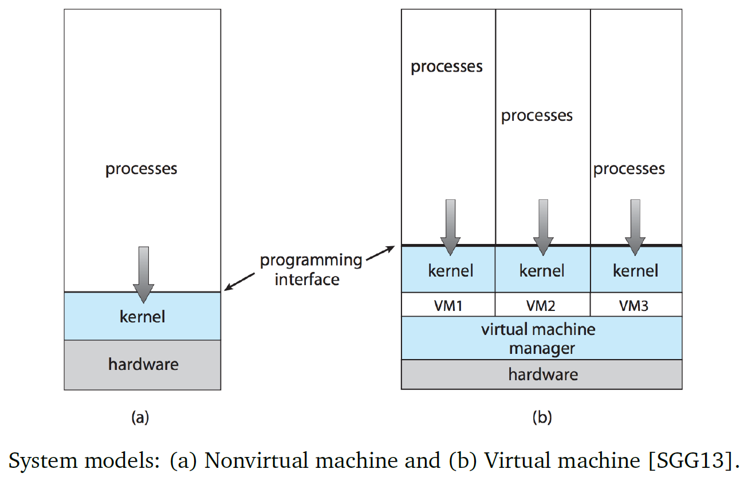

* **Virtual machines (VMs)** abstract the hardware of a single computer into several different executing environments, such as different OSes or multiple copies of one OS
  + **Host**: lowest level, underlying hardware system
  + **Virtual machine manager (VMM)**: creates an interface that appears as a host, but can have multiple copies
  + **Guests**: interact with their own virtual copy of the host, so that multiple systems can exist concurrently on one physical machine
* Virtualization is different from emulation
  + Virtualization involves multiple OSes running on the same x86_64 system architecture, as guests
  + Emulation involves code that runs on the x86_64 environment, to simulate a hardware device with a completely different CPU
    - E.g. Android emulator allows Android apps, which wouldn’t normally be able to run on desktops, run in the simulation of a mobile environment
* The execution of running virtual machines can be suspended/paused, like pausing a process – the current state is stored and can be restored at a later time
  + This allows VMs to be moved to another system and resumed, or to be cloned to get an identical copy somewhere else
* VMs offer protection, since guests and hosts are isolated from each other
  + If one guest gets infected with a virus, other guests aren’t affected
  + It is easy to delete + reinstall guests or roll them back to an earlier state, if we take periodic copies of it
* VMs also offer consolidation, through allowing multiple servers to share the same physical hardware
  + Physical machines can be converted to virtual ones by turning all of their system data and configuration into a snapshot, which is then started up inside the VM

### Behind the Scenes

* **Virtual CPU (VCPU)**: a data structure that holds the state of the CPU according to the guest machine; doesn’t execute any code
  + VMM maintains the state of the VCPU
  + The VCPU stores the state when the guest is not running, and it is then used to restore the state when the guest is scheduled to run
* **Virtual user and kernel modes**: the guest OS runs in user mode, but it sometimes does things that require kernel mode
  + Actions like I/O requests or interrupts that would normally switch from user to kernel mode, now switch from virtual user to virtual kernel mode
* Oneway of implementing the virtual modes is **trap-and-emulate**: if the guest attempts a privileged instruction, it generates a trap (error) because it is in user mode; the VMM picks this up and emulates (simulates) the requested operation

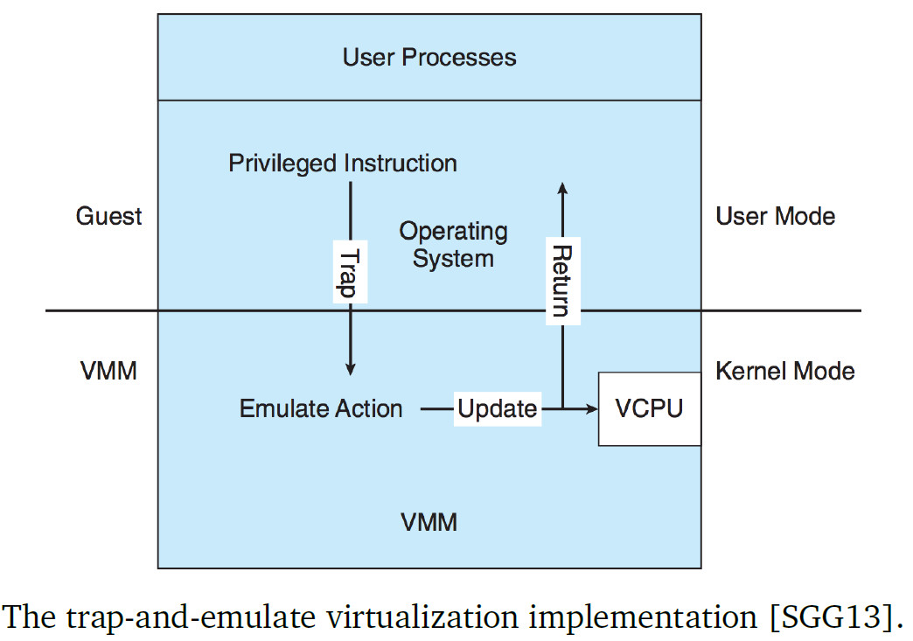

* + Normal instructions run natively on the hardware, which means that privileged instructions have extra overhead – this can cause the guest to run more slowly than it normally would
  + Some CPUs have more than two modes (user/kernel), so they can keep track of virtual user/kernel modes in hardware, preventing the VMM from having to keep track of it in the VCPU
* But some CPUs don’t have a clear definition of privileged vs. non-privileged instructions, including Intel’s x86 (and x86_64) architecture
  + E.g. x86 POPF instruction, which loads the flag register from the contents of the stack
    - If CPU is in kernel mode, all flags are replaced; otherwise, only some flags are replaced
    - If POPF is executed in user mode, no trap will be issued, so trap-and-emulate wouldn’t catch it
  + These types of instructions are called special instructions, since they require special handling
* **Binary translation**: when the guest VCPU is in user mode, it runs instructions natively; when the guest VCPU is in kernel mode, it believes it is in kernel mode;
  + The VMM checks every instruction before it executes – regular instructions are executed natively; special instructions are translated to/replaced by alternative instructions that produce the same result

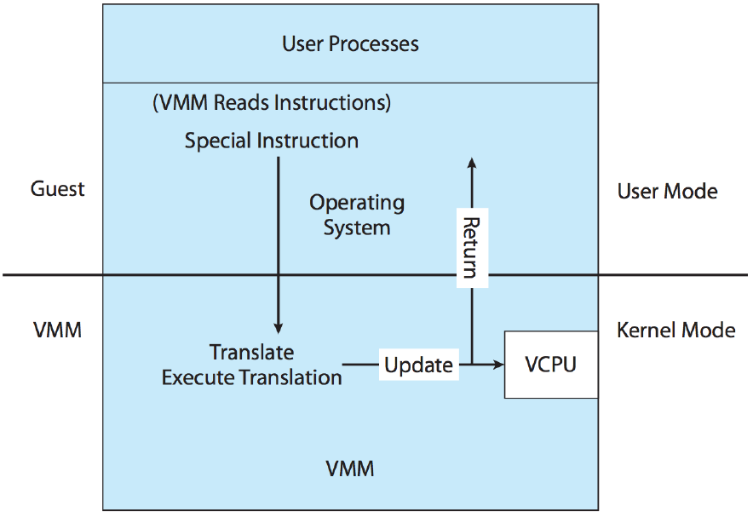

* + There is a small performance decrease when checking/translating instructions, but most instructions can run natively; only a few need to be emulated
  + Intel has also added virtualization support to processors to increase performance
    - Multi-mode operation, including host mode and guest mode
    - If a guest attempts to access a virtualized resource, the VMM takes over to manage the interaction

## The Impact of Virtualization

* Virtualization complicates operations including scheduling, memory management, I/O, and disk

### Scheduling

* Even if there is only one physical CPU, virtualization presents one or more virtual CPUs to guests
* The virtual CPUs’ operations need to all be scheduled on the physical CPU(s), and threads can be either VMM or guest threads
* If there are $n$ physical CPUs in a system:
  + If there are fewer than $n$ virtual CPUs, then just map each virtual CPU to a physical CPU
  + Fully committed: If there are $n$ virtual CPUs, still map each virtual CPU to a physical CPU; since the VMM doesn’t usually need too much time, it can “steal” cycles from CPUs that aren’t busy at the moment
  + Overcommitted: If there are greater than $n$ virtual CPUs, the VMM has to determine how to map the virtual CPUs to the physical ones, based on some scheduling strategy – a scheduling algorithm can be used to schedule all the threads, or determine which guest OS should run next
    - In this case, any guest OS deadlines become inaccurate; e.g. the guest OS scheduler can define a timeslice as 50ms but the real timeslice will be how often the VMM runs the guest OS’s threads

### Memory Management

* The processes that run take up plenty of memory, and the multiple OSes and their data structures also take up memory
* Memory can be overcommitted, where the amount of memory that guests are allocated exceeds the total RAM of the physical machine
* Several techniques can help in memory management:
  + **Nested Page Tables** – guest OS thinks it controls memory and page table management, but in reality, the VMM has a nested page table that re-translates the virtual page table to the physical page table
    - The VMM can provide double-paging, where it tries to help out the guest with its own page replacement strategy
    - But this is generally inefficient because the VMM doesn’t know as much about the guest’s memory patterns
  + **Device Driver**: install a device driver into the guest, which allows the VMM to have some control over the guest
    - When needed, the “balloon” memory manager requests a bunch of free memory and tells the guest to pin its pages in physical memory – makes the guest think that memory is in short supply, so it starts to free up memory
    - VMM knows that balloon pages are free, so can allocate them to other guests if necessary
    - When the memory pressure on the system decreases, balloon pages can be unpinned/deallocated, making the guest think that it has more free memory
  + **Duplicate Detection**: VMM checks if identical pages have been loaded more than once (likely if guests are the same OS), then only keeps one page; can result in significant memory savings if the OS itself takes up a lot of memory
    - Done by taking hash values for memory – first look for identical hash value, then do byte-by-byte comparison
    - However, if a modification to a shared page is necessary, need to make a copy of the page first

### Input/Output

* Unlike CPUs and RAM, guest OSes can generally tolerate changes in I/O devices during operation
  + Device drivers are the interface to the OS, regardless of what type of device it is
  + Guests can see virtual devices as if they are real
* VMM decides how to allocate devices to guests; it can either allocate the device to a specific guest, or provide drivers that translate commands into device commands

### Disk

* **Disk image**: contains all the contents of the root disk of the guest – a large file that can be split into manageable chunks
  + The guest thinks it has access to the entire disk, unaware that it is just a file inside of another system
  + Makes it a lot easier to move VM’s around from one system to another

## Live Migration

* Virtualization allows the ability to move a running system from one machine to another
* Goal: copy one system to another such that that users logged into the guest and programs running on the guest do not notice
* Steps:

1. Source VMM connects to destination VMM
2. Destination VMM creates a configuration for the new guest, including VCPU, nested page table, state
3. Source sends all read-only memory pages to the destination
4. Source sends all read-write pages and marks them as clean
5. Any pages that were modified during step 4 are sent and marked as clean
6. Source freezes the guest, then sends the final state (including VCPU data) and any final dirty pages
7. Destination acknowledges receipt and begins execution of the guest
8. The source terminates the guest

